

Institute of Food Science and Biotechnology

Department of Plant-based Foods (150d)

**Master’s thesis**

Rheology & Printability of protein with different fiber-based inks

**Submitted by:** **Divya Sahu (909158)**

Study program: Food Systems

Department: Department of Plant-based Foods (150d)

Head of Department: Prof. Dr Mario Jekle

1st Supervisor: Prof. Dr Mario Jekle

2nd Supervisor: Prof. Dr.-Ing. habil. Jörg Hinrichs

**Advisor:** **Ms. Esther Addo**

**Submission date:**  **Place, Date**

**Declaration of Independence**

I, Divya Sahu (909158), declare that I have followed the Principles of Good Scientific Practice while writing the present master’s thesis.

I have written the thesis independently and have used no other sources or aids than those given and have marked the passages taken from other works word-for-word or paraphrased.

I furthermore declare that the submitted unencrypted electronic document exactly and without exception corresponds to the contents and wording of the printed copy of the thesis. I give my consent to this electronic version being checked for plagiarism with analytical software.



Place, Date

Name Surname

**Acknowledgements**

Acknowledgements do not have a page number. The acknowledgements do not include assessments of the topic's importance or of the results obtained. For academic theses, there is no right or wrong way to acknowledge people, and who you want to acknowledge is down to personal preference.

**Table of contents**

[**1.** **Zusammenfassung** **1**](https://docs.google.com/document/d/1lVeUlig9X9GEL5f8Ppi35xXZLd0oGQ-6/edit#heading=h.2et92p0)

[**2.** **Abstract** **2**](https://docs.google.com/document/d/1lVeUlig9X9GEL5f8Ppi35xXZLd0oGQ-6/edit#heading=h.tyjcwt)

[**3.** **Highlights and graphical abstract** **3**](https://docs.google.com/document/d/1lVeUlig9X9GEL5f8Ppi35xXZLd0oGQ-6/edit#heading=h.1t3h5sf)

[**4.** **State of scientific knowledge** **4**](https://docs.google.com/document/d/1lVeUlig9X9GEL5f8Ppi35xXZLd0oGQ-6/edit#heading=h.4d34og8)

[4.1. Cereals and secondary metabolites 4](https://docs.google.com/document/d/1lVeUlig9X9GEL5f8Ppi35xXZLd0oGQ-6/edit#heading=h.2s8eyo1)

[4.2. Saponins 4](https://docs.google.com/document/d/1lVeUlig9X9GEL5f8Ppi35xXZLd0oGQ-6/edit#heading=h.17dp8vu)

[4.2.1. Foaming behaviour 4](https://docs.google.com/document/d/1lVeUlig9X9GEL5f8Ppi35xXZLd0oGQ-6/edit#heading=h.3rdcrjn)

[4.2.2. Extraction 4](https://docs.google.com/document/d/1lVeUlig9X9GEL5f8Ppi35xXZLd0oGQ-6/edit#heading=h.lnxbz9)

[**5.** **Motivation and Outline** **5**](https://docs.google.com/document/d/1lVeUlig9X9GEL5f8Ppi35xXZLd0oGQ-6/edit#heading=h.35nkun2)

[**6.** **Material and methods** **6**](https://docs.google.com/document/d/1lVeUlig9X9GEL5f8Ppi35xXZLd0oGQ-6/edit#heading=h.1ksv4uv)

[6.1. Materials and instruments 6](https://docs.google.com/document/d/1lVeUlig9X9GEL5f8Ppi35xXZLd0oGQ-6/edit#heading=h.44sinio)

[6.2. Methods 7](https://docs.google.com/document/d/1lVeUlig9X9GEL5f8Ppi35xXZLd0oGQ-6/edit#heading=h.1y810tw)

[6.2.1. Grinding 7](https://docs.google.com/document/d/1lVeUlig9X9GEL5f8Ppi35xXZLd0oGQ-6/edit#heading=h.4i7ojhp)

[6.2.2. Extraction 7](https://docs.google.com/document/d/1lVeUlig9X9GEL5f8Ppi35xXZLd0oGQ-6/edit#heading=h.2xcytpi)

[**7.** **Results and discussion** **8**](https://docs.google.com/document/d/1lVeUlig9X9GEL5f8Ppi35xXZLd0oGQ-6/edit#heading=h.1ci93xb)

[7.1. Extraction 8](https://docs.google.com/document/d/1lVeUlig9X9GEL5f8Ppi35xXZLd0oGQ-6/edit#heading=h.3whwml4)

[7.2. Saponin quantification 8](https://docs.google.com/document/d/1lVeUlig9X9GEL5f8Ppi35xXZLd0oGQ-6/edit#heading=h.2bn6wsx)

[**8.** **Conclusion and further perspectives** **10**](https://docs.google.com/document/d/1lVeUlig9X9GEL5f8Ppi35xXZLd0oGQ-6/edit#heading=h.qsh70q)

[**9.** **References** **11**](https://docs.google.com/document/d/1lVeUlig9X9GEL5f8Ppi35xXZLd0oGQ-6/edit#heading=h.3as4poj)

[**10.** **Appendix** **12**](https://docs.google.com/document/d/1lVeUlig9X9GEL5f8Ppi35xXZLd0oGQ-6/edit#heading=h.23ckvvd)

**List of abbreviations**

| ***FD*** | Foam density | **TLC** | Thin layer chromatography |
| --- | --- | --- | --- |
| ***FR*** | Foaming rate | **TQ** | Triple Quadruple |
| ***FS*** | Foam stability | **TSC** | Total saponin content |
| ***FSI*** | Foam stability index | **UAE** | Ultrasound-assisted extraction |

**Materials and Methods**

| Material | Specifications | Manufacturer |
| --- | --- | --- |
| Pea protein isolate | 00021032209/2024 | bulkTM (Colchester, UK) |
| Soy protein isolate | 0016680405/2023 | bulkTM (Colchester, UK) |
| Zein protein |  |  |
| Psyllium husk | 2205270017 & 2304260001 | Aurica(Apotheke, Kirchheimer Strasse, Germany) |
| Polydextrose | 20210924024 |  |
| Oats fiber | G04052222 | *SANACEL*®  oat30 |
| Wheat fiber | G02301841 | *SANACEL*® wheat 30 |
| Lactic acid | K47012266541 | *Emprove* ® exp |

**2.0 Methods**

**Preliminary tests for zein**

To understand the zein behavior preliminary tests were carried out with the three different concentrations of lactic acid that is 5%, 10% and 15%. The tests were performed with amplitude sweeps and to know the effect of wheat fibers with the different five concentrations 0%, 12.5%, 25%, 37.5% & 50% at 25°C. The storage modulus and loss modulus were calculated which helped to understand the rheology of zein protein.

**Preliminary tests for PPI and SPI protein inks**

Different approaches were performed to prepare the PPI gels including gelation from salt and gelation at various temperatures. Apart from that two alternative PPI:SPI ratios (1:0.3 and 1:0.4) were tested with five different concentrations of dietary fiber (psyllium husks), which are as follows 3%, 5%, 7%, and 9%, to make the protein-based gels (as shown in the appendix), and 1:0.3 of PPI: SPI was chosen for further research.

*2.1 Preparation of protein-based protein inks*

2.1.1 Pea protein Inks

For the following work, protein hydrogels were prepared with five different hydrations that are as follows in the table below. The gels consisted of pea protein isolates (PPI) and soy protein isolates (SPI) in the ratio of 1:0.3. For the preparation, the respective amounts of proteins and fibers were weighed in a beaker as shown below in the table and hydrated with the respective hydrations of deionized water using the spatula. Later a hand mixer was used to mix the sample properly for 1 minute. Simultaneously, suspensions were wrapped with aluminum foil to prevent the absorption of water from the water bath while heating up. Subsequently, the beaker was placed into a water bath (Kottermann Labortechnik, made in Germany), which was kept at 95 °C for approximately 20-30 minutes. After 20 min, the protein suspension was taken out, and to achieve rapid cooling the beaker was first placed into a cool water bath (~20 °C). In between the samples were covered with parafilm and cooled to room temperature. During the cooling, the polymers aggregate and form a 3D network.

**Table: - Composition of prepared PPI/SPI hydrogels**

| Hydrations (%) | PPI | | SPI | | Distilled water (mL) | | Fibers | |
| --- | --- | --- | --- | --- | --- | --- | --- | --- |
|  | **Mass ratio** [% (w/V)] |  | **Mass ratio** [% (w/V)] |  | **Mass ratio** [%(w/V)] |  | **Mass ratio** [% (w/V)] |
| 75 |  | 17.69 |  | 5.30 |  | 75 |  | 2 |
| 77.5 |  | 15.76 |  | 4.73 |  | 77.5 |  | 2 |
| 80 |  | 13.84 |  | 4.15 |  | 80 |  | 2 |
| 82.5 |  | 11.92 |  | 3.57 |  | 82.5 |  | 2 |
| 85 |  | 10 |  | 3 |  | 85 |  | 2 |

2.2.2 SPI protein inks

The protein gels were prepared with four different hydrations that are as follows below the table. The gels consisted of soy protein isolates (SPI) and fibers. For the preparation of hydrogels, the respective amounts of SPI and fibers were weighed in a beaker and hydrated with the respective hydrations of deionized water using the spatula. Later a hand mixer was used to mix the sample properly for 1 minute. Subsequently, the beaker was placed into a water bath (Kottermann Labortechnik, made in Germany), which was kept at 90 °C for approximately 20-30 minutes. After 30 min, the protein suspension was taken out, and to achieve rapid cooling the beaker was first placed into a cool water bath (~20 °C). In between the samples were covered with parafilm and cooled to room temperature. During the cooling, the polymers aggregate and form a 3D network.

**Table: - Composition of prepared SPI hydrogels**

| Hydrations (%) | SPI | | Distilled water (mL) | | Fibers (Oats, wheat, polydextrose and psyllium husks) | |
| --- | --- | --- | --- | --- | --- | --- |
|  | **Mass ratio** [% (w/V)] |  | **Mass ratio** [%(w/V)] |  | **Mass ratio** [% (w/V)] |
| 77.5 |  | 20.5 |  | 77.5 |  | 2 |
| 80 |  | 18 |  | 80 |  | 2 |
| 82.5 |  | 15.5 |  | 82.5 |  | 2 |
| 85 |  | 13 |  | 85 |  | 2 |

**2.2 Rheological analyses**

Rheological analyses were performed using the MCR302e rotational rheometer (Anton Paar, Ostfildern-Scharnhausen, Germany). For the pea protein isolates with wheat, oat and polydextrose fibers, a cone/plate or cone and plate measuring geometry was used. This prevented the runny and viscous samples from slipping through the measurement. All the samples were weighed and kept 10.5 g as a constant to prevent deviations before measuring. Whereas for the other samples such as pea protein isolates with psyllium husks, soy protein isolates with psyllium husk, wheat, oat and polydextrose fibers were measured with plate-plate geometry (gap = 1 mm). For all the samples, the measurement was performed at a constant temperature, the Peltier system and water bath was kept at 25°C. The samples were placed at measurement area along with that every time to prevent the errors and always zero gap was performed. The gap was adjusted, and samples were smoothly trimmed and the same amount of parafilm oil was spread around all the samples. Before the measurement all the samples went into 2 min of waiting time for structure recovery and stress relaxation. Different tests were performed including amplitude sweep, frequency sweep and flow curve.

Stress sweep tests were conducted using a shear strain that increased logarithmically, covering a range from 0.1 to 100% deformation. These tests were performed at a consistent frequency of 1 Hz. The values for G΄ (storage modulus), G’’ (loss modulus) and tanδ (damping factor) were calculated by taking the average of the three triplicate samples obtained during the amplitude sweep, with 25 measuring points. The yield stress (σy) was determined by identifying the stress at which the storage modulus (G΄) intersected with the loss modulus (G΄΄) (Ozkan, Xin, & Chen, 2002). The aim of amplitude sweeps is generally to describe the behavior of the samples in the non-destructive deformation range and to determine the upper limit of the range. When the upper limit exceeds with the increasing deformation, then the inner structure of the soft gel, starts to flow or breaks down in a brittle way (Anton Paar).

Frequency sweep experiments were performed over a frequency range of 0.1-100 Hz, maintaining a consistent shear strain of 0.1%. The rheological measurements were then modeled using the power-law equation (G΄ = K⋅ω^n), wherein ω represents the angular frequency, K stands for the power-law coefficient, and n signifies the frequency exponent. This exponent n characterizes the frequency-dependent viscoelastic properties of the samples Bi et al. in 2018 and Quinchia et al. in 2011. Typically, frequency sweeps are used to describe whether a sample is time-dependent behavior in the non-destructive deformation range or not. Low frequencies are used for representing slow motion on long timeframes or at rest, while high frequencies are used to represent fast motion on short durations. Frequency sweeps maintain a steady oscillation amplitude while gradually changing the oscillation frequency from one measuring point to the next (Anton Paar).

To assess the viscosity of the food inks, a rotational test was conducted. This involved measuring both the apparent viscosity and shear stress across a range of shear from 1 to 100 1/s. As a result, every one-second interval produced a set of 100 measurement data points, which were captured logarithmically.

Table (-) Measurement parameters of the performed experiments for viscosity measurement, amplitude sweep and frequency sweep.

|  | Deformation  (%) | Frequency (Hz) | Shear rate (1/s) | Temperature (°C) | Measurement Points |
| --- | --- | --- | --- | --- | --- |
| Viscosity measurement | - | - | 1-100 | 25 | 100 |
| Amplitude sweep | 0.01-10 | 1 | - | 25 | 25 |
| Frequency sweep | 0.1 | 0.1-100 | - | 25 | 16 |

**2.3 3D printing setup, structure designs and printing parameters**

3D printing was carried out using a customized extrusion-based 3D printer, where the foundation consisted of aluminium profiles provided by Industrietechnik GmbH, Solingen, Germany. A drylin® room gantry linear robot, powered by stepper motors and toothed belts, managed the extrusion unit's movement along the Cartesian coordinates. This extrusion unit incorporated the vipro-HEAD 3 from ViscoTec, Töging a. Inn, Germany, comprising a progressive cavity pump (PCP) extruder and a side-mounted paste injection cartridge for material storage.

To ensure continuous material flow to the extruder's dosing unit, the paste injection cartridge received a constant air pressure of 3 bar. For precise deposition of the plant-based materials onto the printing platform, a dispenser needle with a nozzle diameter of 0.84 mm, sourced from ViscoTec, was affixed to the extruder head. The printing platform, measuring 235 mm x 235 mm, consisted of an aluminium build plate. Before initiating printing, manual levelling of the printing platform was performed using four corner setscrews. This process helped to ensure the same levelling consistency at a minimal distance between the nozzle tip and the printing platform. All printing operations were executed at room temperature. (Continue the next part).

**Results & Discussion**

1. **Evaluation of printing quality using image analysis**

**1.1 Camera system integration**

A high-resolution camera (model- acA1920-155uc) with C11-1620-12M-p F16m objective lens from Basler AG in Ahrensburg, Germany was installed to assess the geometrical shape of the printed objects. The camera system from Pylon Viewer (Basler AG, Ahrensburg, Germany) was positioned at the same level as the printing platform and in front of the 3D printer. The main purpose of this setup was to capture side-images of the printed objects. To establish a reference scale, a reference object was placed at a distance from the camera as the printed objects. For the optimal results, the reference object was bigger than the printed object to achieve the maximum contrast. Thus, the same reference object was used for all the samples.

Table 2.1 - Dimension of reference object used for image analysis of 3D printed objects.

|  | Length (mm) | Height (mm) |
| --- | --- | --- |
| White reference | 23.83 | 9.65 |

1.2 Image analysis

Image analysis was done by using MATLAB (MathWorks Inc, Massachusetts, USA) script (Fahmy et al., 2020). The algorithm assisted to determine the dimensions of the printed structure by using the side-view pictures (Figure – add grayscale pictures) where the original image was first converted into greyscale to increase the contrast between the black background and the sample whereas also simultaneously decreasing the degree of received information. This was accomplished by applying the weighted average luminous model, where the perceived luminance L for each pixel's RGB channel was determined using the following equation.

L = 0.229 ∙ R+ 0.587 ∙ G + 0.114 ∙ B

Here, the variable represents the levels of red, green, and blue in 8 bits. (Anderson, Motta, Chandrasekar, & Stokes, 1996). Additionally, a threshold value was derived by analyzing the collective histogram. This threshold value was employed for the purpose of converting the images into black and white. The process of achieving black and white images involved utilizing clustering-based image thresholding, specifically using Otsu's method (Otsu, 1979).

Following the threshold step, a size-based segmentation technique was employed using a flood fill algorithm. This was carried out to isolate individual image components for subsequent pixel-based analysis. For calculating the spatial resolution, the algorithm employs a combination of techniques. The boundary or edge detection method is used, along with the bounding box technique applied to a reference object. The bounding box technique is based on the concept of rotating calipers, as introduced by Toussaint (Toussaint, 1983). This approach aids in determining the spatial resolution of the analyzed image components. The following images represent how boundary detection works which was performed for the length and height for the printed lines.

a) 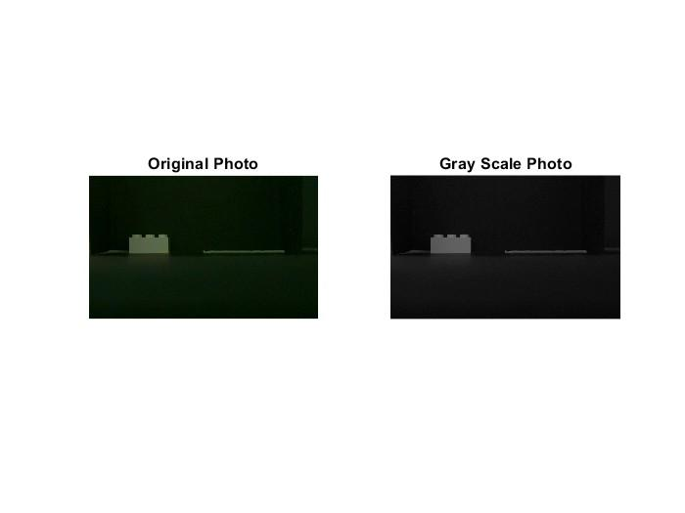b) c)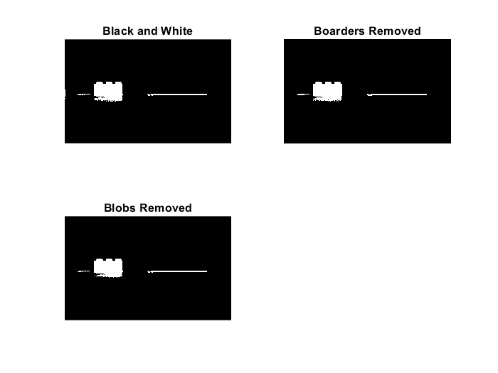

d)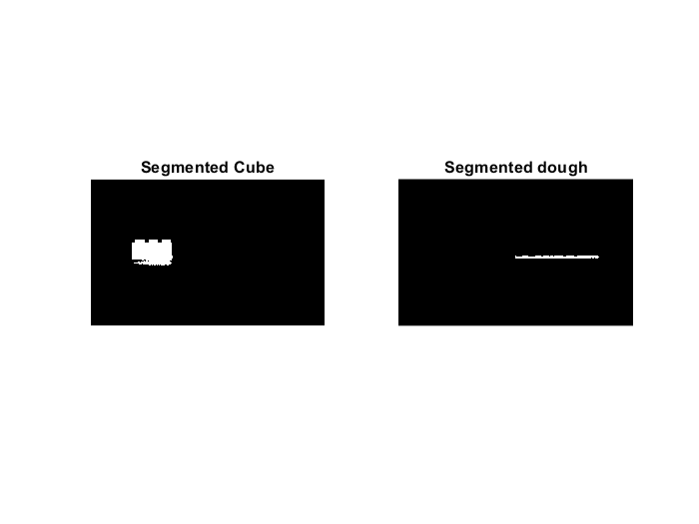 e)  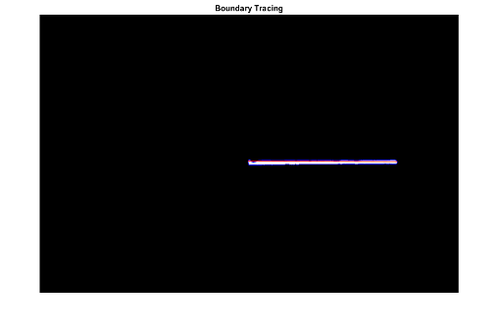

Figure : The above images represent the sequence of image analysis algorithm a) original image b) greyscale image c) black and white image d) segmented reference with boundary detection e) segmented line f) segmented line with boundary detection.

Moreover, after the spatial resolution, a boundary detection algorithm was used for the printed lines by Moore-Neighbor tracing algorithm which was modified by Jacob’s stopping criteria. Where the extruded lines were calculated by the following equation: -

Lext = √((x2 - x1)^2 + (y2 - y1)^2)

Lf = (Lext / Linput) * 100

Here, the variables indicate the two detected matrix pixels' planar positions (x1, x2, y1, y2), which signify the length extremes, whereas (Linput) is the theoretical line length. The length and height of printed lines and cubes were determined. But also, the influence of different hydrations and soluble and insoluble fibers were investigated on printing. Similarly, the following images represent how boundary detection works which was performed for the length and height for the printed cubes.

a) 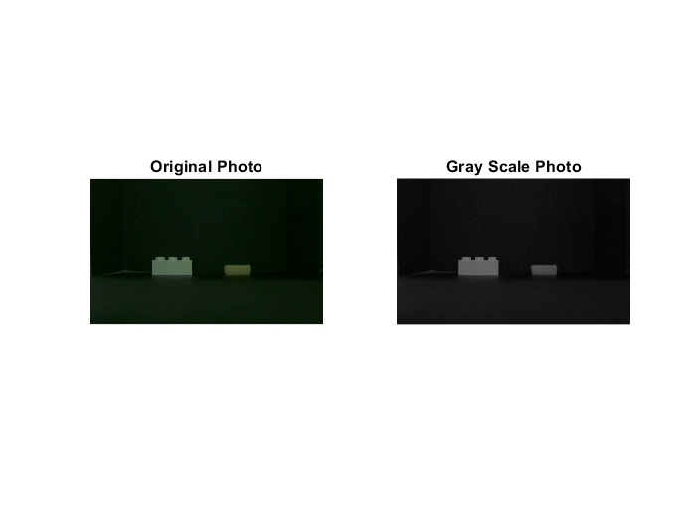b) c) 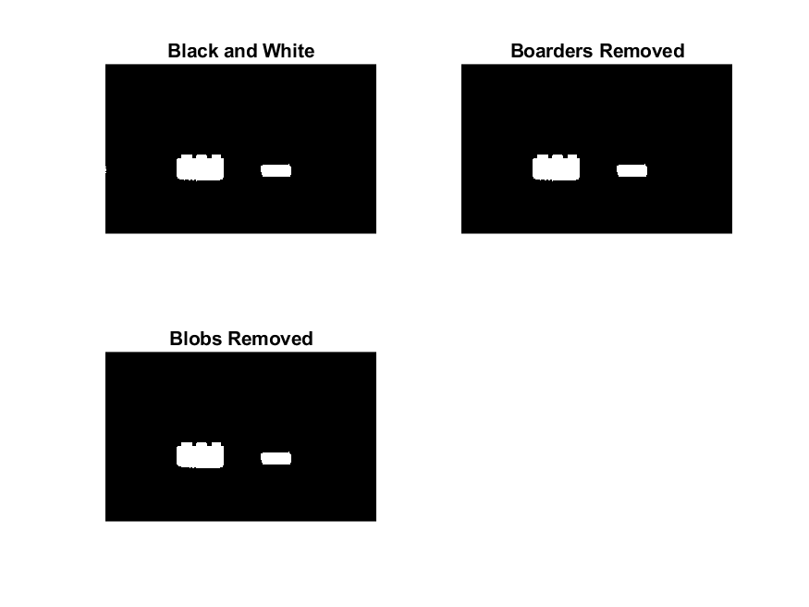

d) 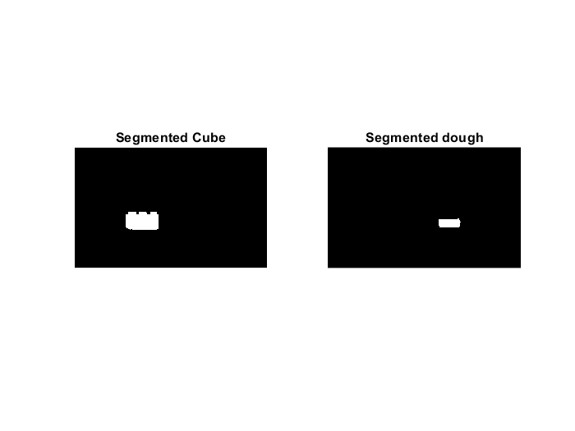 e)  f) 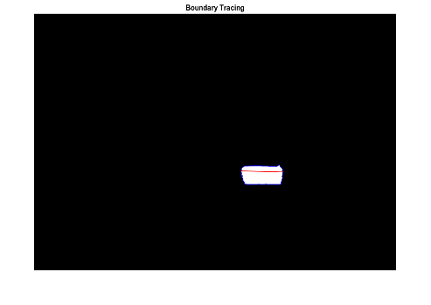

Figure : The above images represent the sequence of image analysis algorithm a) original image b) greyscale image c) black and white image d) segmented reference with boundary detection e) segmented cube f) segmented cube with boundary detection.

**Data Analysis**

*Preliminary tests for zein*

For 5% lactic acid it was observed that 0% showed the lowest storage and loss modulus followed by 12.5% and 50%. The lowest storage was observed by 12.5% of dietary fibers followed by 50%, 25% and 37.5% whereas 50% wheat dietary fibers should have seen the highest storage modulus theoretically, but this could be possible due to the fact that due to too much adding of wheat dietary fibers showed poor binding properties which resulted into not properly homogenous system for 10% lactic acid. Whereas for 15% lactic acid the lowest storage modulus was seen for 0% followed by 12.5%, 25%, 37.5% and 50% respectively as shown in the graph (appendix). Although for loss modulus it was observed that the lowest for 0%, 12.5%, 37.5%, 50% and 25% respectively. Theoretically, the storage and loss modulus should have been increasing with the addition of wheat dietary fibers but there was slight difference and high standard deviation was observed. The reason behind this could be due to many reasons such as error, non-homogenous of the particle, improper mixing or too much mixing, due to material behavior or different temperatures while measuring the amplitude sweep. Overall, it was concluded that the 15% lactic acid was the most elastic food inks than the other 10%, 5% moreover, the storage and loss modulus was also greater than the 10% and 5% lactic acid. Moreover, increasing the wheat dietary fibers increased the storage as well as loss modulus. The following table depicts the observation during the experiment done:-

| **S.no** | **% of Lactic Acid** | **% of Dietary Fibers** | **Observation** |
| --- | --- | --- | --- |
| 1. | 5% | 0%, 12.5% and 50% | 0% ink was the most brittle, poor hydrophilicity, 12.5% showed some elasticity whereas 50% ink showed good hydrophilicity but poor binding properties. |
| 2. | 10% | 12.5%, 25%, 37.5% & 50% | Increase in the hydration properties while increasing the dietary fibers but with 50% it showed poor binding properties whereas 25% showed good elasticity. |
| 3. | 15% | 0%, 12.5%, 25%, 37.5% & 50% | Most elastic properties are shown by the 15% samples compare to others concentration of lactic acid whereas 50% ink sample was not able to form an ink. Most elasticity was shown by 21.5% and 25% sample. |

*Preliminary tests for PPI and SPI protein inks*

A graph between storage modulus (Pa) and shear strain (%) was plotted to understand the effect of dietary fiber. For these two different ratios that are 10:3 and 10:4 were taken for PPI:SPI. Along with those different concentrations of psyllium husk from 0%, 0.3%, 0.5%, 0.7% & 0.9% were taken. The results are as shown below in the graph: -

At 0% of psyllium husk the storage modulus was the lowest whereas for 0.3% it was at 600 Pa and slightly higher for 0.5% while 1100 Pa was observed for 0.7% and the highest was observed for 0.9% with 1450 Pa as shown in figure . The same pattern was observed for 10:4 ratio of PPI:SPI but slightly higher standard deviations were observed for both 0.7% and 0.9%. The reason for this could be improper mixing of psyllium particles into the food inks as shown in figure .

Overall, from the results it can be considered that increasing the psyllium husk is increasing the storage modulus and providing more elasticity to the gels. Whereas for the 10:4 it can be observed that the storage modulus was more than 10:3 which indicates that SPI helped to make stronger gel and viscous gel. Thus, for further research 10: 3 ratios of PPI: SPI was considered.

a) 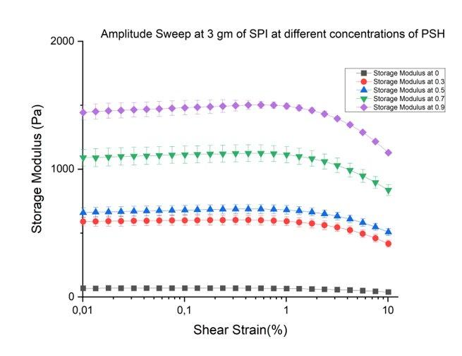b)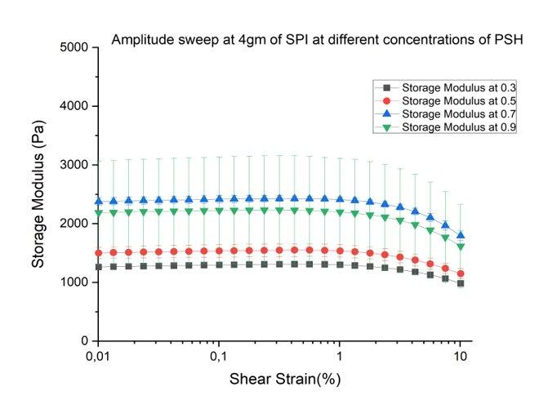

**Rheological properties**

Amplitude sweep

| Sample | G’LVER [Pa] | Yield stress (τy) [Pa] | Flow point (τf) [Pa] |
| --- | --- | --- | --- |
| PPI poly 80% | 356.96 | 43.86 | 26.64 |
| PPI poly 82.5% | 106.03 | 0.89 | 3.66 |
| PPI poly 85% | 20.37 | 0.057 | 0.71 |
| PPI psh 75% | 10736.01 | 123.76 | 997.79 |
| PPI psh 85% | 865.32 | 84.85 | 611.46 |
| PPI oats 80% | 414.14 | 0.34 | 30.98 |
| PPI oats 82.5% | 42.23 | 0.281 | 20.61 |
| PPI oats 85% | 8.73 | 0.20 | 0.35 |
| PPI wheat 75% | 3054.94 | 59.10 | 273.09 |
| PPI wheat 80% | 311.93 | 30.55 | 22.64 |
| PPI wheat 82.5% | 74.10 | 0.32 | 3.22 |
| PPI wheat 85% | 14.86 | 0.03 | 0.235 |
| SPI oats 80% | 4309.31 | 94.25 | 433.39 |
| SPI oats 82.5% | 1634.39 | 24.99 | 129.21 |
| SPI oats 85% | 504.52 | 5.02 | 40.55 |
| SPI wheat 77.5% | 17858.26 | 610.09 | 2243.9 |
| SPI wheat 82.5% | 1600.66 | 33.82 | 151.48 |
| SPI wheat 85% | 602.78 | 2.87 | 48.63 |
| SPI poly 77.5% | 7130.84 | 241.45 | 898.72 |
| SPI poly 82.5% | 545.55 | 17.67 | 58.69 |
| SPI poly 85% | 515.15 | 16.06 | 46.84 |
| SPI psh 77.5% | 11347.37 | 84.31 | 508.61 |
| SPI psh 80% | 8789.67 | 418 | 103.69 |
| SPI psh 85% | 2260.85 | 104.99 | 39.20 |

The rheological properties of protein-based inks were obtained by oscillatory tests such as amplitude sweep, frequency sweep as viscosity. The rheological parameters storage modulus (G’), loss modulus (G’’), loss factor (tan δ) and flow index were plotted accordingly. Moreover, amplitude sweep characterizes the viscoelastic properties which helps to determine linear viscoelastic region (G’LVER), yield stress as well as flow point as shown in the figure (-). Yield point τy also known as yield stress is a point where the value of shear stress is at the limit of LVE region. Whereas flow point τf also known as flow stress is the point where the value of shear stress crossover the point of G’=G’’. Indicating at higher shear values, the viscous portion will dominate the flow. The region between yield point and flow point, where storage modulus (G’) > loss modulus (G’’) within this yield zone sample displays the properties of solid matter or a gel. And when the yield point and flow point are equal, withing this region the index value is 1 and the sample has a higher tendency to show brittle fracturing. [(*Amplitude Sweeps | Anton Paar Wiki*, n.d.)](https://www.zotero.org/google-docs/?cUXEY2)

As shown in the graphs (-) it can be concluded that increasing the hydrations with same content of protein and dietary fibers decreasing the G’LVER, flow point and yield point in all the protein-based inks. Moreover, for all the samples G’ > G’’ means elastic properties dominates the viscous properties, indicating a gel like character. The G’LVER, yield point and flow point are shown in the table below (-). The PPI protein-based inks with both the soluble (psyllium husk, polydextrose) and insoluble dietary fibers (wheat, oats) showed lower values as compared to SPI protein. Moreover, lower hydration showed higher value of G’LVER, yield point and flow point and vice versa whereas the highest value of G’LVER, yield point and flow point were observed for PPI psyllium husk with 75% hydration followed by PPI wheat with 75% hydration. The following order was observed for the hydrations for both the dietary fibers in terms of G’LVER,  yield point and flow point 75% > 77.5% > 80% > 82.5% > 85%. Whereas the following order was seen for the dietary fibers in terms of increasing of the G’LVER, yield point and flow point psyllium husk > wheat > oats > polydextrose. Although it should be noted that SPI 75% of hydration for both soluble and insoluble dietary fibers was not possible to measure the rheological properties due to not having the sufficient water which shows that SPI requires more hydration as compared to PPI for both soluble and insoluble dietary fibers. This depicts that psyllium husk forms stronger gels followed by wheat, oats and then polydextrose. On the other hand, increasing hydration effects can be seen by decreasing the strength of gel properties and forming a weaker gel. To understand the viscoelastic properties of the protein-based inks further frequency sweep were analyzed.

According to [(Makshakova & Zuev, 2022)](https://www.zotero.org/google-docs/?swu4P4)~~interaction~~ with a higher value of G’ indicates, the formation of stronger and tighter interactions between the protein and polysaccharide. Mainly results have shown that protein-polysaccharide interaction can be achieved by electrostatic interactions, hydrogen bonds, and hydrophobic interaction resulting in a well distributed network structure forming stronger gel rigidity which was seen consistently for all the samples. [(Berland & Launay, n.d.)](https://www.zotero.org/google-docs/?JYn1en) also observed in their research that increasing water content from 43.8% to 49.4% in the dough caused strong plasticizing effects but probably water does not modify the supramolecular organization of high molecular weight proteins. They proved that increasing water content leads to softening effect with the decrease in G’, G’’ and n along with loss factor do not vary with water content. This could be the reason for the pattern seen for both SPI and PPI that why G’ and G’’ are decreasing. Another important observation is that G’LVER, is more than other fibers that represent that psyllium husk has stronger gel ability than wheat, oats followed by polydextrose.

The reason why polydextrose is not able to form stronger gel properties can be explained by the fact that polydextrose is a hygroscopic ingredient [(Aidoo et al., 2015)](https://www.zotero.org/google-docs/?5rw8ho) that is highly branched with a degree of polymerization between 2 and 110 and has an average molecular weight of around 2000 Daltons with all the possible linkage of glycosidic carbon of glucose that is α- and β (1,2), (1,3), (1,4) and (1,6) with the (1,6) linkage predominating. Moreover, it has similar rheological properties as sucrose along with high solubility and clarity [(Nath et al., 2015).](https://www.zotero.org/google-docs/?RDMA0c)

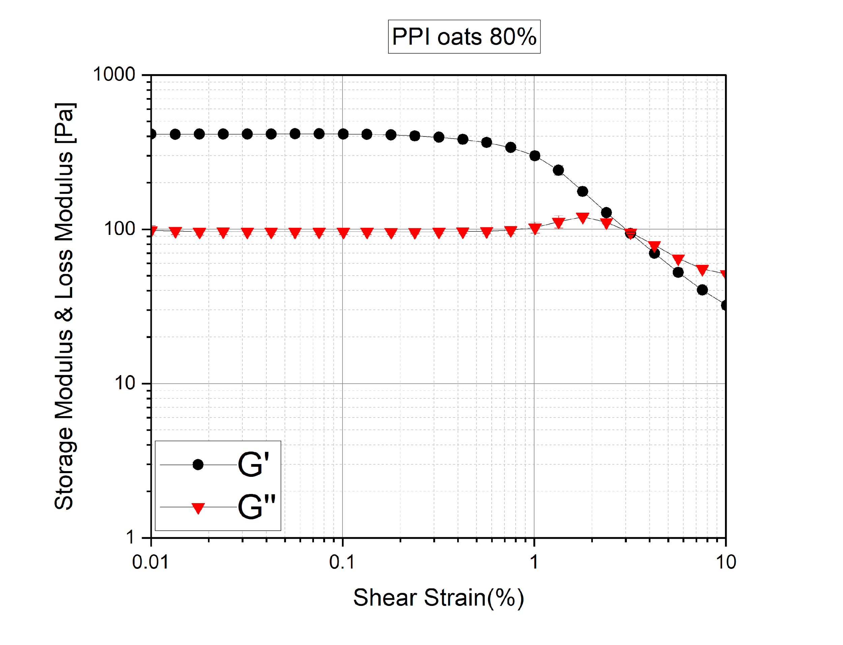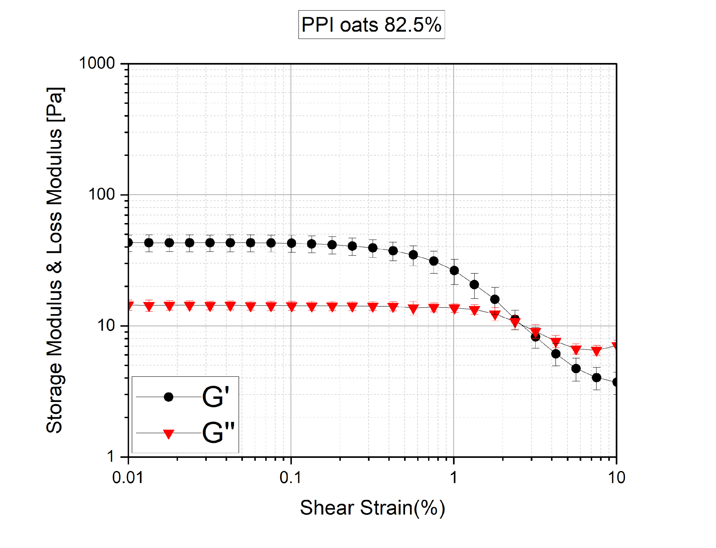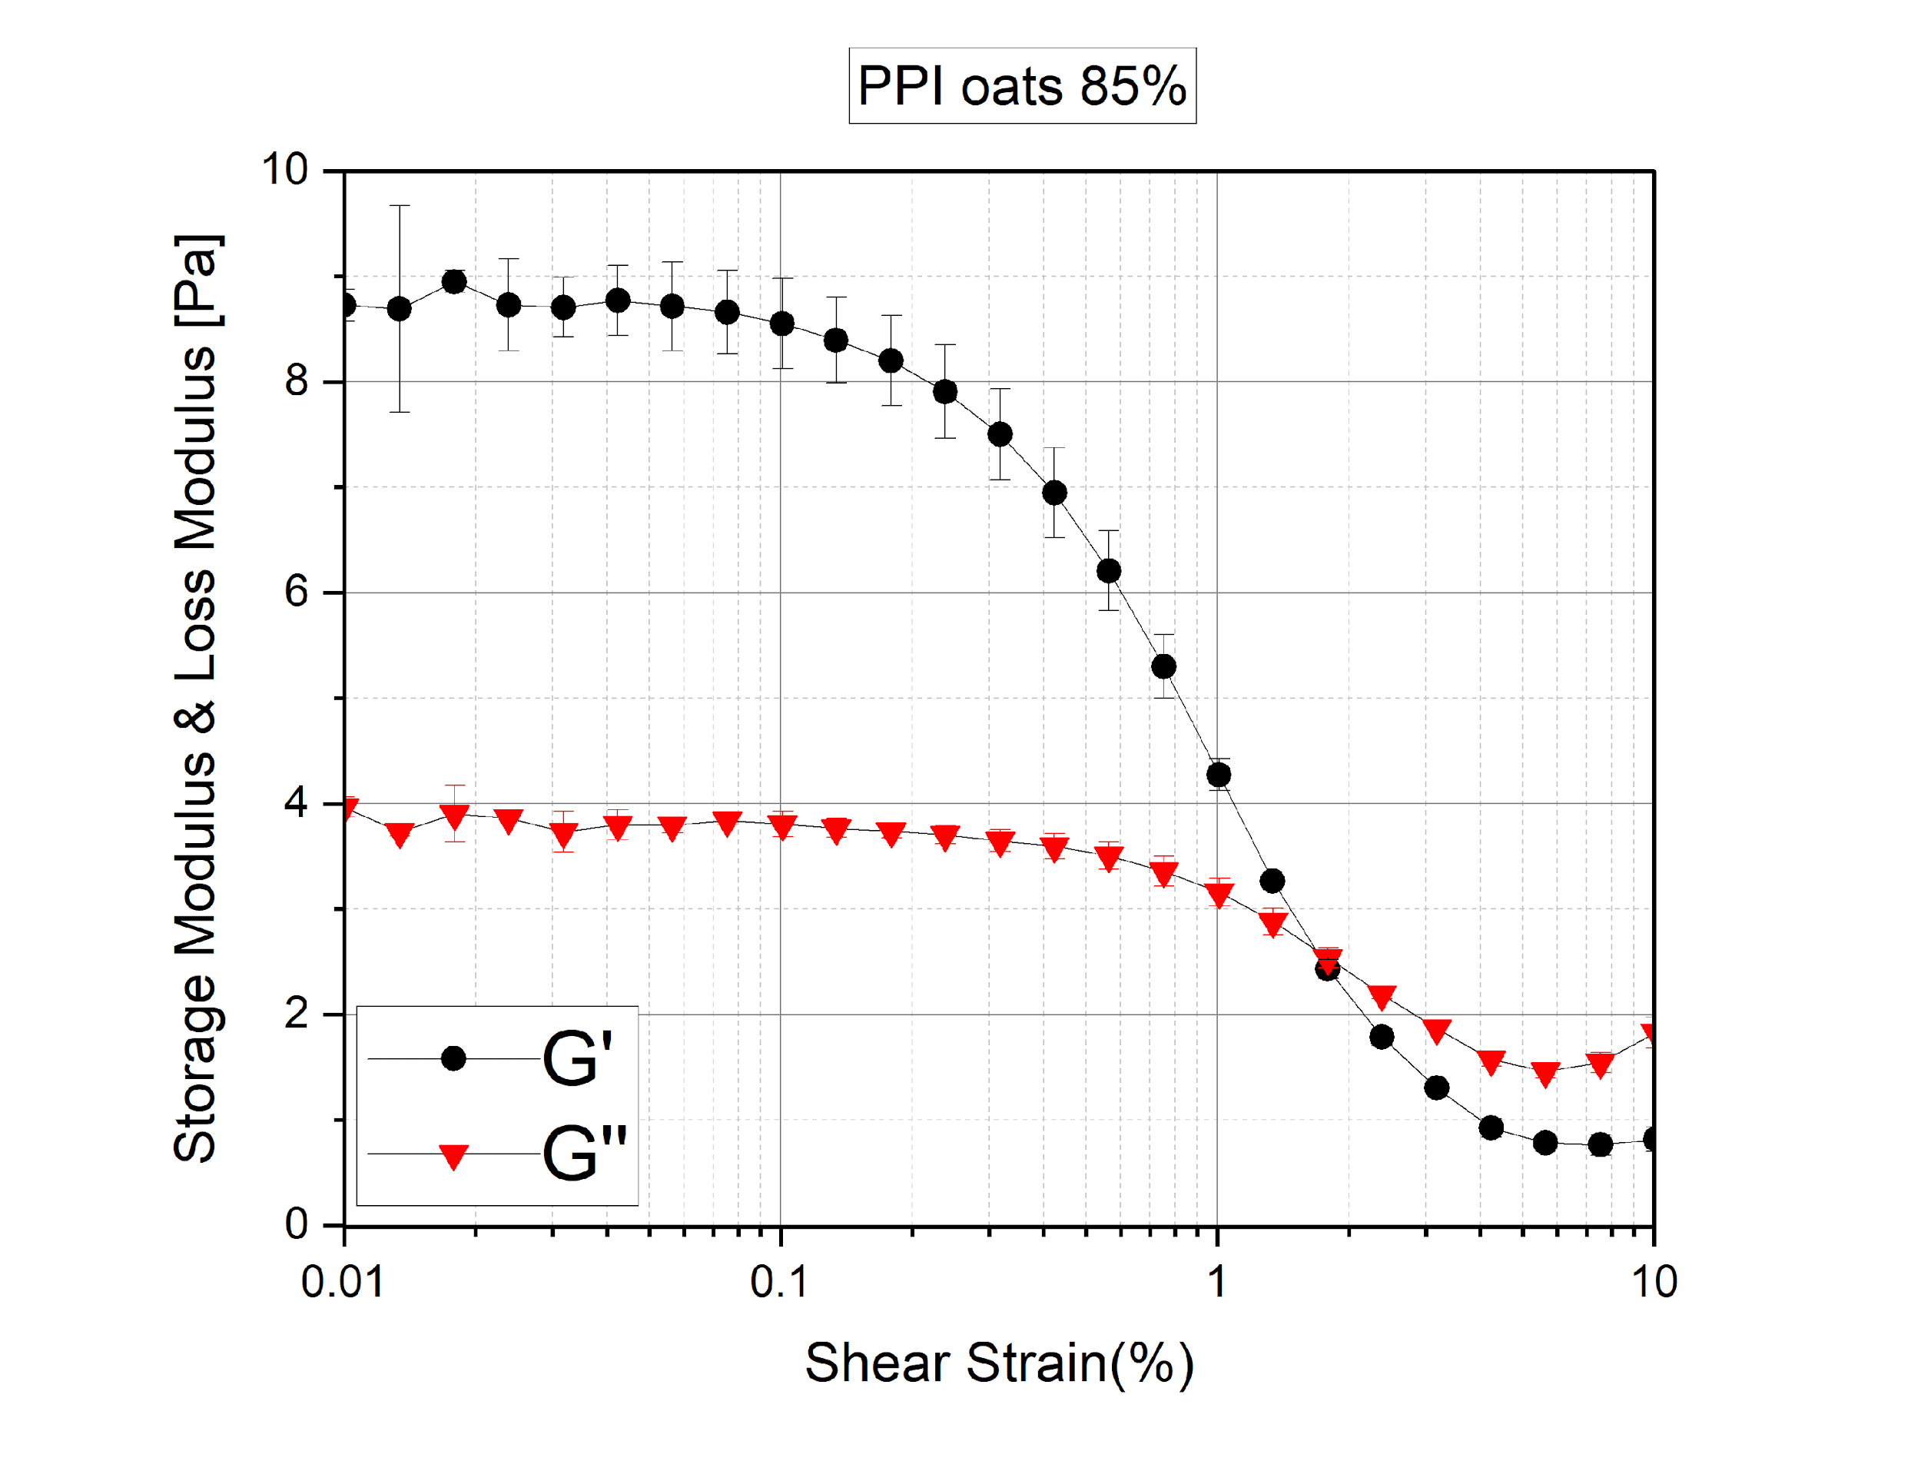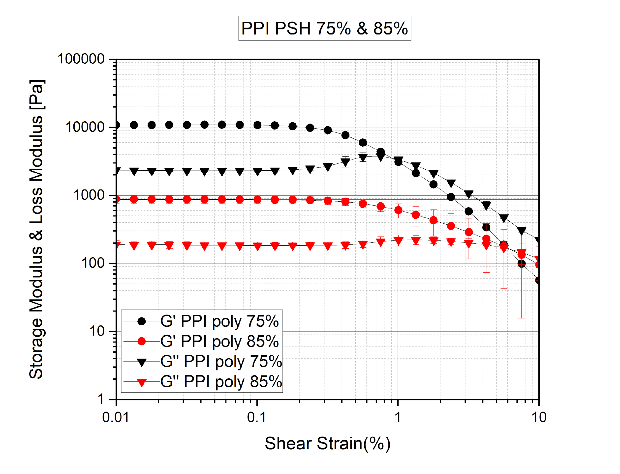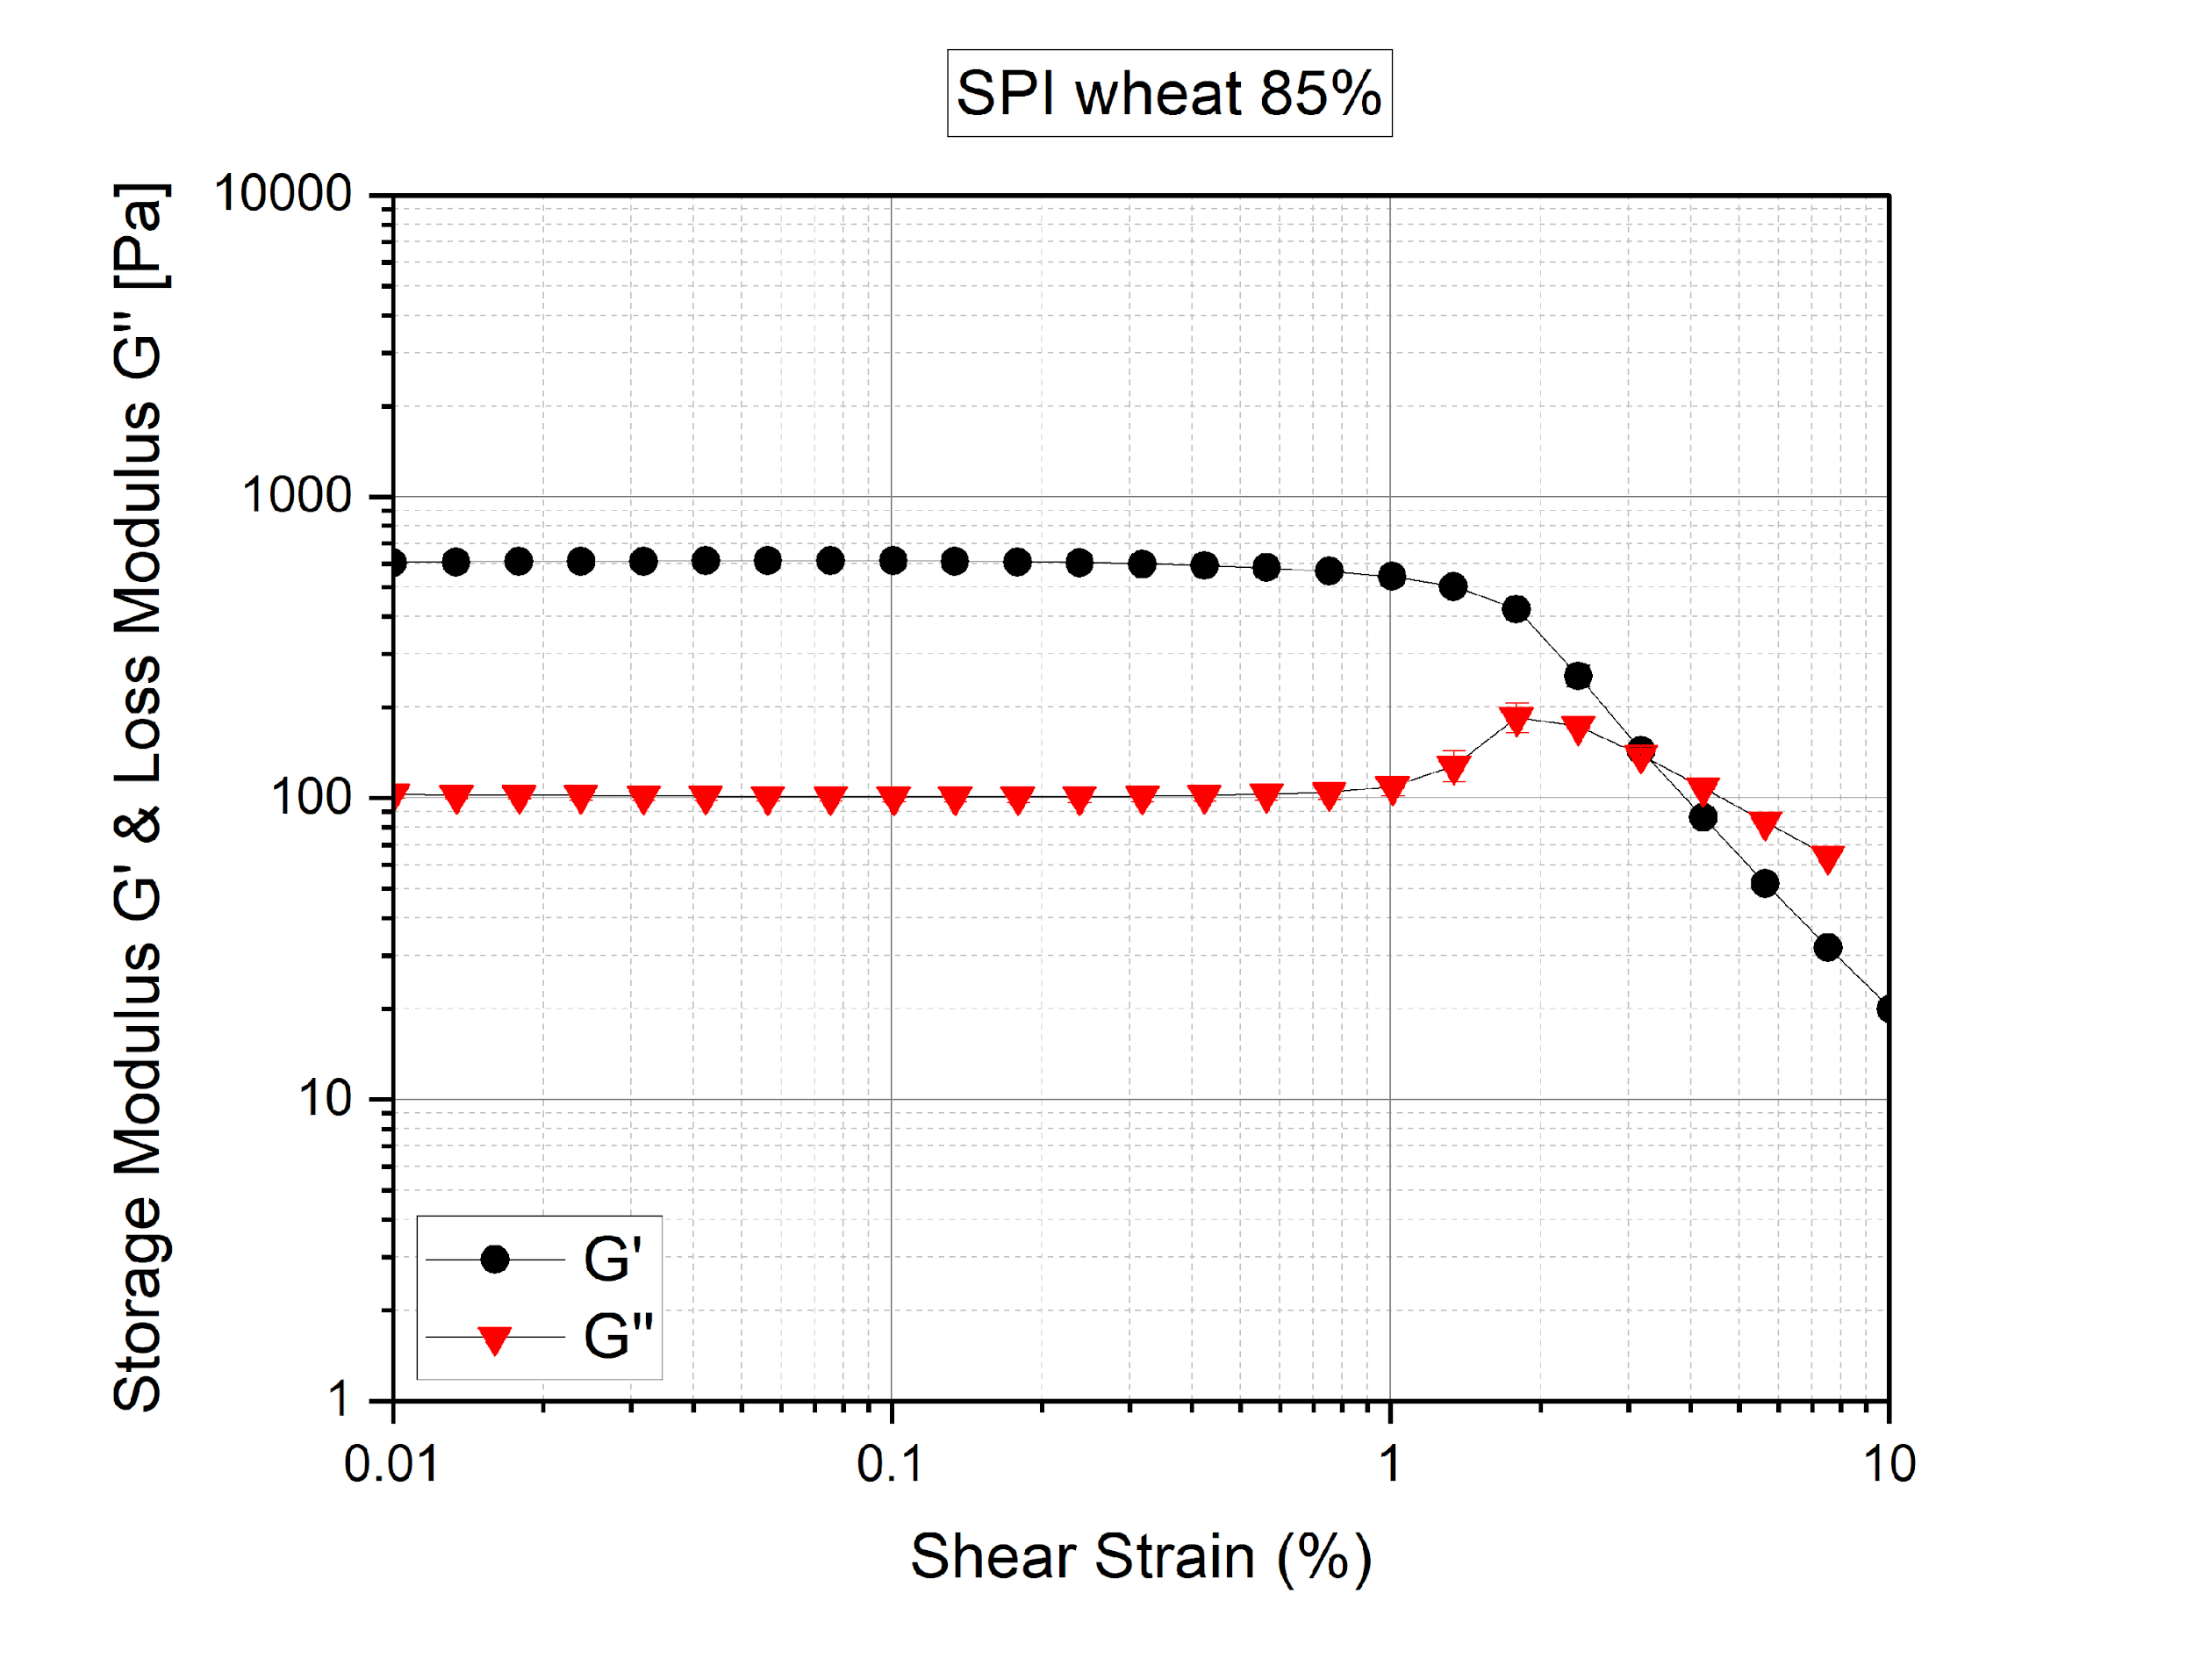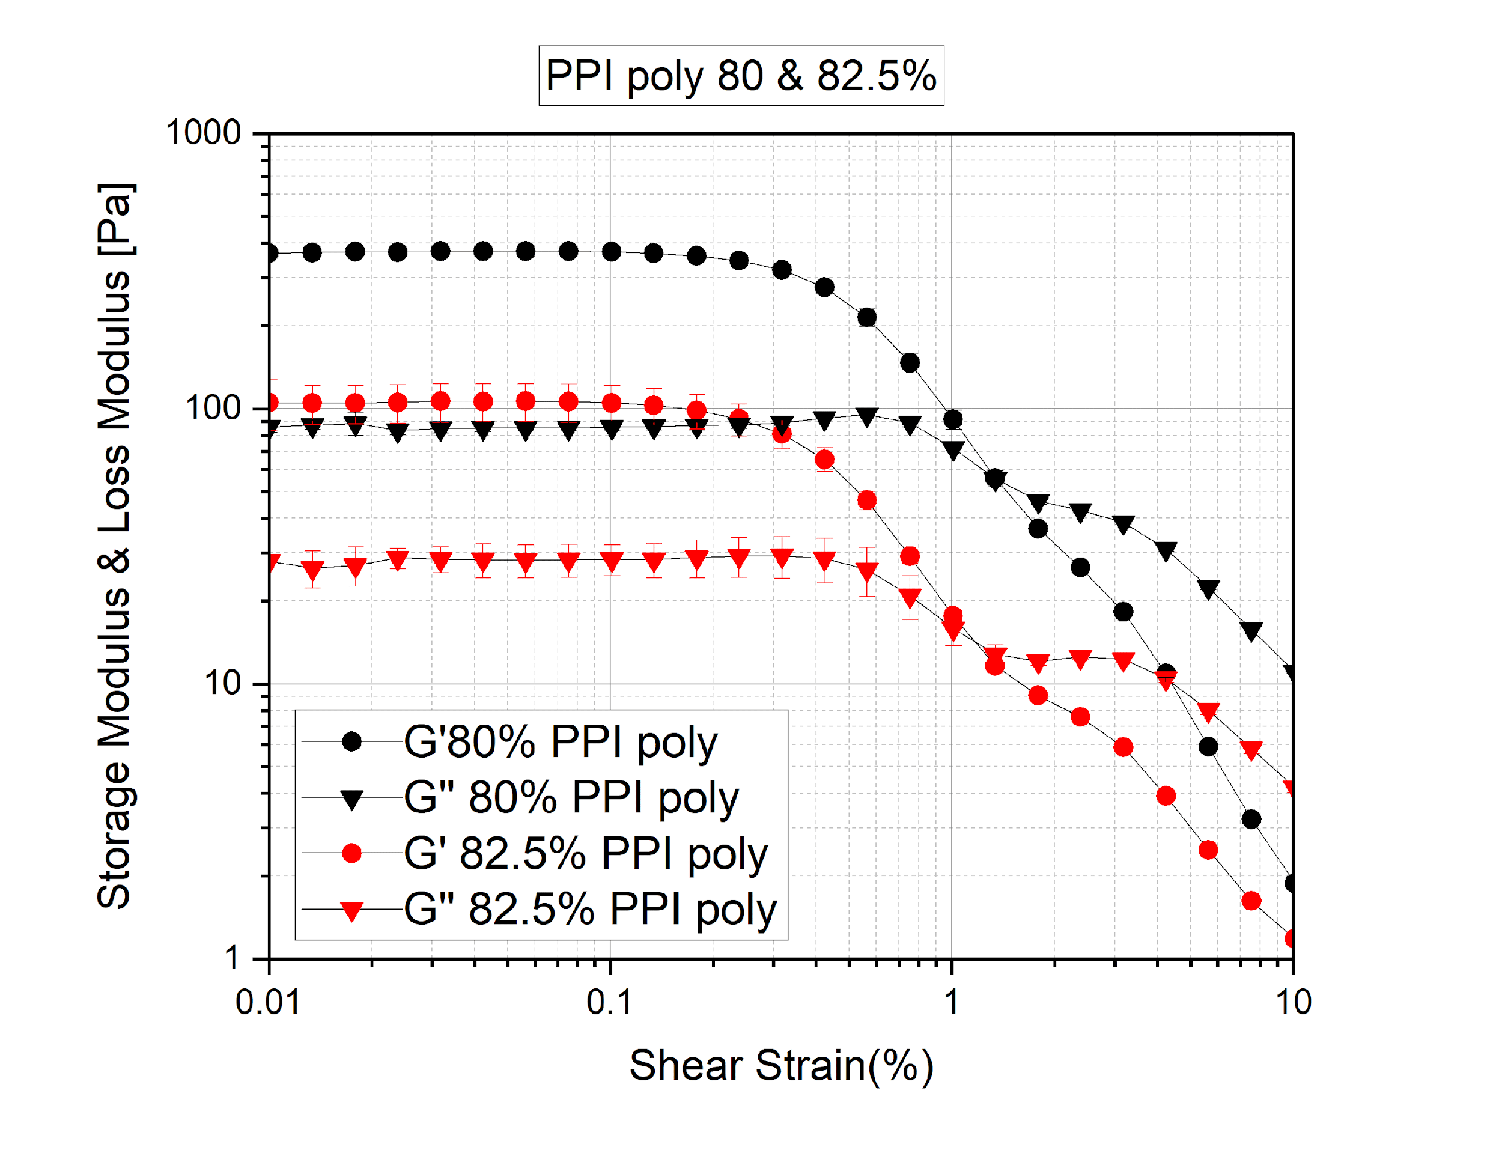

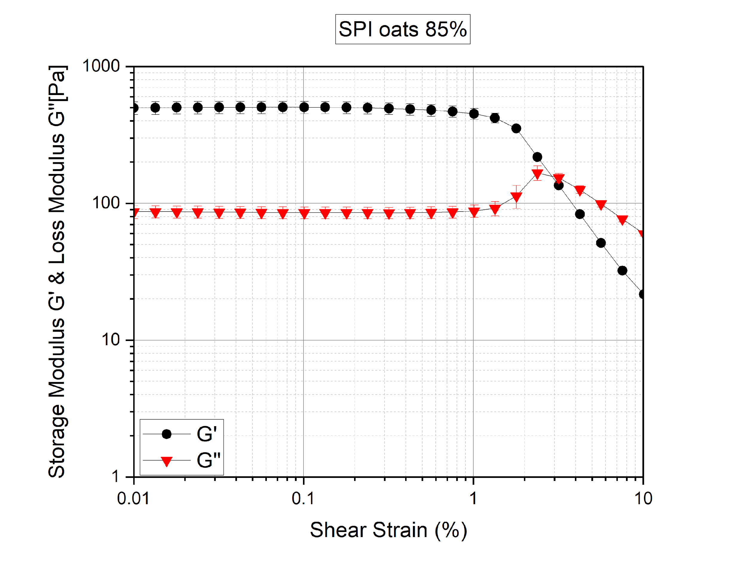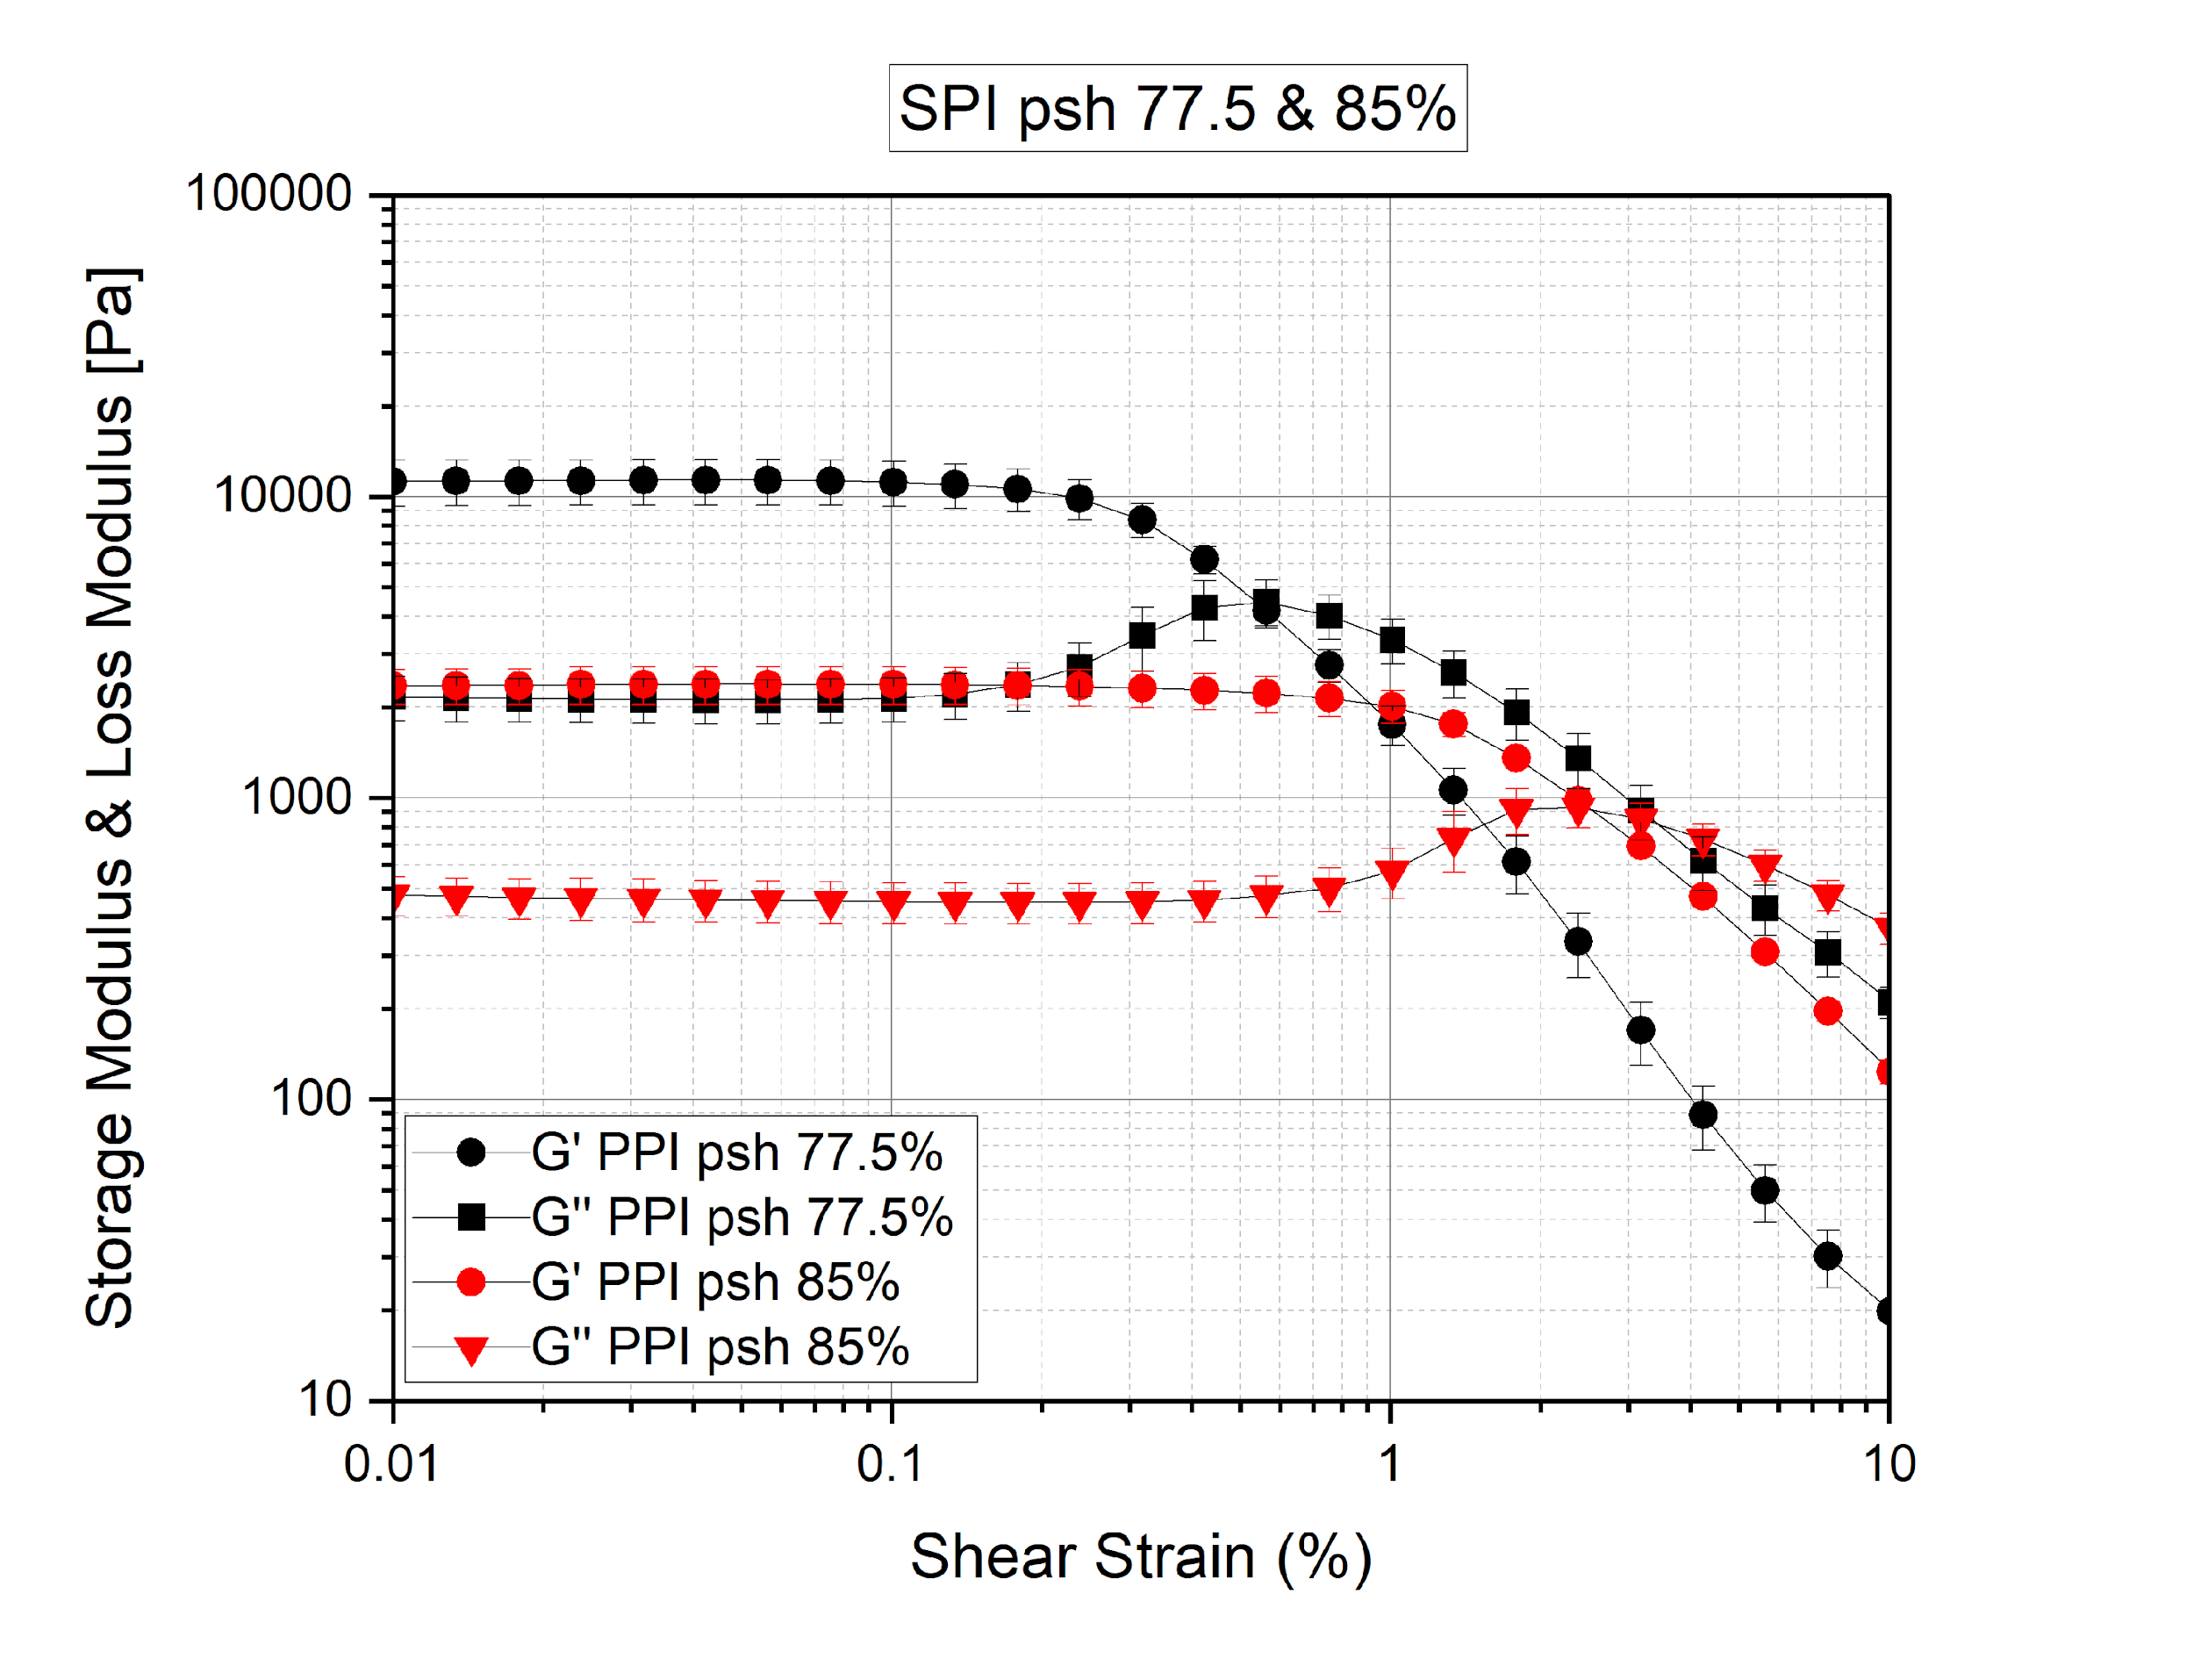

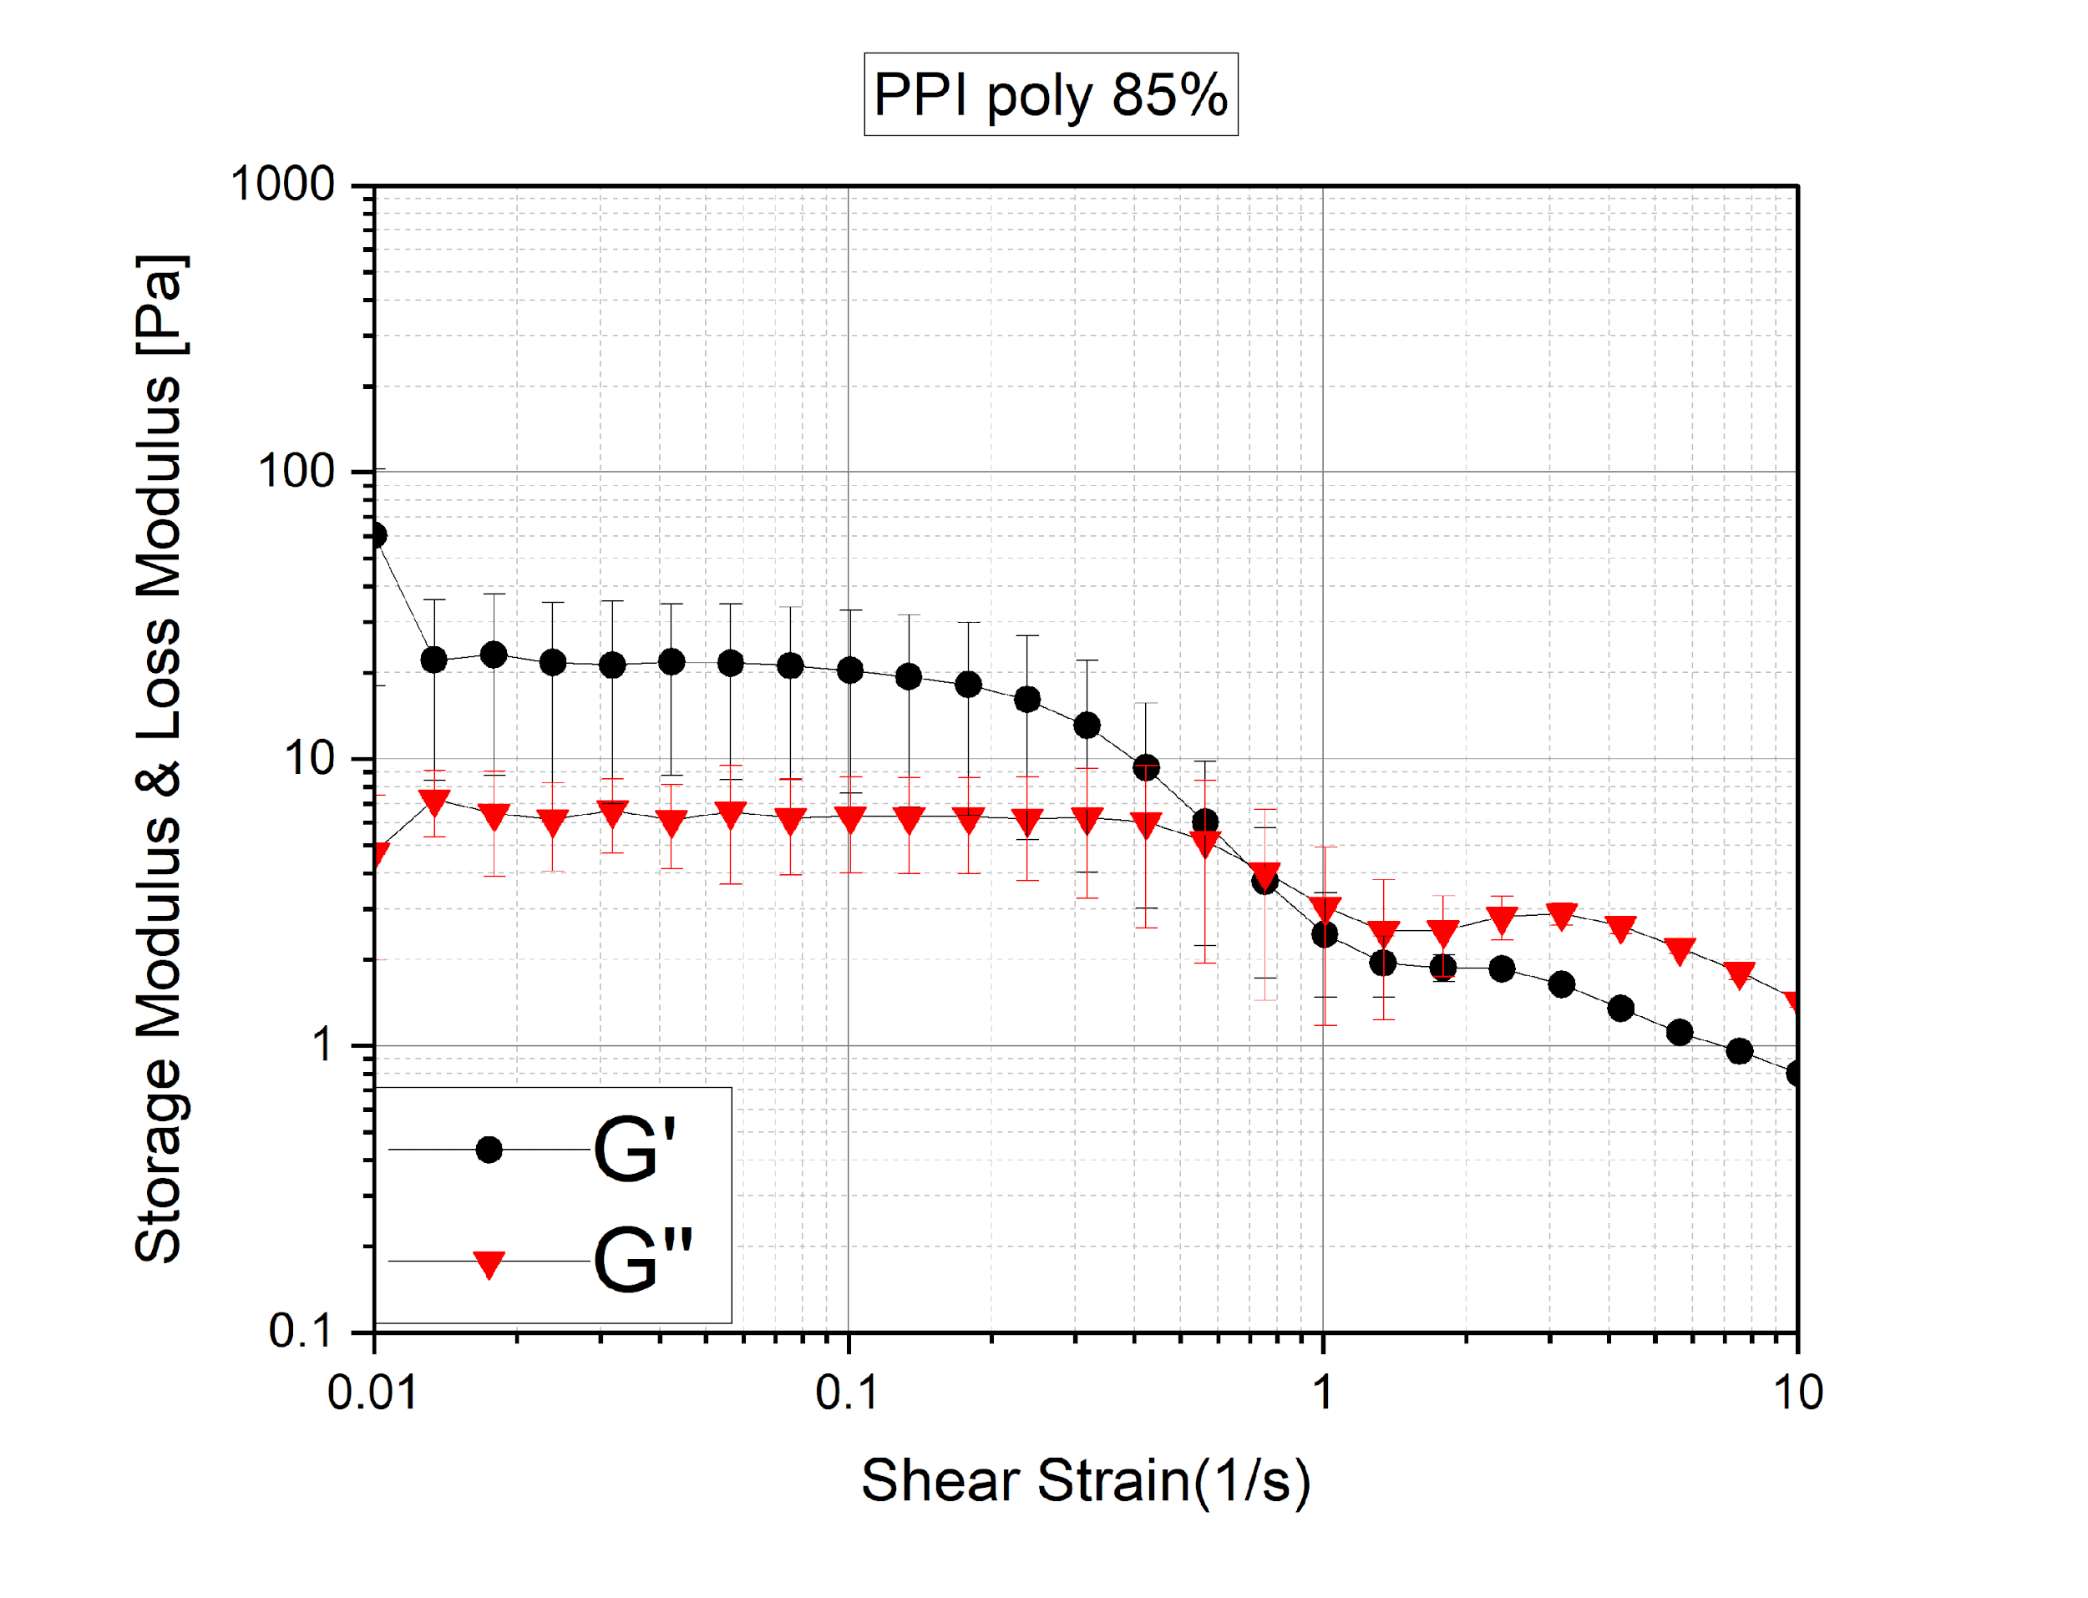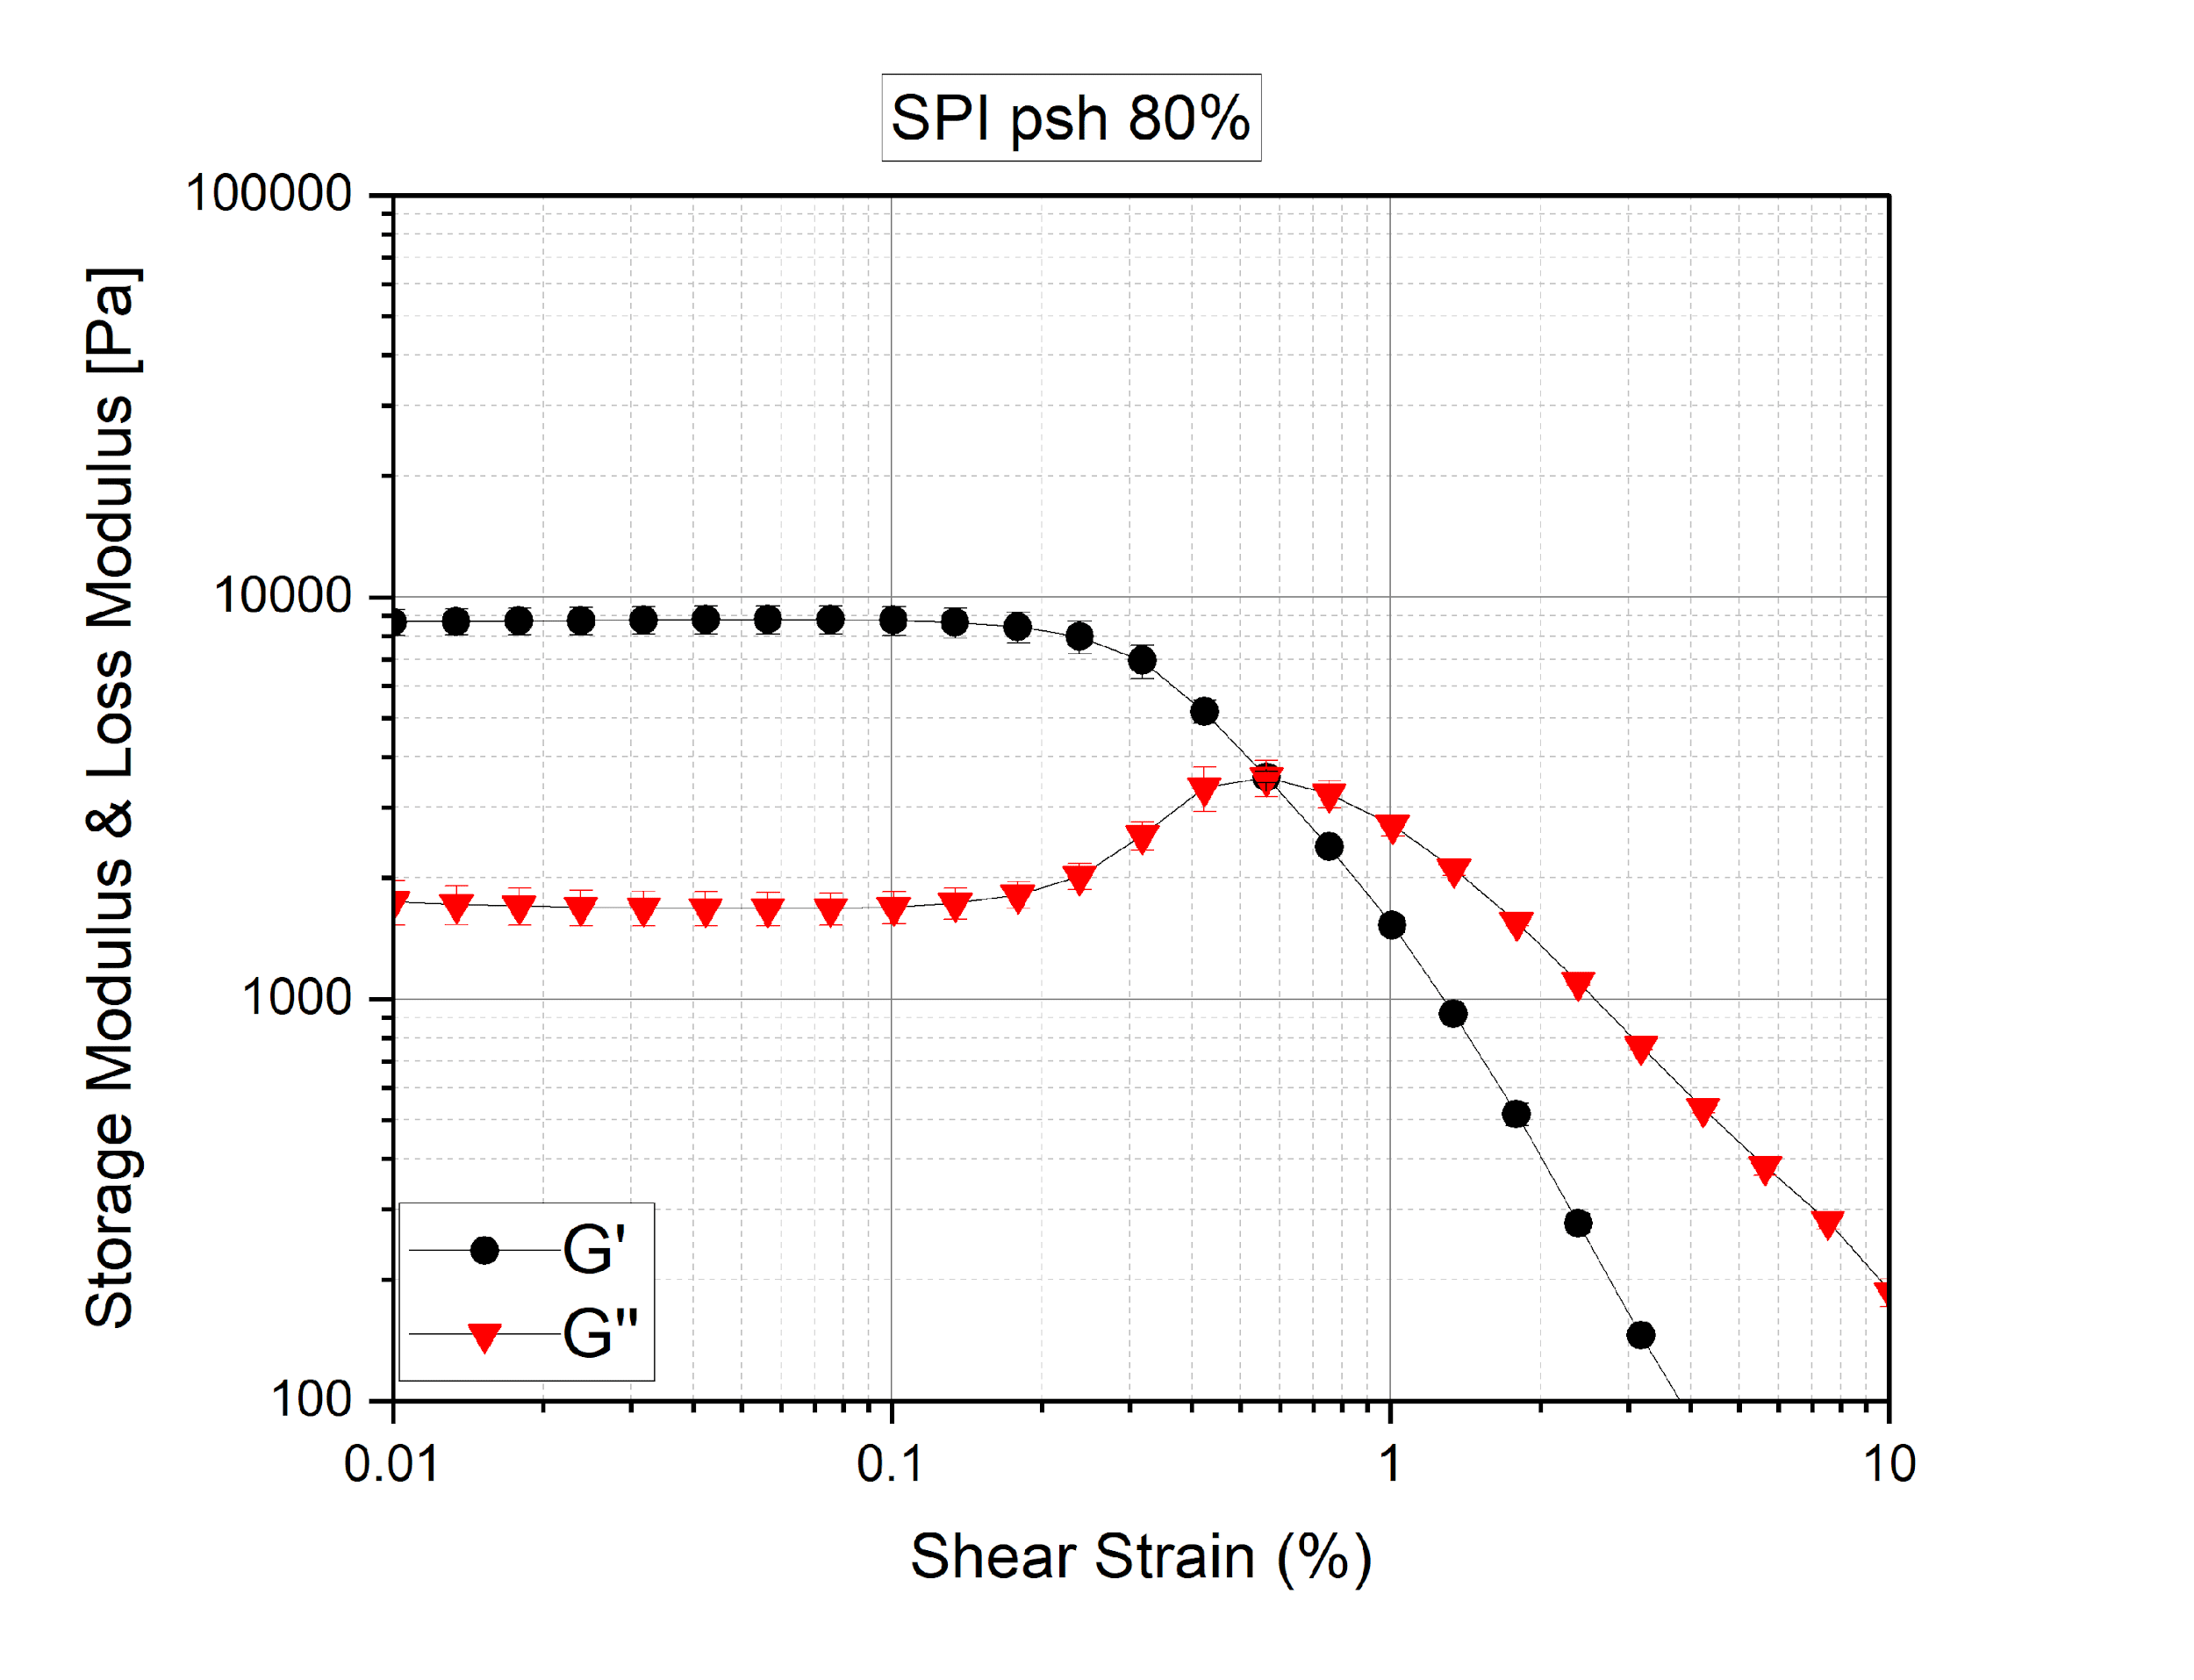

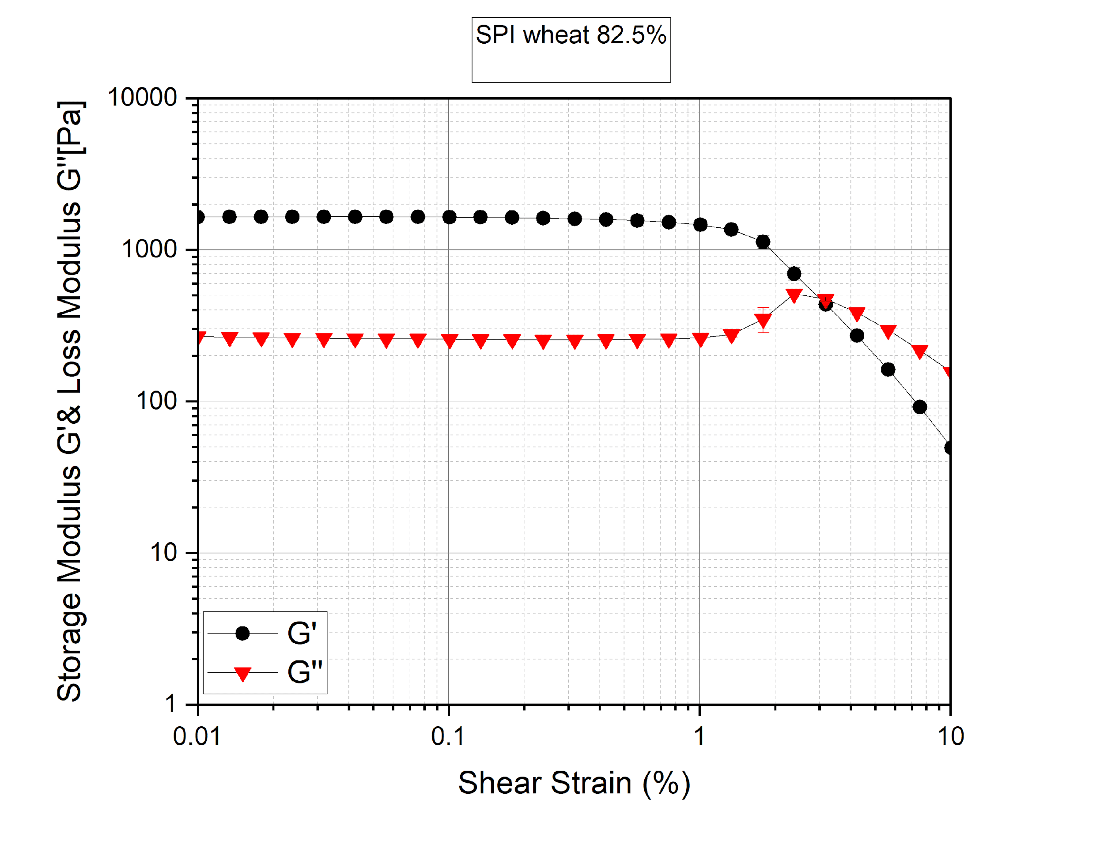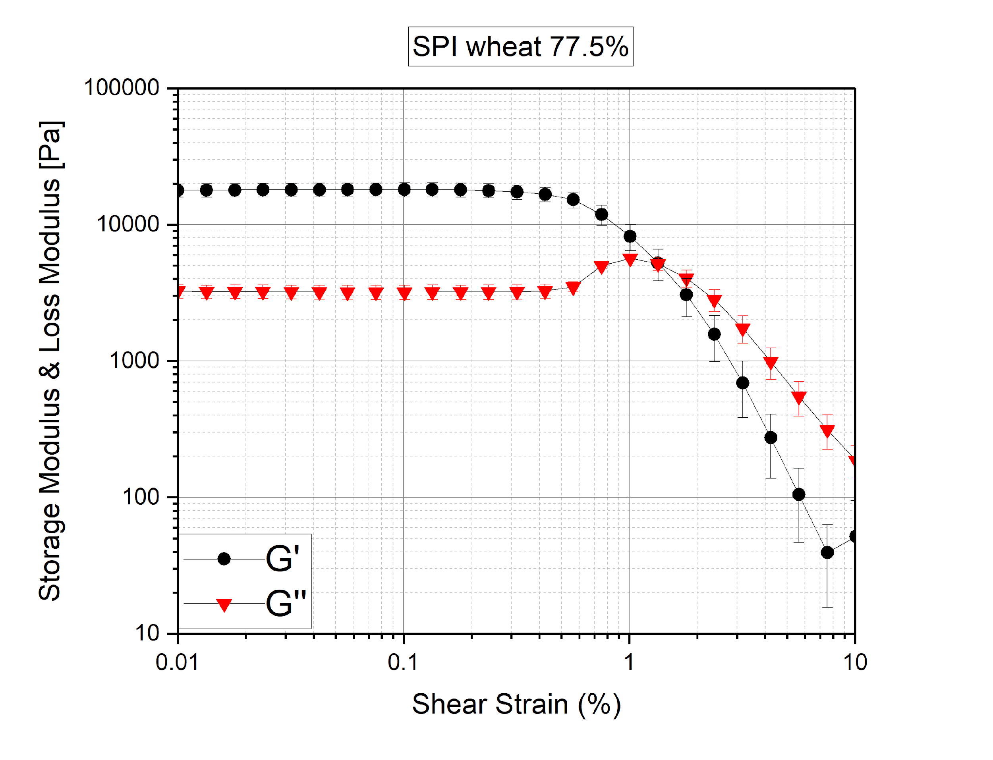

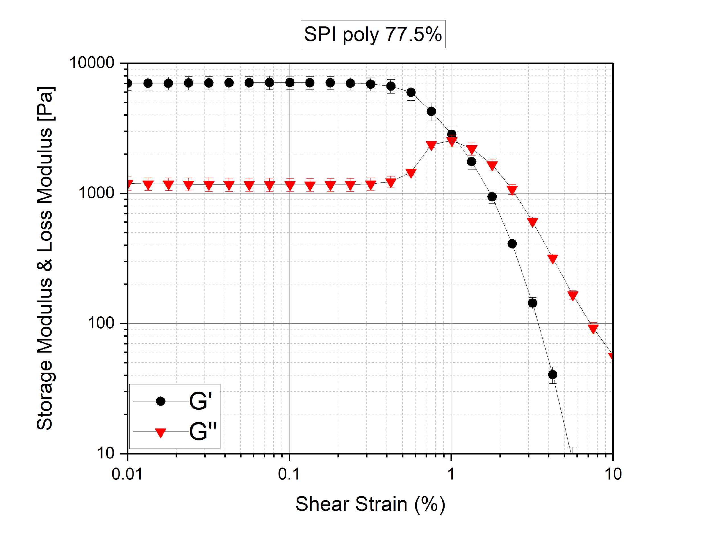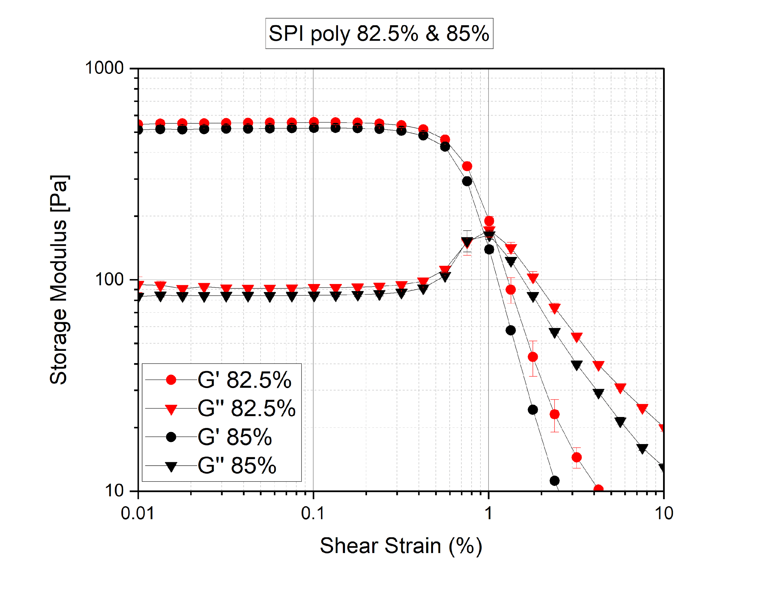

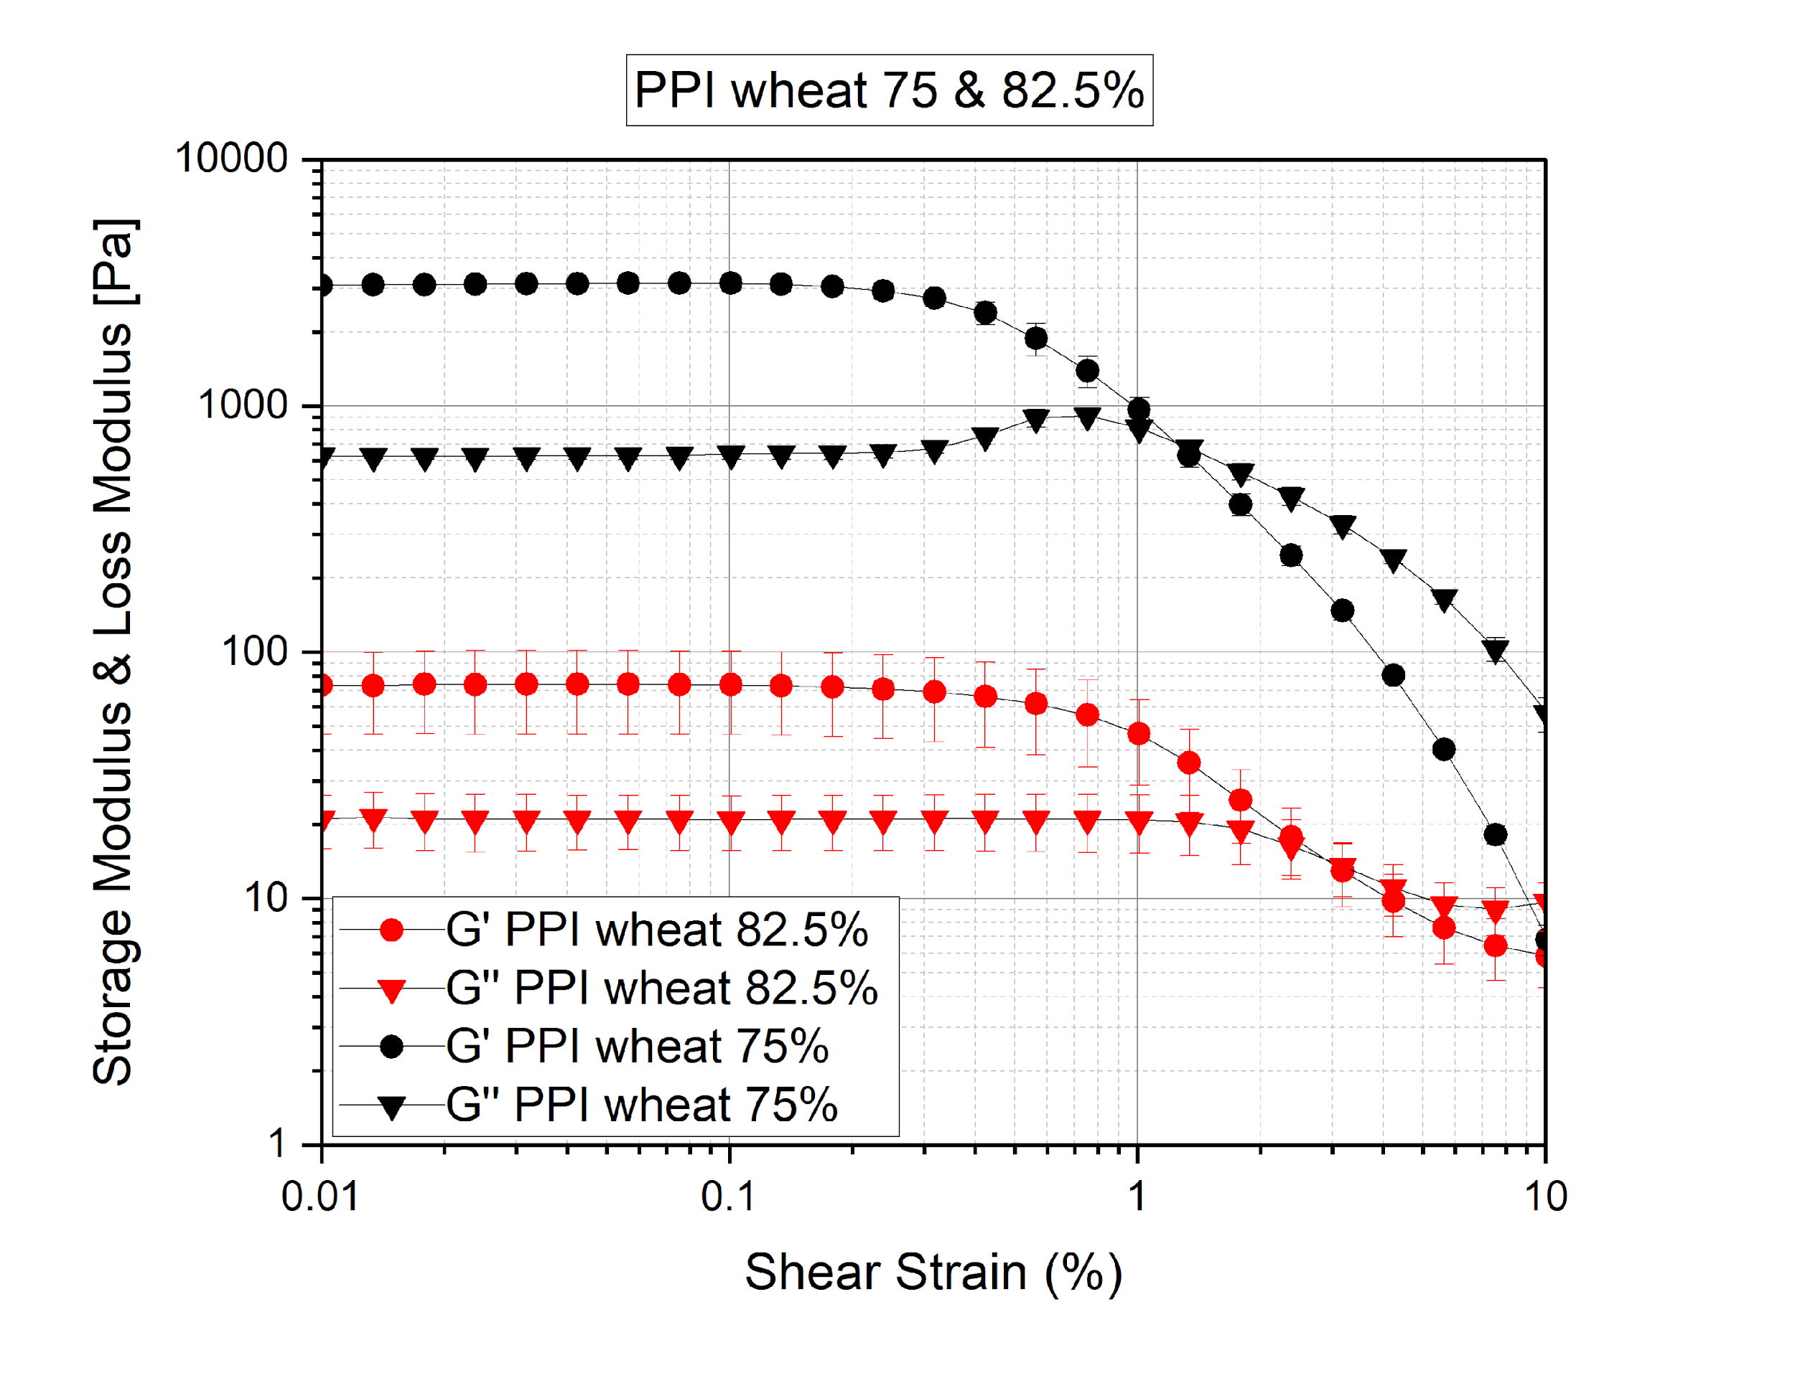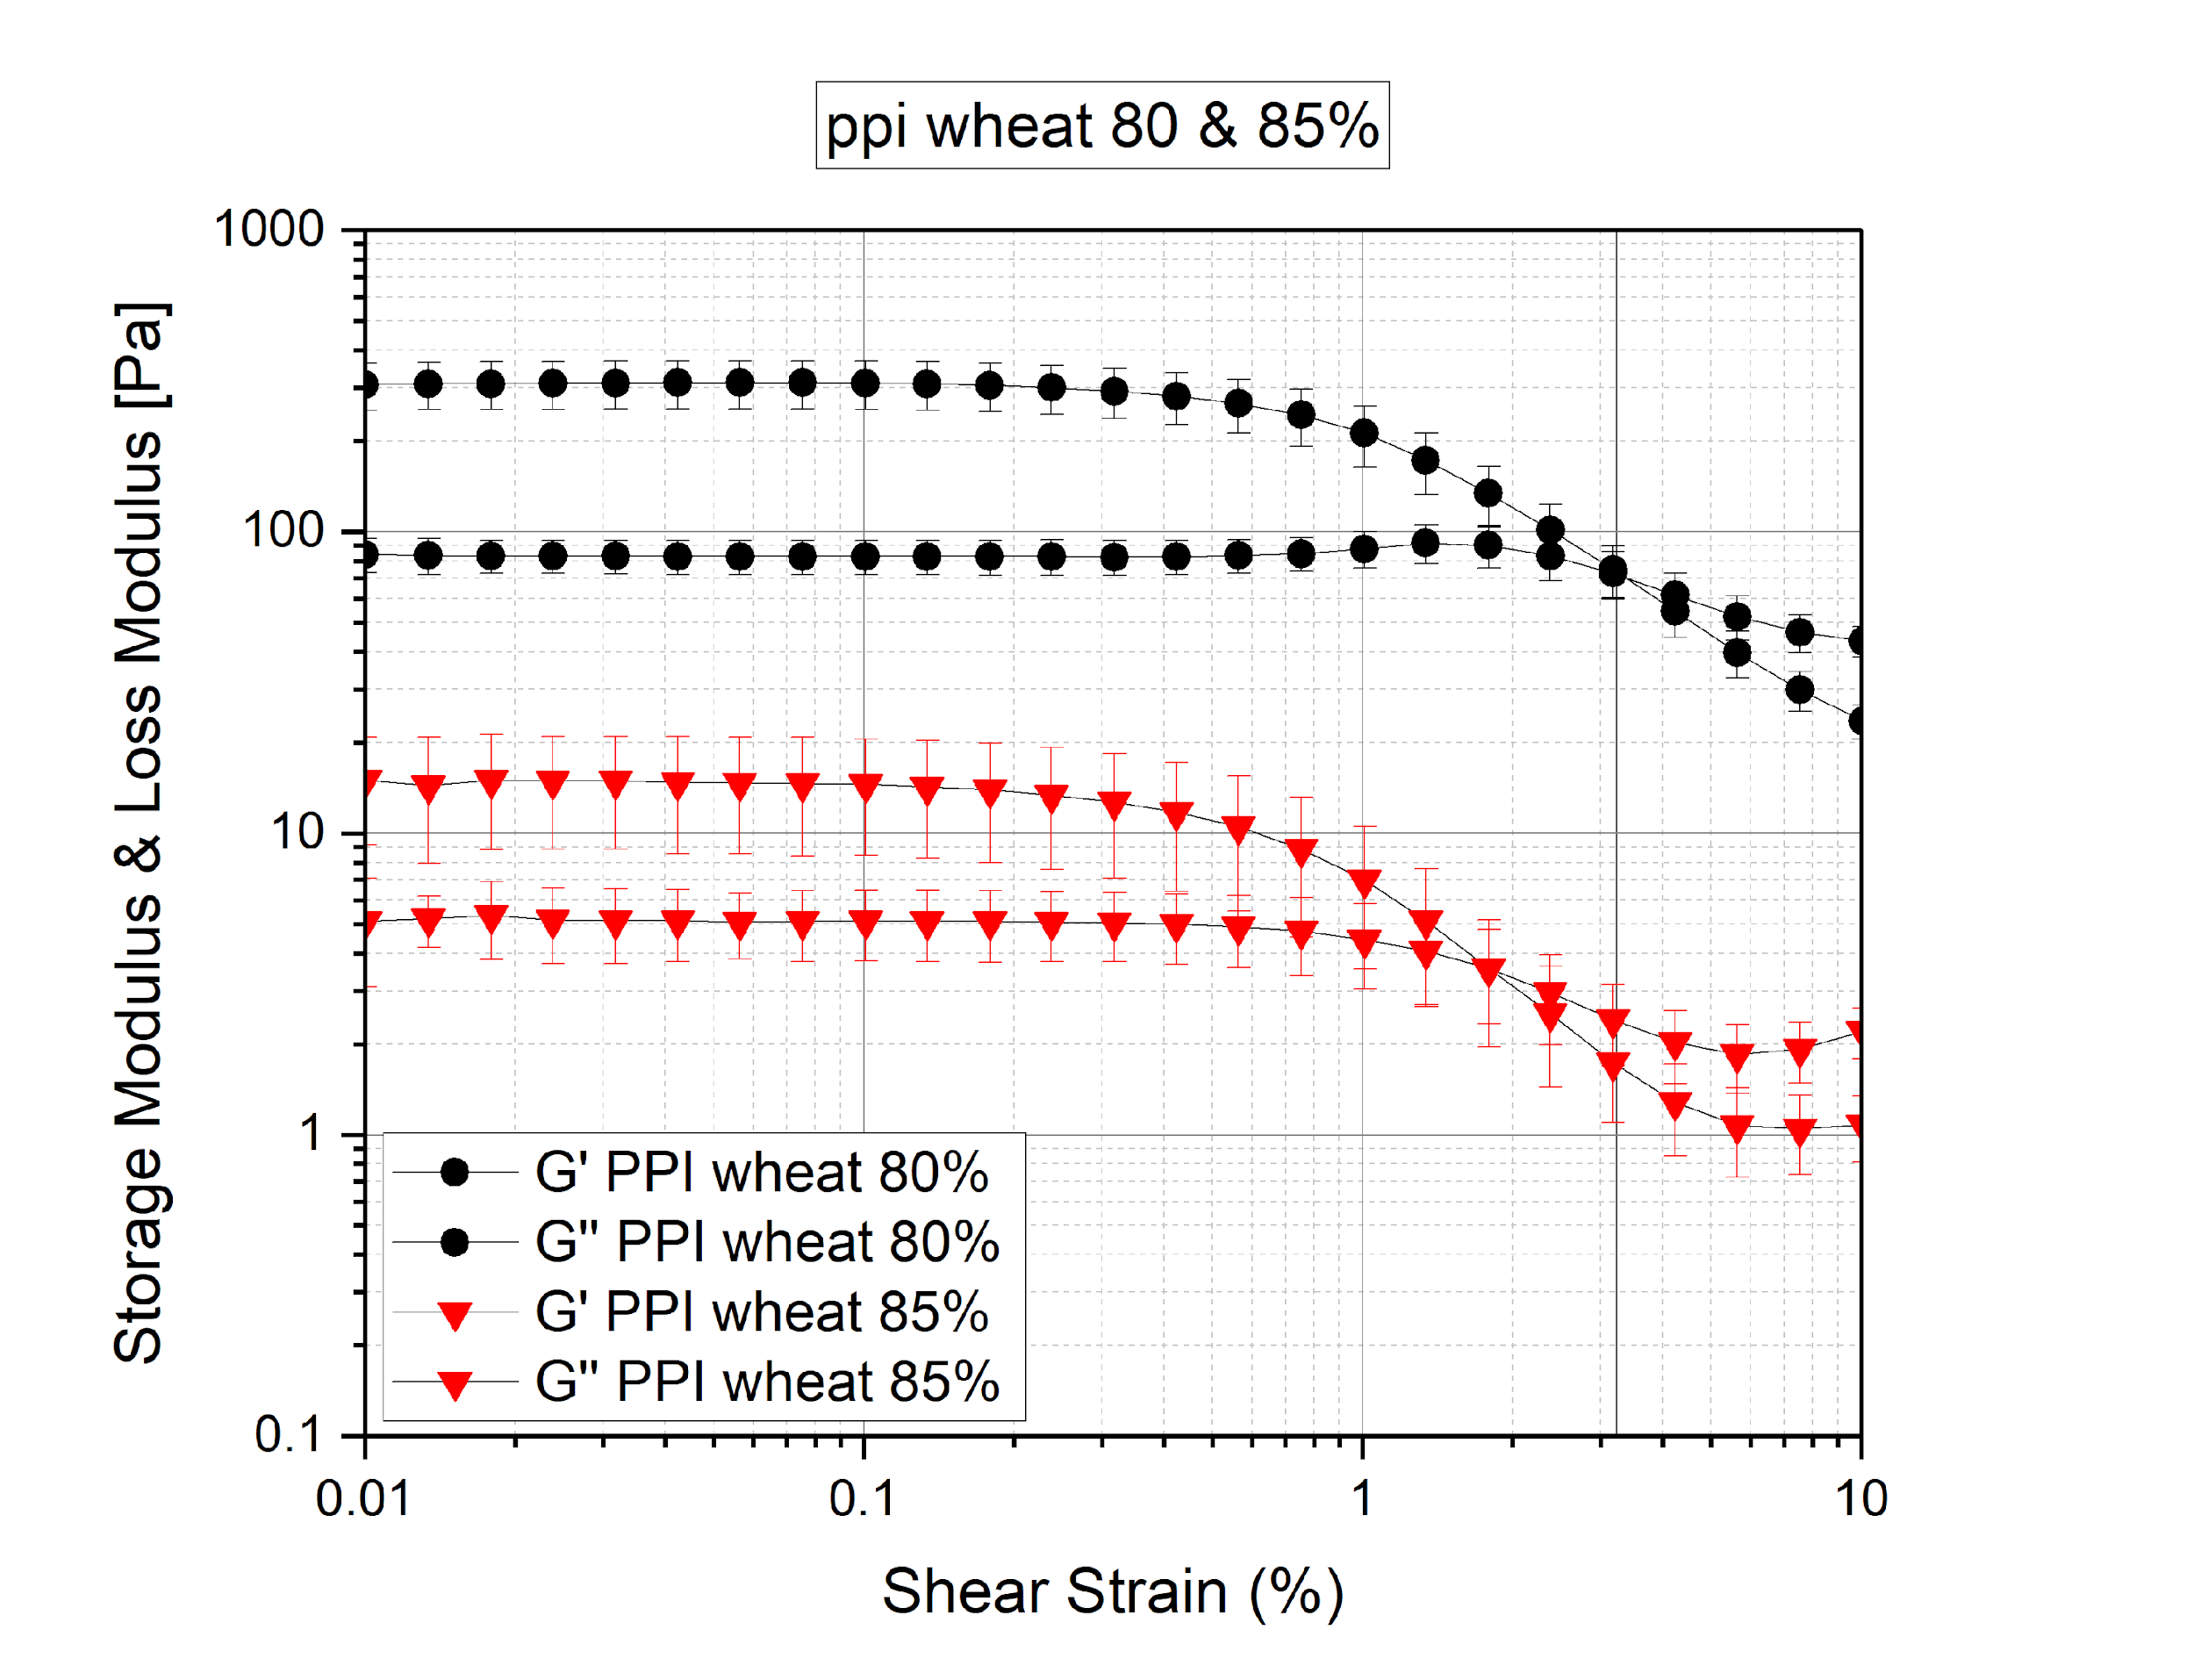**Frequency sweep**

Frequency sweeps give information about the behavior of the sample as well as the inner structure of polymers and long-term stability of the dispersions. It describes the time-dependent behavior of a sample in the non-destructive deformation range. High frequencies are used to stimulate fast motion on short duration whereas low frequencies are used to stimulate slow motion on long time periods or rest [(*Frequency Sweeps | Anton Paar Wiki*, n.d.).](https://www.zotero.org/google-docs/?xKL4Qs) Following loss factor or damping factor tan δ is shown over angular frequency sweep (rad/s). Where loss factor describes the ratio of two regions of the viscoelastic behavior that is loss modulus (G’’) / storage modulus (G’). An ideal elastic behavior shows value of 0 whereas 90 shows viscous behavior.

The graphs show that increasing hydrations increases the value of loss factor meaning 85% has more loss factor value than 82.5% and followed by 80% > 77.5% > 75% for PPI protein-based inks. Moreover, it shows that 75% hydration shows more elastic behavior. The lowest value of loss factor was observed for PPI psyllium husk 75% followed by PPI wheat 75%. The following decreasing values are observed which is as follows: -

PPI oats 85% > PPI wheat 85% > PPI oats 82.5% > PPI poly 85% > PPI 82.5% wheat > ppi OATS 80% > PPI wheat 80% > PPI poly 82.5% > PPI poly 80% > PPI psh 85% > PPI wheat 75% > PPI psh 75%

Whereas the same pattern wasn’t observed for SPI protein-based inks the highest value of loss factor was seen for SPI psh 77.5% followed by SPI psh 80% and lowest value for SPI poly 75 % and SPI polydextrose 85%. The following decreasing pattern can be observed from the graphs as shown below. The SPI protein with wheat, oats and polydextrose showed similar same values for the loss factor for 85%, 80%. 77.5% and 85% hydrations.

SPI psh 77.5% > SPI psh 80% > SPI wheat 77.5% > SPI oats 77.5% > SPI wheat 85% > SPI wheat 85% > SPI oats 80% > SPI wheat 82.5% > SPI 77.5% poly > SPI 85% poly.

To summarize the rheological properties, all the protein-based inks showed gel-like and shear thinning behaviors except for. For both the proteins, tan δ was slightly different from each other, where the loss factor was less than 1 thus characterized as solid/ elastic-like. Nevertheless, SPI protein-based inks showed scattered data for loss factor which may indicate that the structure of SPI proteins are inhomogeneous than PPI.

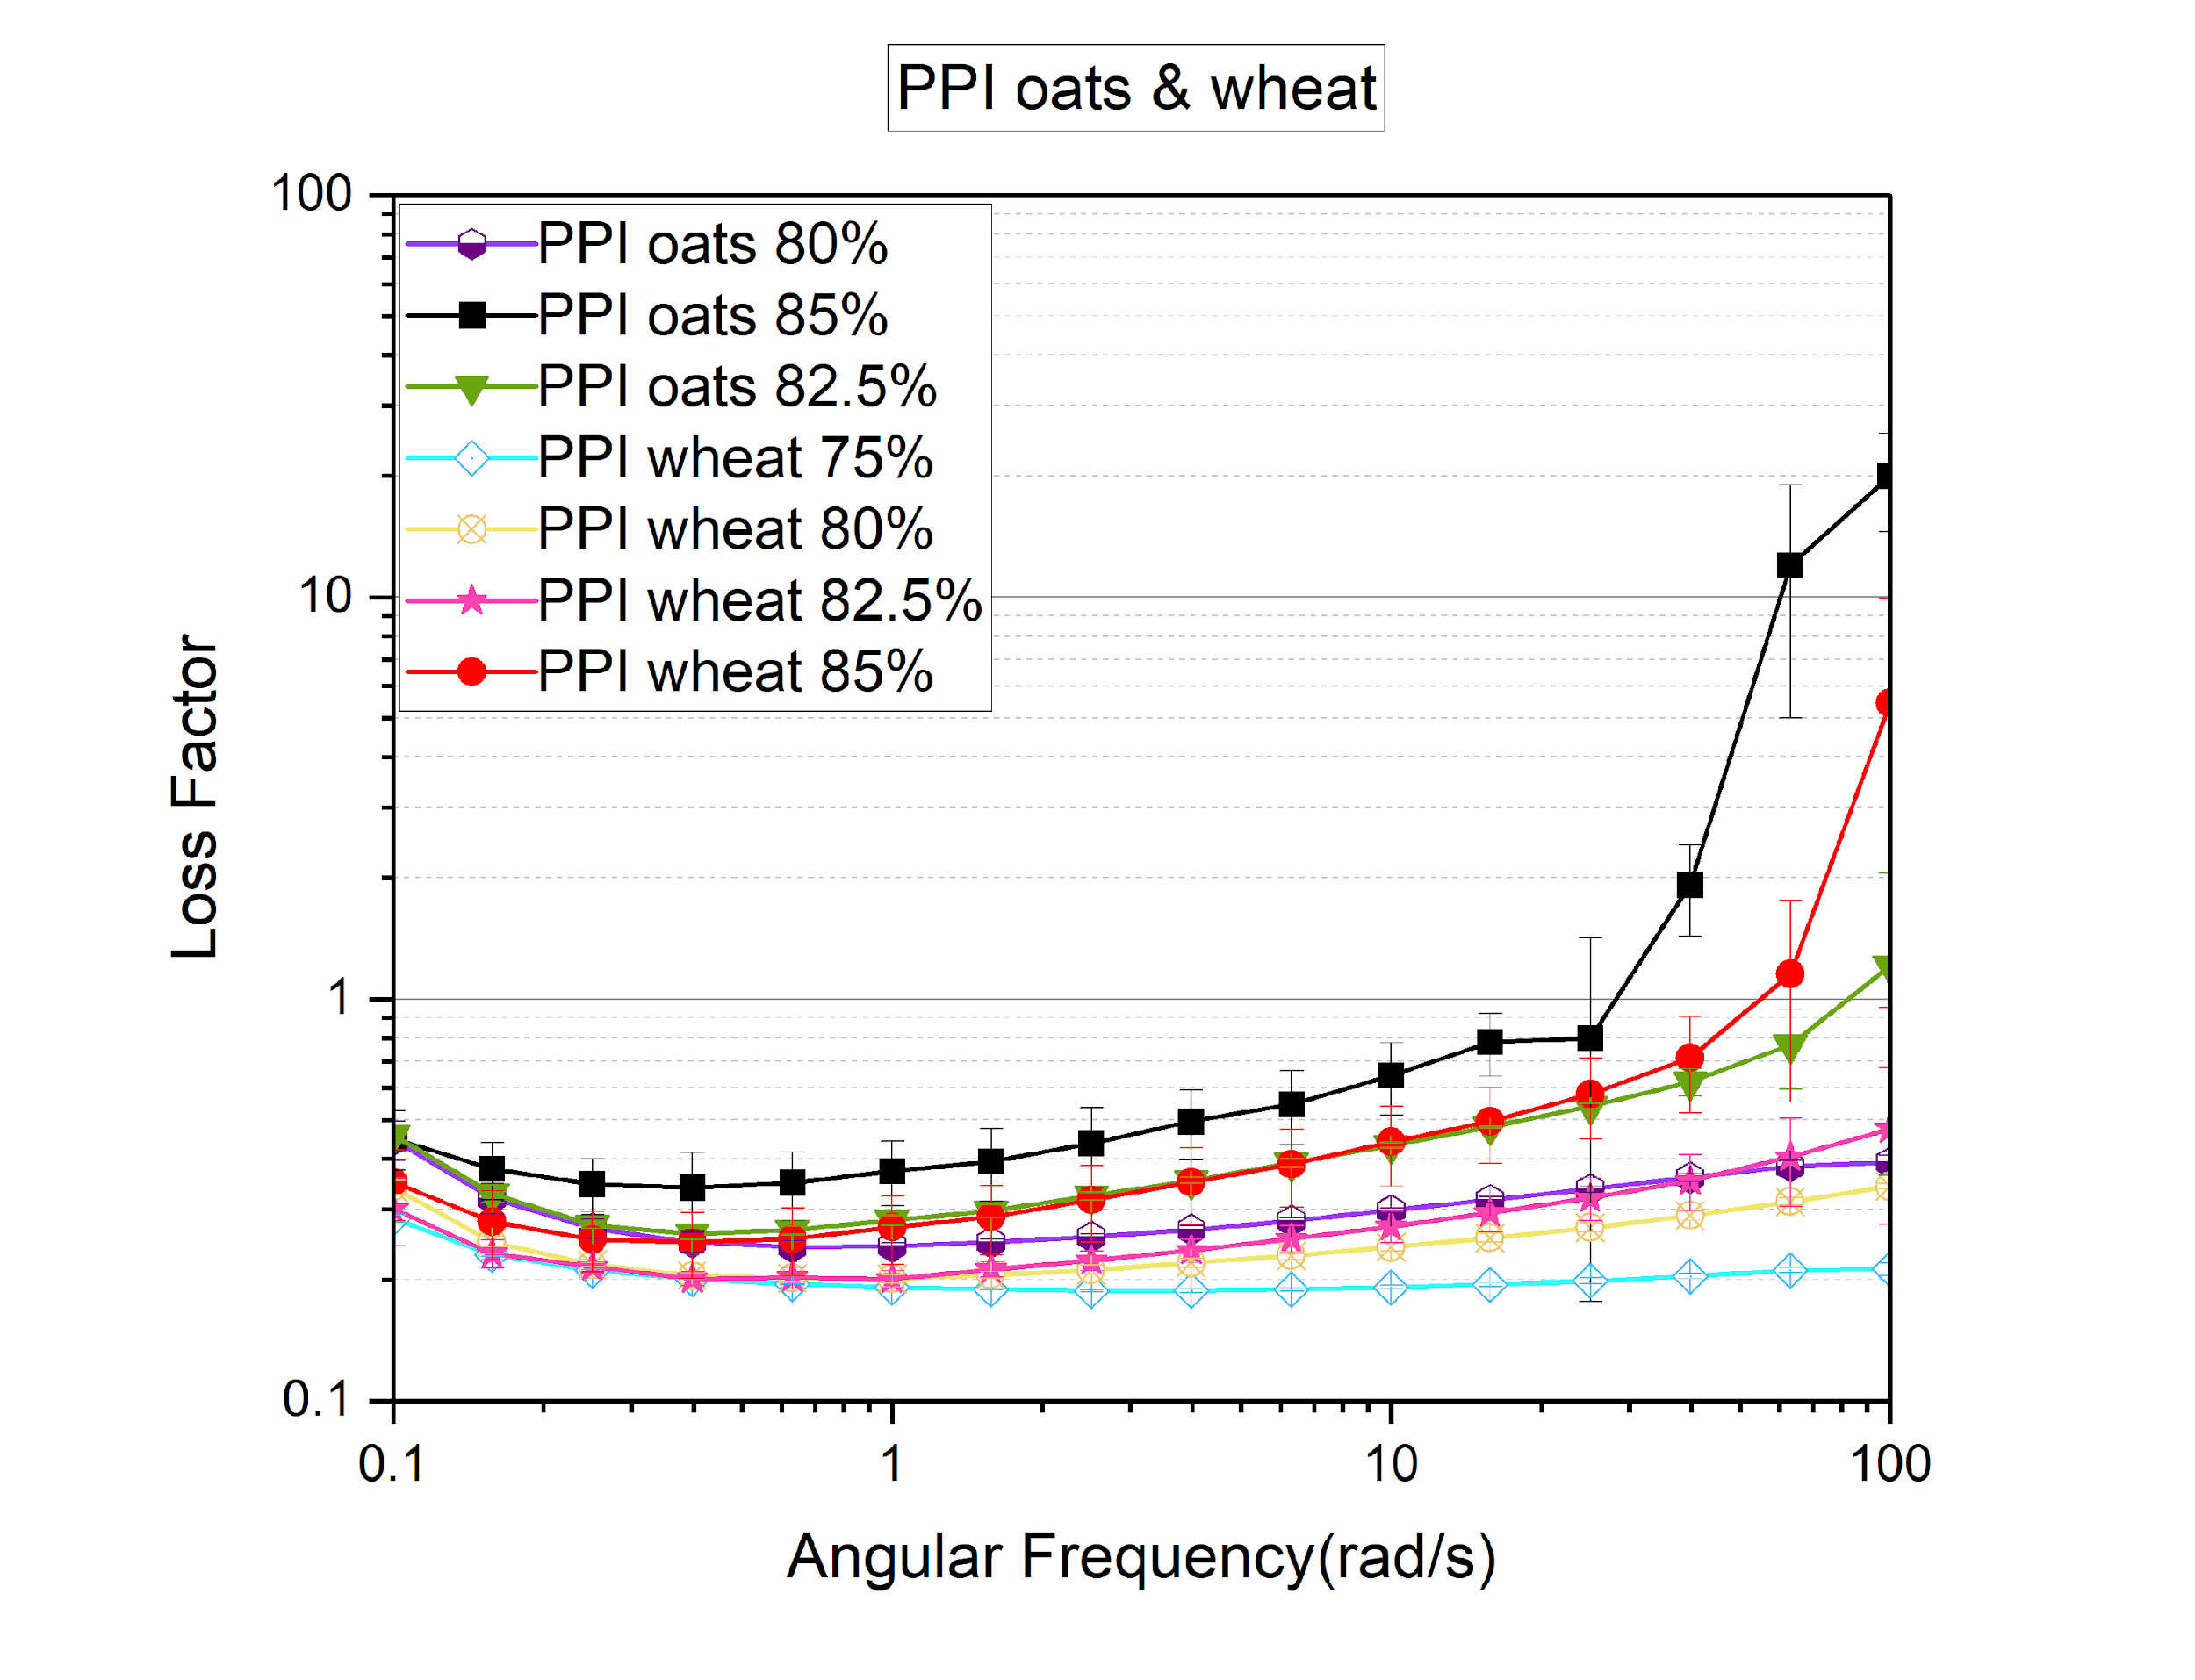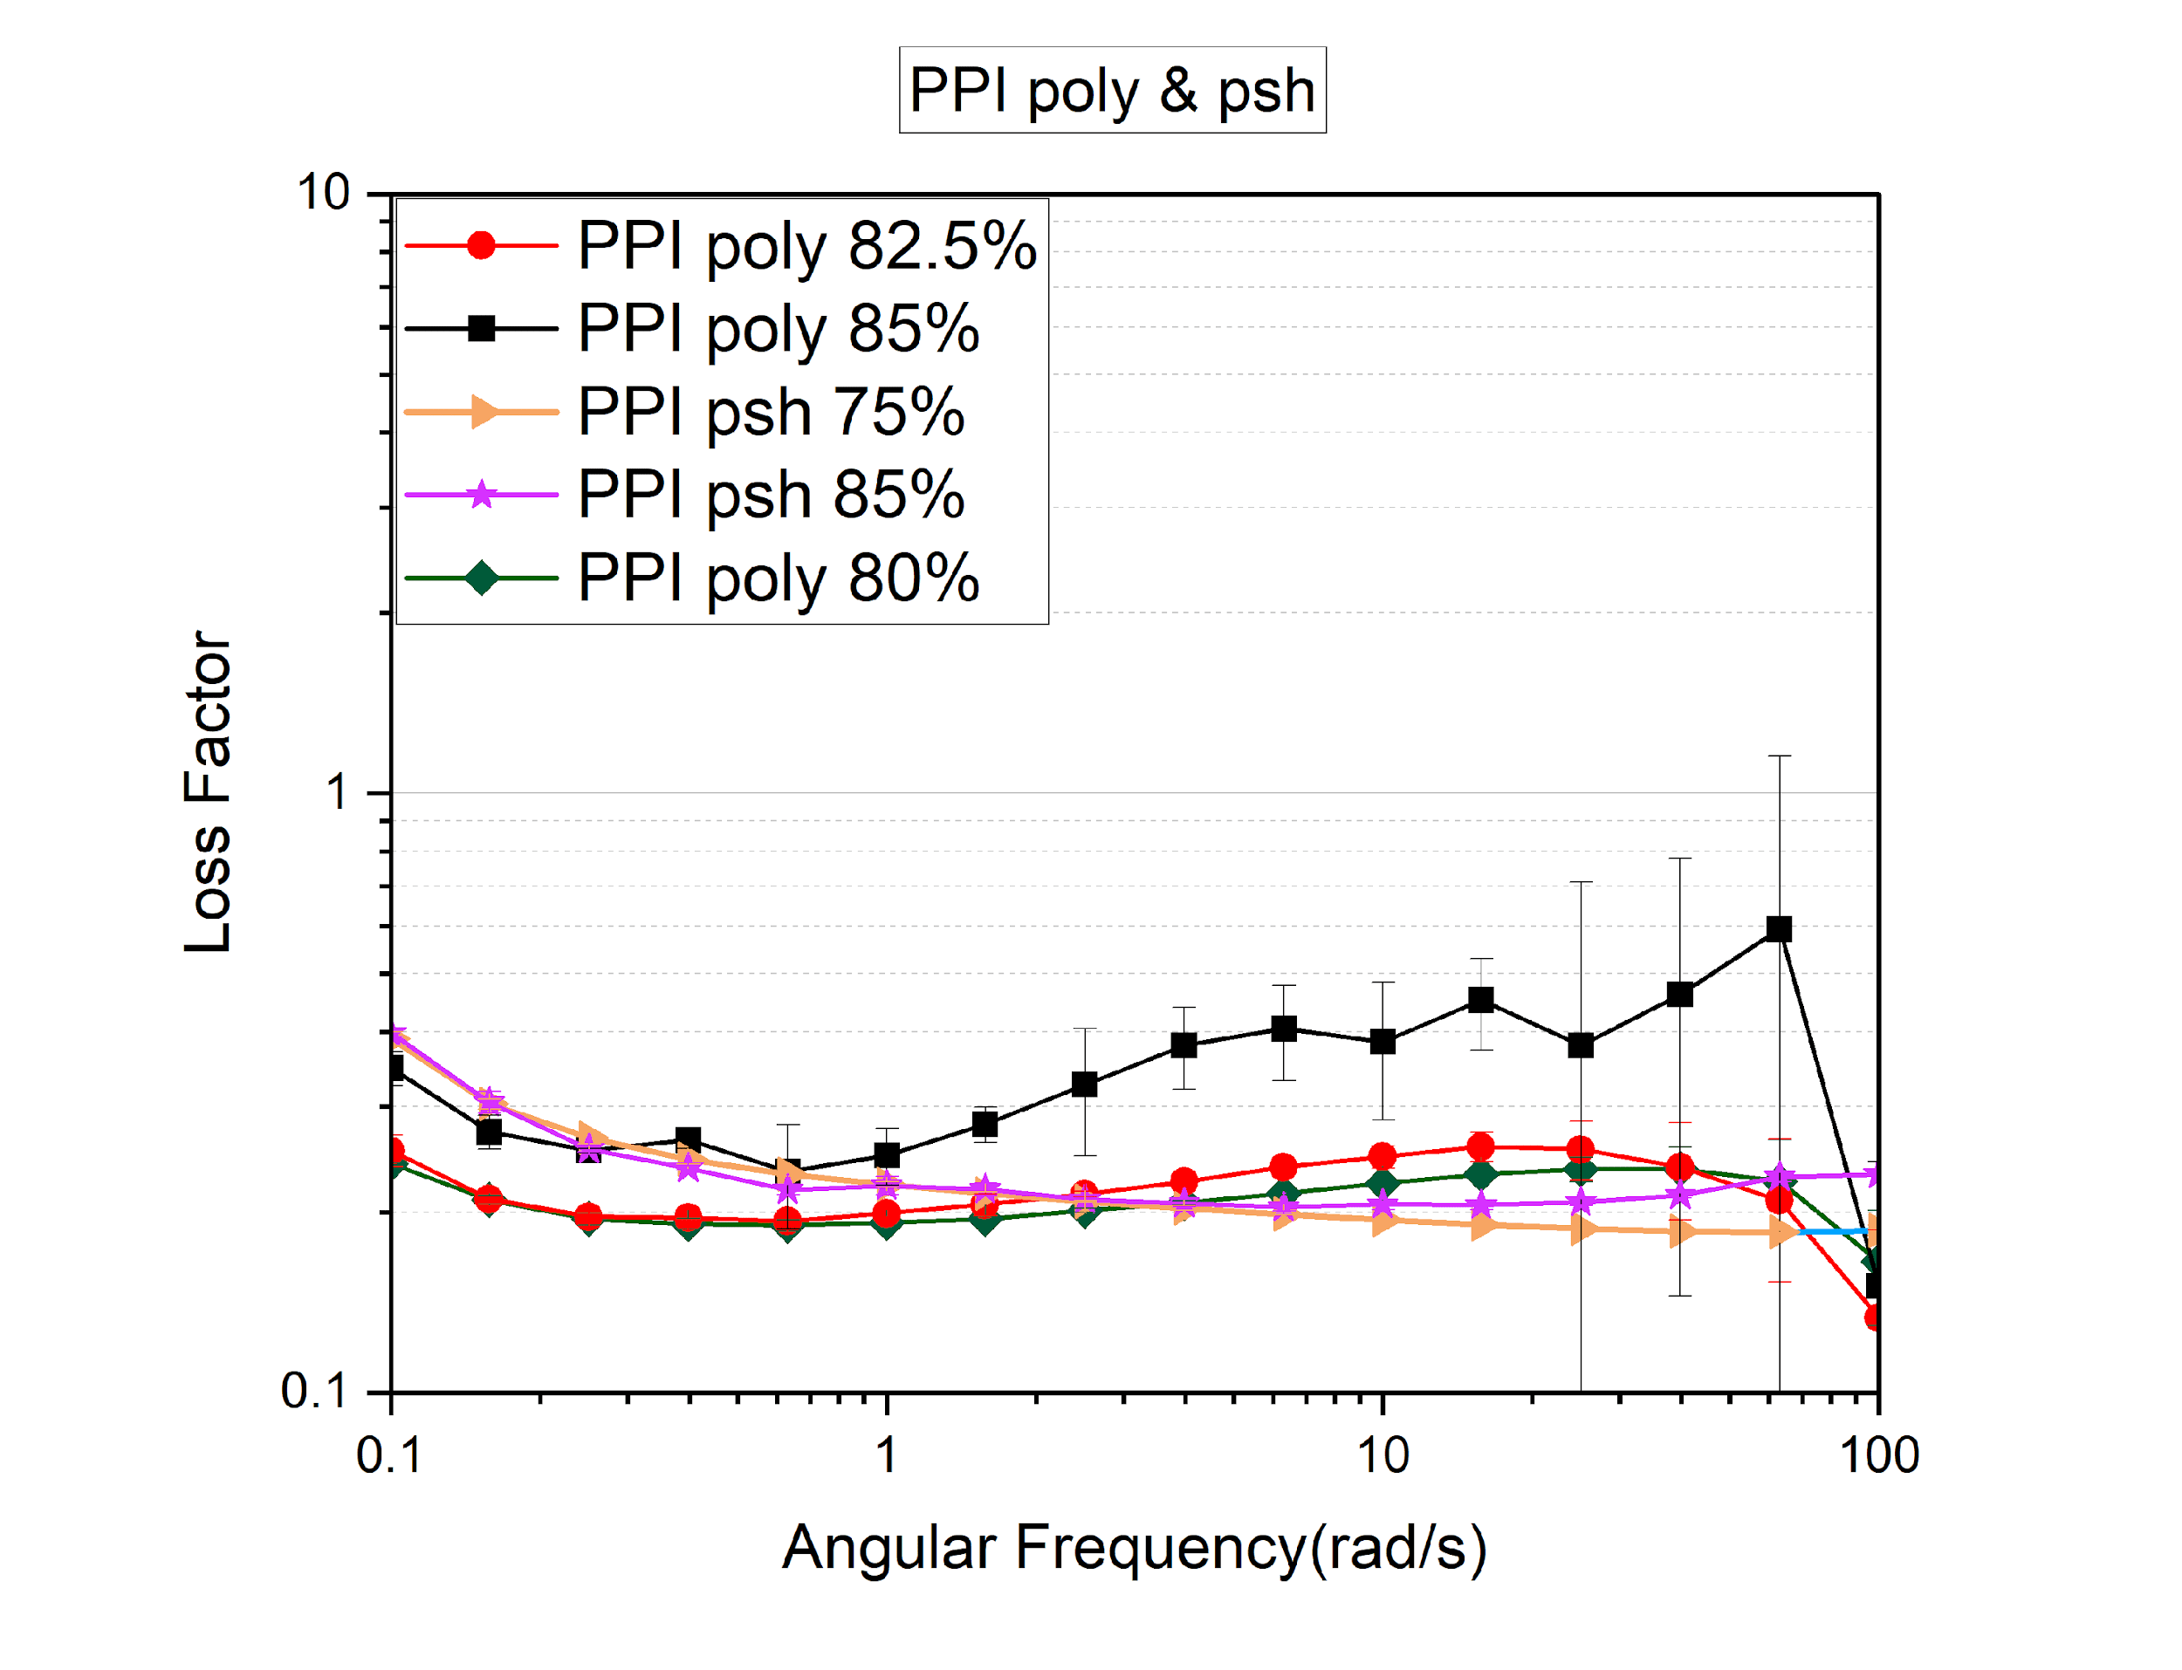

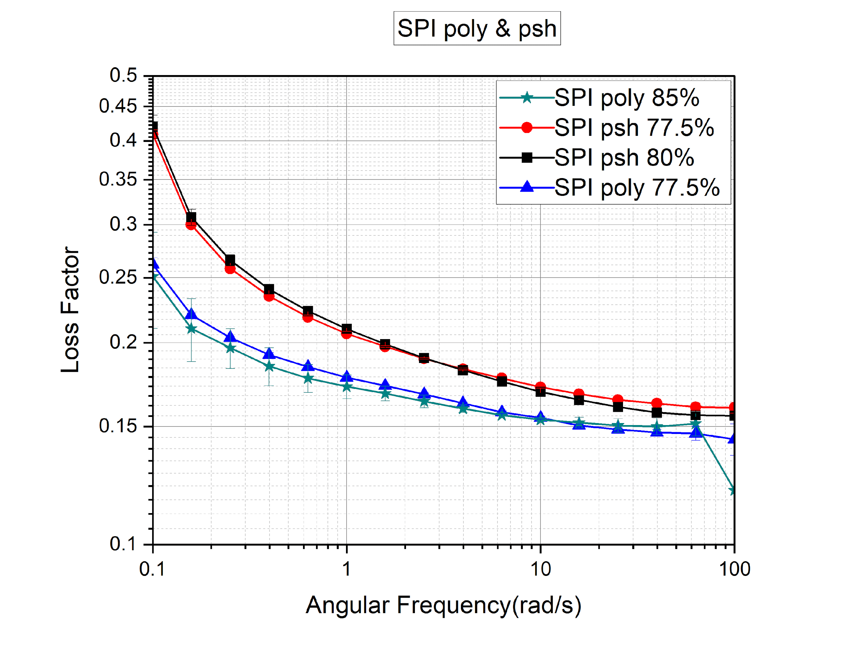 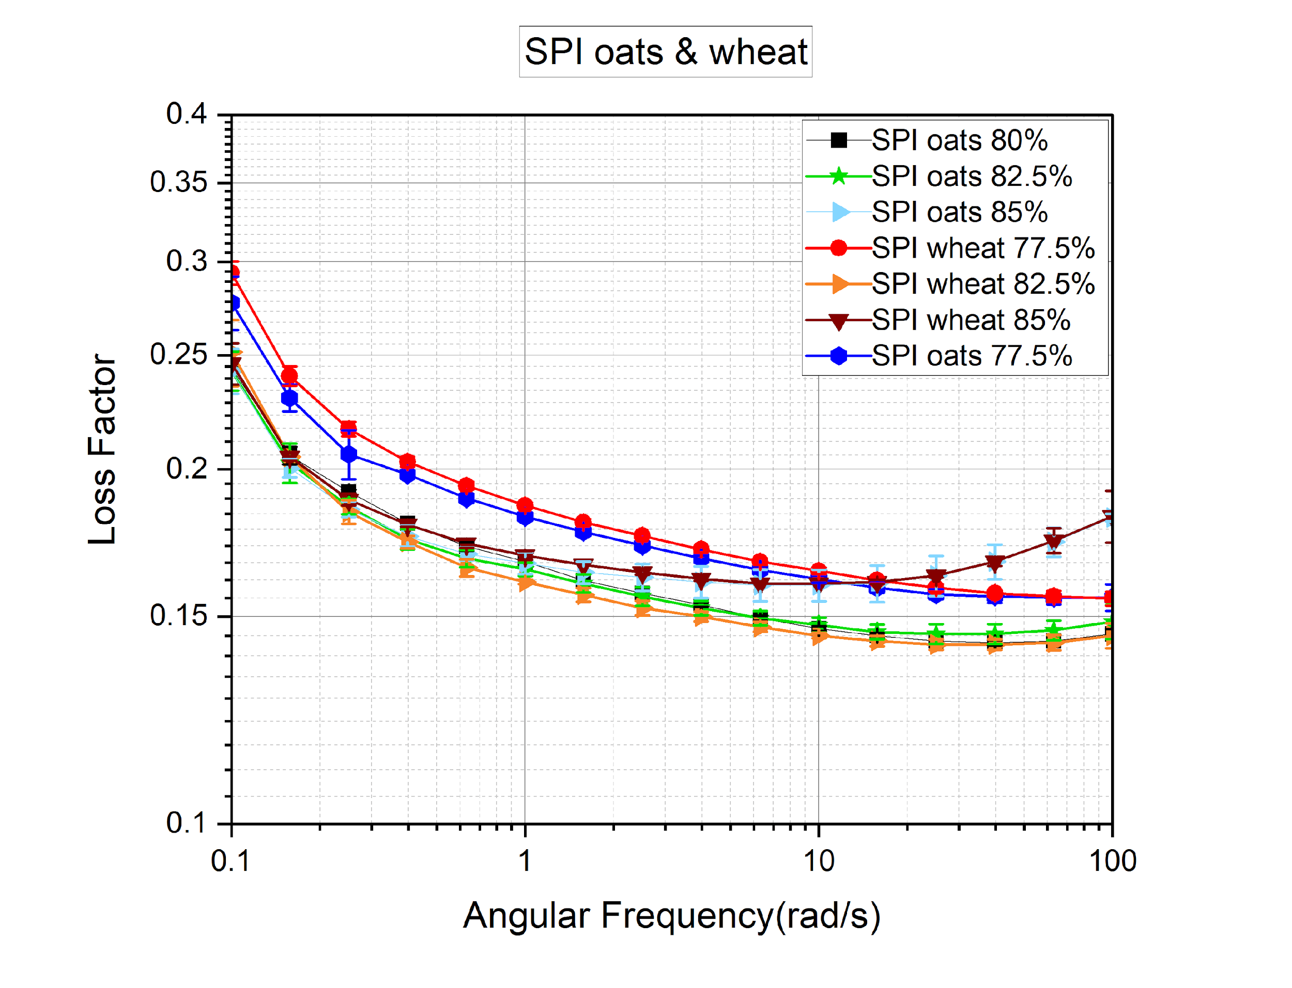

**Viscosity & Flow curve**

To understand the relation between hydration effect on the viscosity and flow curve, tests were done possibly for all the samples including food inks which can print and the samples which are not able to print. The results are shown above in the table for flow curve and graph for the viscosity. The power law of exponential was calculated using the Origin Pro 2023 with the power law model along with the following equation fitted to the resulting curve.

Y = *K*x^n*

Where Y represents shear stress (Pa), K is the consistency index (Pasn), x indicates shear rate (1/s) and n is the flow index (-).

The value of power law index (n) indicates the rheology of the fluid where for newtonian fluids n = 1 and n ≠ 1 indicates non-newtonian fluids. The values of the flow index represent that for newtonian fluids, there is a linear relationship between the shear rate and shear stress whereas for the non-newtonian fluids, a nonlinear relationship is possible. It can be summed up that applied shear rate changes the viscosity of a newtonian fluids remains constant throughout the changes whereas for non-newtonian fluids, viscosities vary with the shear rate.

All the samples are behaving shear-thinning meaning protein-based inks viscosity becoming lower at higher shear rates (1/s) except PPI psyllium husk 75%, 85% PPI wheat 75%, SPI oats 80%, SPI polydextrose 77.5% which showed shear thickening behavior. This kind of behavior is mainly seen in ketchup, molten chocolate, coating and in many foods' samples [(*Flow Curve and Yield Point Determination with Rotational Viscometry | Anton Paar Wiki*, n.d.).](https://www.zotero.org/google-docs/?eUyqhq)All the results for power law were negative, meaning it showed a downward trend representing that inverse power-law relationship. Moreover, it indicated that increasing the shear rate is decreasing the viscosity continuously.

PPI polydextrose-based inks showed values of 0.88, 0.80 and 0.50 for 80%, 82.5% and 85% respectively. Whereas SPI based inks for polydextrose also showed a similar value from 1.41, 0.78 and 0.66 for 77.5%, 82.5% and 85% respectively. The reason for showing the value greater than 1 for SPI polydextrose could be because of non-homogeneous sample or data error. Although for PPI psyllium husk 75% and 85% showed the value of 1.09 and 1.19 which means there was very slight difference while increasing the hydration and the material is behaving shear-thickening. While SPI psyllium husk 77.5% and 80% showed values smaller than 1 indicating that the food ink was behaving as shear-thickening.

Whereas PPI oats have values of 0.72, 0.65 & 0.22 for 80%, 82.5% and 85% respectively. Definitely increasing the water hydration has caused slight changes in the value of power law model. On the other hand, for SPI oats except 80% all the inks showed shear thinning behavior with the value of 0.73, 0.65 & 0.69 for 77.5%, 82.5% & 85% whereas 1.21 for 80%. For PPI wheat-based inks have value from 1.13, 0.88, 0.82 & 0.66 for 75%, 80%, 82.5% & 85% which clearly shows that increasing the hydration is causing a slight difference change in the value. SPI wheat 77.5%, 82.5% & 85% have value around 0.61, 0.63 & 0.69.

Overall, for PPI with the fibers such as oats, wheat and polydextrose it was clearly observed that increasing the water content is decreasing the power vale slightly except psyllium husk was opposite whereas for SPI wheat, polydextrose, psyllium same pattern was observed as PPI but not for wheat. The reason for this could be due to non-homogenous of the food inks.

| Sample | Flow index (-) |
| --- | --- |
| PPI poly 80% | 0.883 ± 0.002 |
| PPI poly 82.5% | 0.808 ± 0.003 |
| PPI poly 85% | 0.578 ± 0.001 |
| PPI psh 75% | 1.093 ± 0.032 |
| PPI psh 85% | 1.194 ± 0.017 |
| PPI oats 80% | 0.724 ± 0.004 |
| PPI oats 82.5% | 0.650 ± 0.002 |
| PPI oats 85% | 0.227 ± 0.010 |
| PPI wheat 75% | 1.132 ± 0.003 |
| PPI wheat 80% | 0.884 ± 0.002 |
| PPI wheat 82.5% | 0.822 ± 0.002 |
| PPI wheat 85% | 0.667 ± 0.002 |
| SPI oats 77.5% | 0.736 ± 0.015 |
| SPI oats 80% | 1.210± 0.025 |
| SPI oats 82.5% | 0.655 ± 0.010 |
| SPI oats 85% | 0.697 ± 0.008 |
| SPI wheat 77.5% | 0.610 ± 0.014 |
| SPI wheat 82.5% | 0.639± 0.010 |
| SPI wheat 85% | 0.697 ± 0.005 |
| SPI poly 77.5% | 1.417 ± 0.020 |
| SPI poly 82.5% | 0.786 ± 0.036 |
| SPI poly 85% | 0.66 ± 0.020 |
| SPI psh 77.5% | 0.589 ± 0.011 |

To determine the viscosity of food inks, all the graphs were plotted between shear rate (1/s) from 1 to 100 and viscosity (Pa.s) from 0.1 to 1000. The results are shown in the following figure (-). The following trend was observed 77.5% wheat >77.5% oats >77.5% psh>80% psh> 77.5% poly>80% oats>82.5 5 wheat > 82.5% wheat > 82.5% poly > almost all at the same level 85 % wheat oats and poly for SPI based inks.

Whereas following trend was observed for PPI based food inks 75% psh> 75% wheat>85% psh > 80% wheat >80% oats> 80% poly> 82.5% wheat > 82.5% oats >82.5% poly >85% wheat > 85% oats > 85% poly.

For both SPI and PPI same pattern was observed in the result that is increasing the water hydrations is causing decrease in the viscosities of the inks except for 80% psyllium which represented slightly higher viscosity than then 77.5% polydextrose and 80% oats and a similar pattern was observed for PPI as well where the viscosity of psyllium husk was more than 80% wheat and oats for 85% psyllium which should have been lowest viscosity with 85% of other dietary fibers. The reason for this is that psyllium husk forms a strong gel as explained by (Agarwal et al., 2021) how the anionic character of psyllium polysaccharide, which is a manifestation of its negatively charged carboxyl groups, enables it to form a gel with wide water-absorbing capability because of its powerful capacity to hold the high-water content. Due to the homo-charges in psyllium polysaccharides generate electrostatic repulsion within the chains, which causes them to fully extend and interpenetrate amongst each other resulting in the intermolecular physical cross-linking that forms into the final gelation of polysaccharide. The extraordinary water uptake and gelling properties of psyllium polysaccharides are due to the inter and intra-molecular hydrogen bonds formed between polysaccharides and water. Ultimately causing the entanglement of polysaccharide chains, which causes more and more water to be trapped within the polysaccharide chains.

With the increase in shear rate, the viscosity of all the samples showed a downward trend representing that the protein-based inks have good fluidity and shear-thinning behavior except PPI psyllium husk 75%, 85% PPI wheat 75%, SPI oats 80%, SPI polydextrose 77.5%. However, [(Guo et al., 2023)](https://www.zotero.org/google-docs/?q5bVFg) observed in their research that increasing the soy protein content with oats promotes the formation of a denser network structure due to the cross-linking between proteins and polysaccharides. Moreover, they explained that a decrease in viscosity with increasing shear rate can be due to the orientation and entanglement of cellulose molecular chains. Increasing the shear rate causes deformation of the chain structure orientation of macromolecular substances and the more scattered chain particles roll, rotate, and contract with the clusters, which decreases the mutual interaction and leads to the reduction of flow resistance. [(Rahman et al., 2020)](https://www.zotero.org/google-docs/?pLWyQI), mentioned that low viscous samples ensure good flow but the structure collapses after printing if not solidified properly and thus this could be the possible reason why low viscous inks collapsed since there was no solidification after printing. On the other hand, it was also mentioned that a highly viscous sample causes clogging of the nozzle resulting in discontinuing printing with poor resolution. Whereas this may be another reason why even high viscous properties having, SPI psyllium husk 77.5% hydration was not able to print. Where clogging was observed during the printing, or another reason could be that psyllium husk was inhomogeneous in the system.

[(Berland & Launay, n.d.)](https://www.zotero.org/google-docs/?JYn1en) observed that increasing water content in the dough causes a decrease in the G’, G’’ and complex viscosity exponentially. Moreover, their research showed that power law exponent n is independent of water content. Increasing the water content does not vary with the shift of power law exponent n. Thus, possibly this could be the reason why there is no relation between the water content and power law exponent and why there is only slight change with increasing the water content.

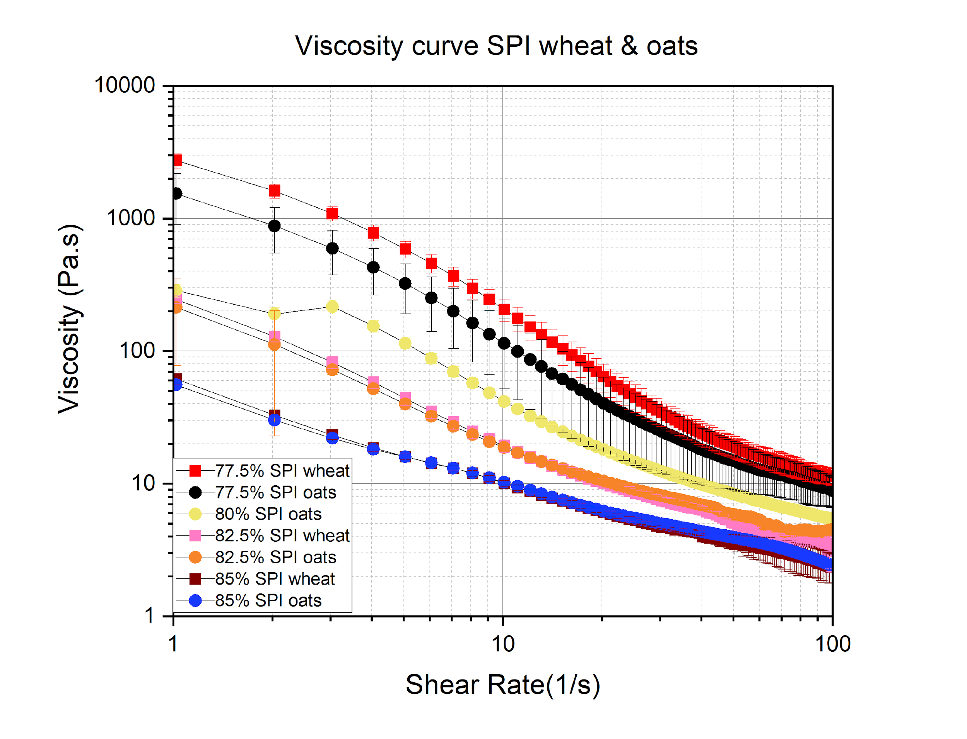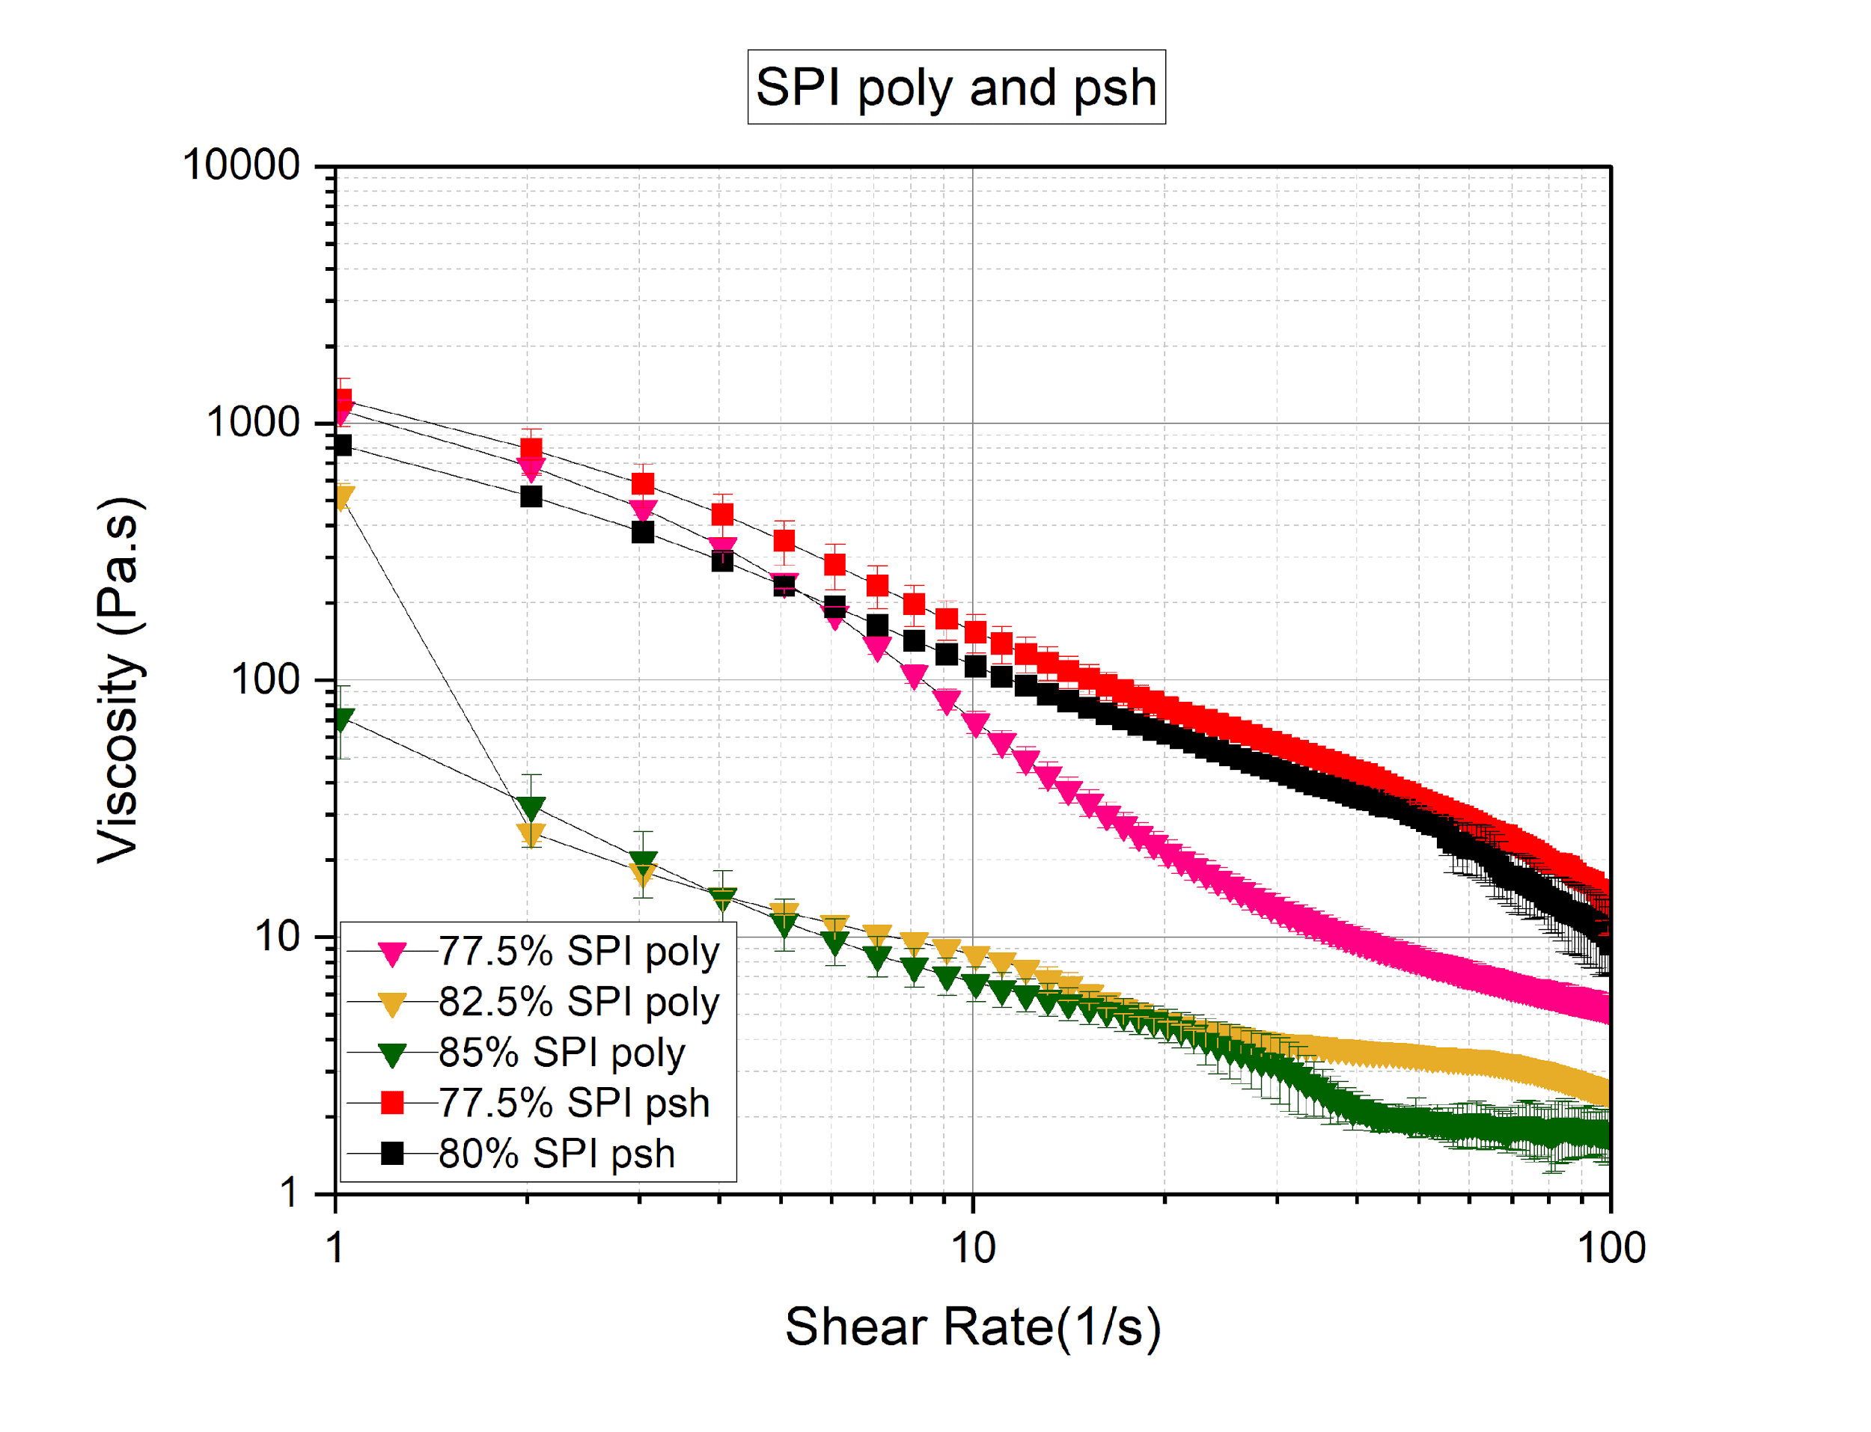

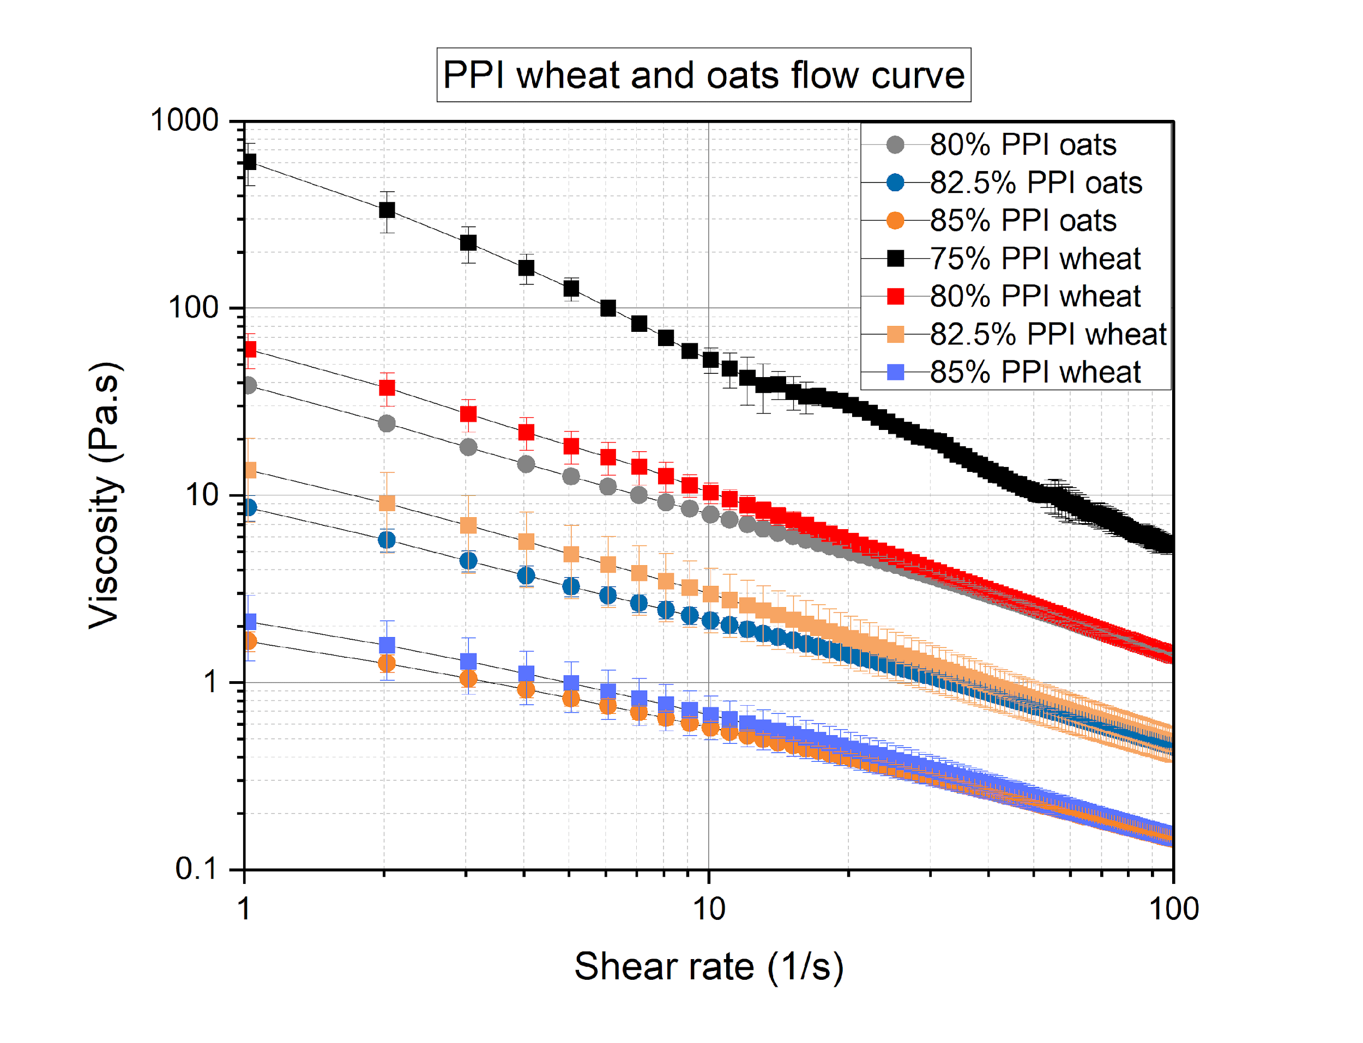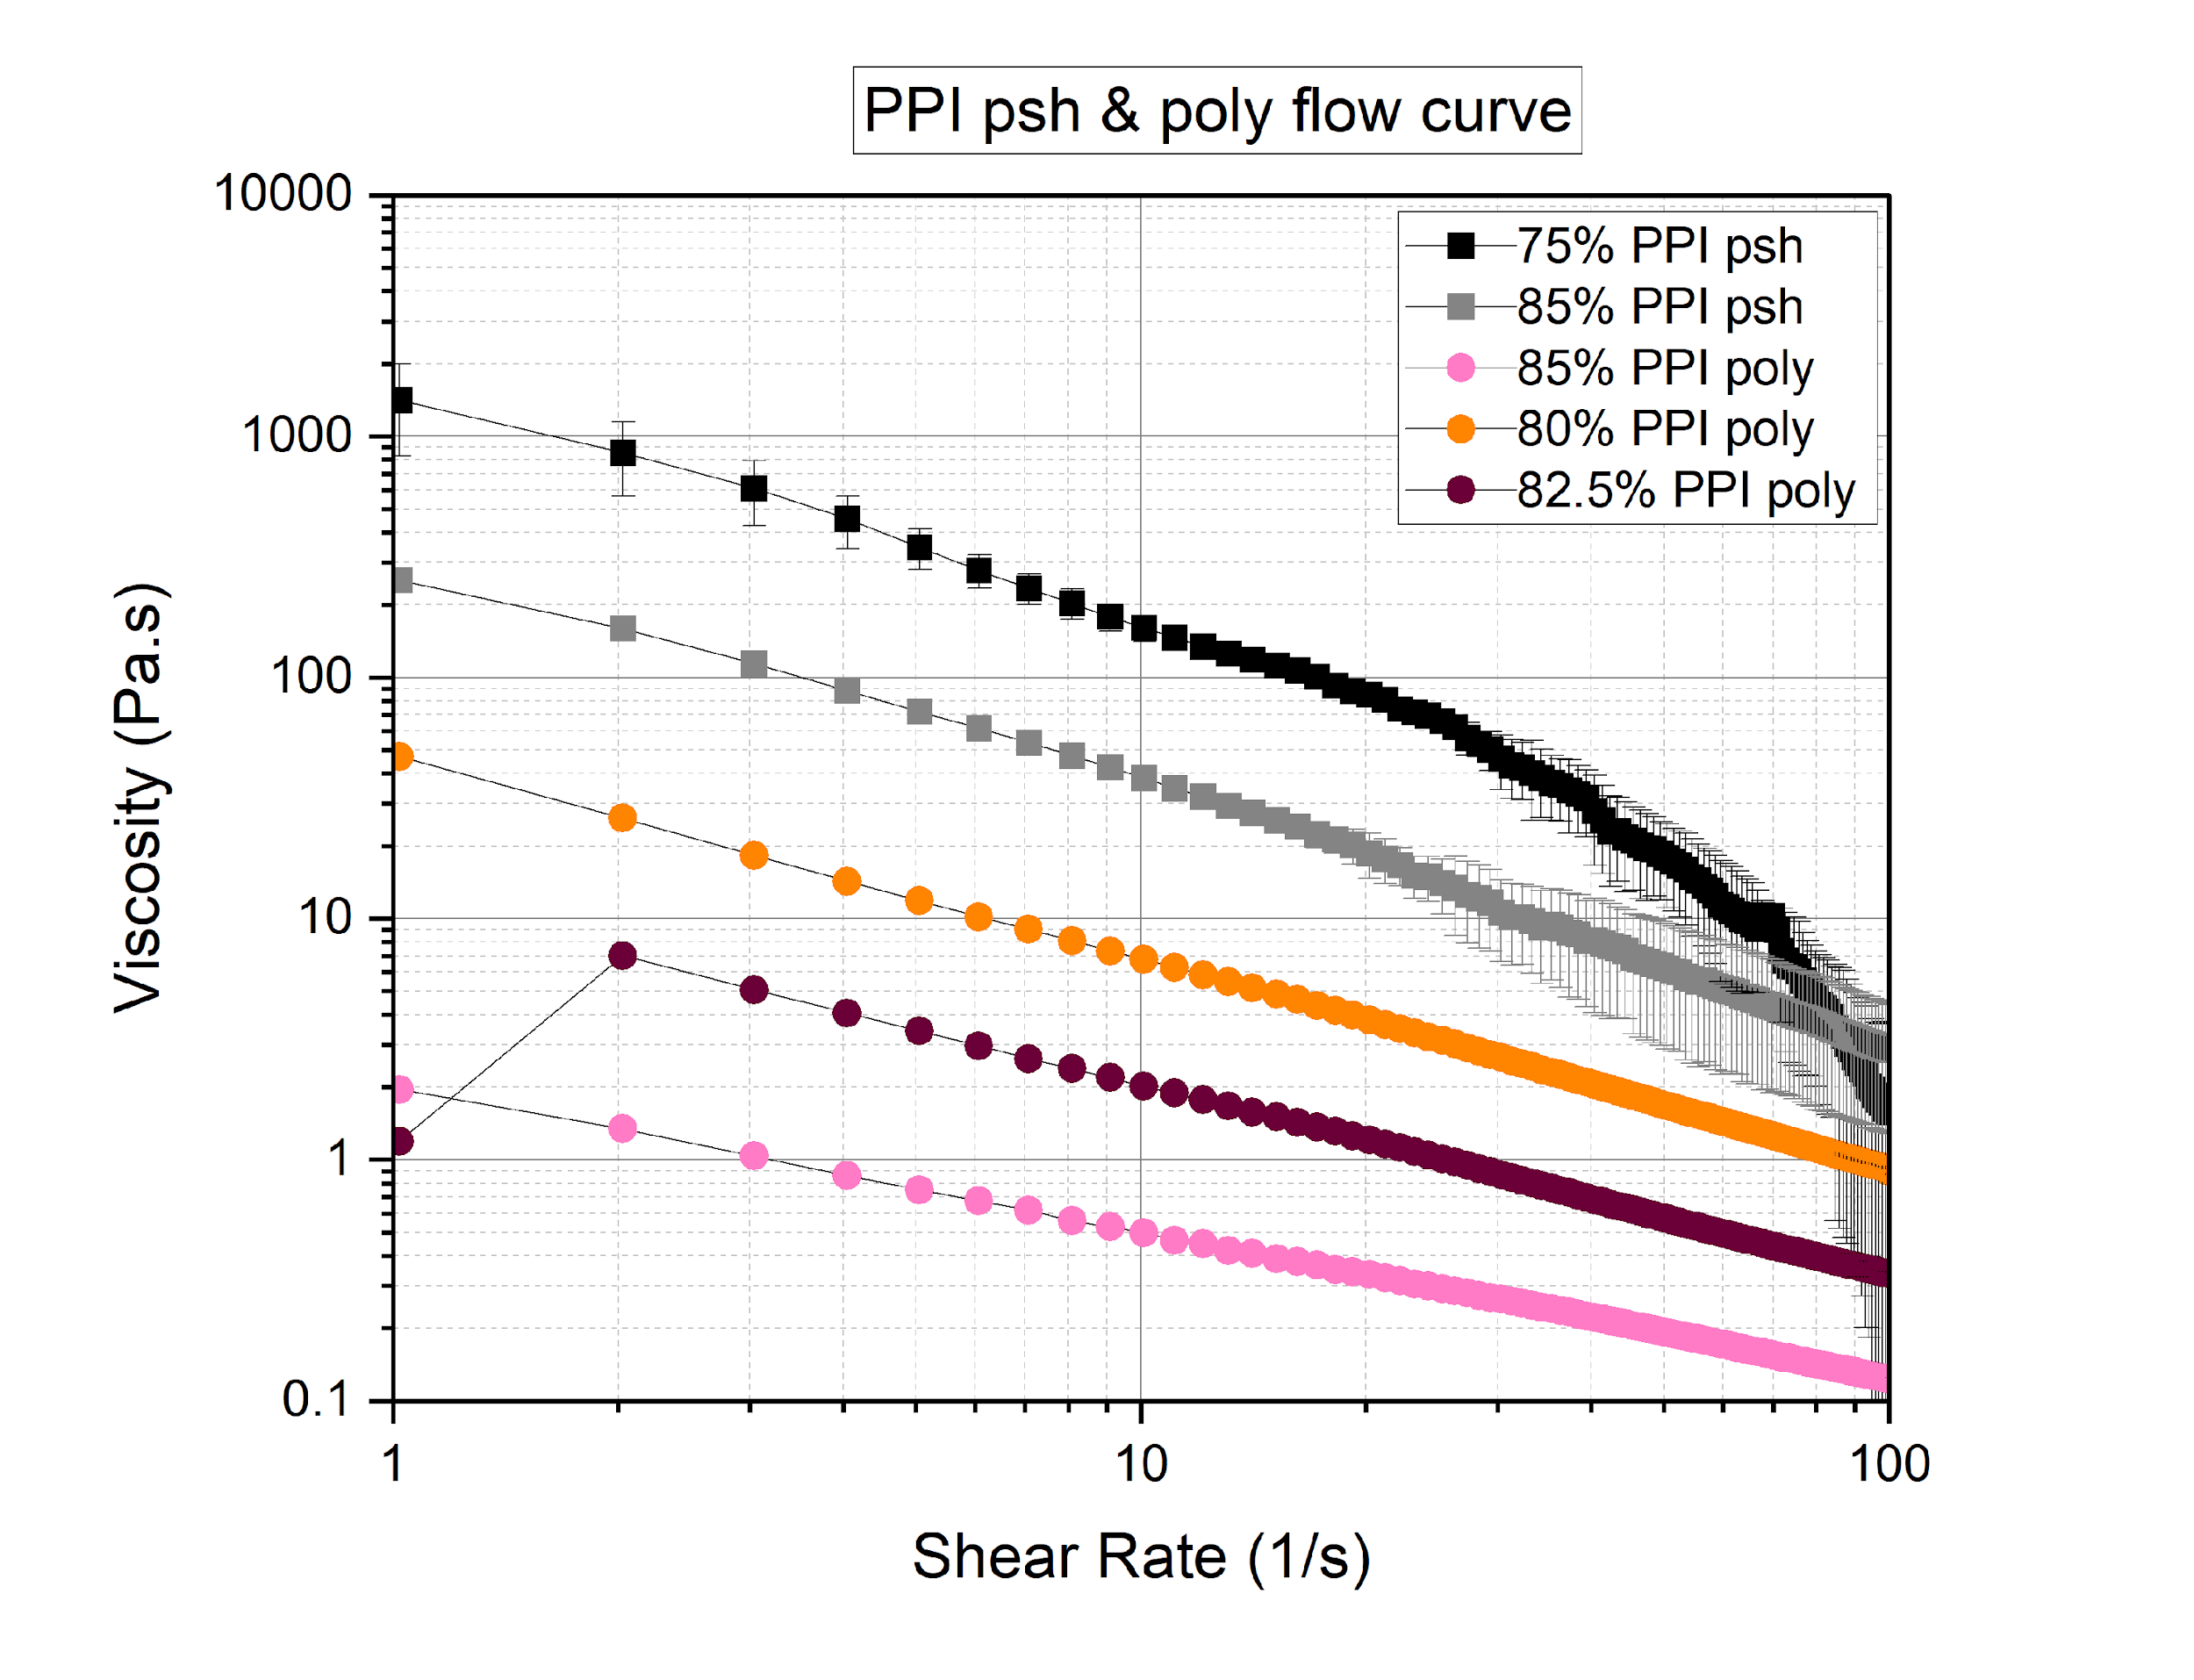

**3.4 Geometrical stability of 3D printed lines**

To examine the geometrical stability of the lines, a dimension of 50*0.84 mm line was created using 3D printing technology. To evaluate the printability of printed lines, side view pictures were taken, and length and height were analyzed using the image analysis algorithm in MATLAB with the specific script created by (Ahmed). The printed lines are shown below.

SPI Polydextrose

| 77.5% |  |  |
| --- | --- | --- |
| 80% |  |  |
| 82.5% |  |  |

SPI oats

| 77.5% |  |  |
| --- | --- | --- |
| 80% |  |  |
| 82.5% |  |  |

PPI psyllium husk

| 75% |  |  |
| --- | --- | --- |
| 77.5% |  |  |
| 80% |  |  |
| 82.5% |  |  |

PPI wheat

| 75% |  |  |
| --- | --- | --- |
| 77.5% |  |  |
| 80% |  |  |

PPI polydextrose

| 75% |  |  |
| --- | --- | --- |
| 77.5% |  |  |
| 80% |  |  |

PPI oats

| 75% |  |  |
| --- | --- | --- |
| 77.5% |  |  |
| 80% |  |  |

To understand the relation between printability and rheology varying with five different hydrations for PPI and four different hydrations for SPI. The filament diameter, flow and printing speed were the same for all samples. Below are the printing parameters used.

| **Filament diameter [mm]** | **Flow rate [%]** | **Printing speed [mm/s]** |
| --- | --- | --- |
| 0.45 | 98 | 3 |

Using these standard parameters, lines were adjusted and printed moreover, the printing bed level, lighting was kept at the constant for all the food inks. The height and length of the lines was determined, using the side view pictures and are shown in Figure (-).

It should be noted that for SPI 75% for all the fibers such as oats, psyllium husk, polydextrose and wheat weren’t possible to print since the inks were not properly hydrated and led to segregation of the SPI particles. Thus, it could be concluded that 75% of hydration wasn’t enough for SPI to form a proper food ink whereas for PPI 75% of hydration worked for all the fibers since PPI requires less water hydration than SPI and forms a weak interaction between the system. This can be explained as soy protein contains more sulphur than pea protein thus it forms more disulfide bonds to stabilize the gel network [(Shand et al., 2007)](https://www.zotero.org/google-docs/?m5857L). Moreover, the total protein content of soy was 5% higher than the PPI thus causing higher polymer concentrations with an increase in the SPI concentrations leading them to higher viscosities [(Bryant & Anseth, 2002).](https://www.zotero.org/google-docs/?zQPctC)

Moreover, printing for SPI 80% psyllium husk for cubes as well as line wasn’t also possible due to the formation of strong hydrogen bonds between the psyllium husk and SPI system. The standard printing parameters weren’t suitable for this ink. Moreover, psyllium husk was not-homogenous distributed in the ink causing the obstruction in nozzle which landed into the clogging of the nozzle. Whereas SPI 77.5% oats and PPI 80% oats were able to print although the MATLAB script for lines both for the height as well as length didn’t run due to the insufficient light and setting problems.

For SPI based inks 80% hydration for wheat and polydextrose, 82.5% oats and psyllium husks and 85% hydration for psyllium husk were observed to maintain the same height as the nozzle diameter that is around 0.84 mm. Whereas for other hydrations such as 82.5% wheat, wheat 77.5%, 85% and 82.5% of polydextrose couldn’t maintain the same height as the nozzle diameter. The reason behind could be that water content that is hydration levels wasn’t good enough or caused them to have a lower viscosity which made them to be water runny samples.

Whereas for the PPI based inks, 75% hydration wheat, oats poly worked but for psyllium husk height was around 0.63 which can be considered as low as required. This can be understood from that, psyllium husk was strongly attracted to the particles and due to the strong force caused them lesser height than others. Moreover, 77.5% psyllium husk, wheat and polydextrose was also around 0.84 mm. Although 80% hydration for psyllium husk performed better than wheat and polydextrose. But 85% hydration of psyllium husk didn’t perform better and couldn’t maintain the height.

a)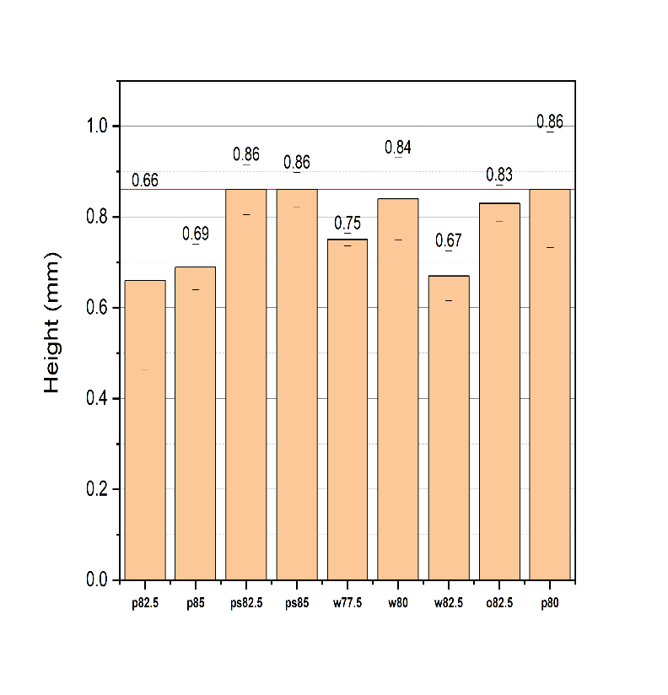b)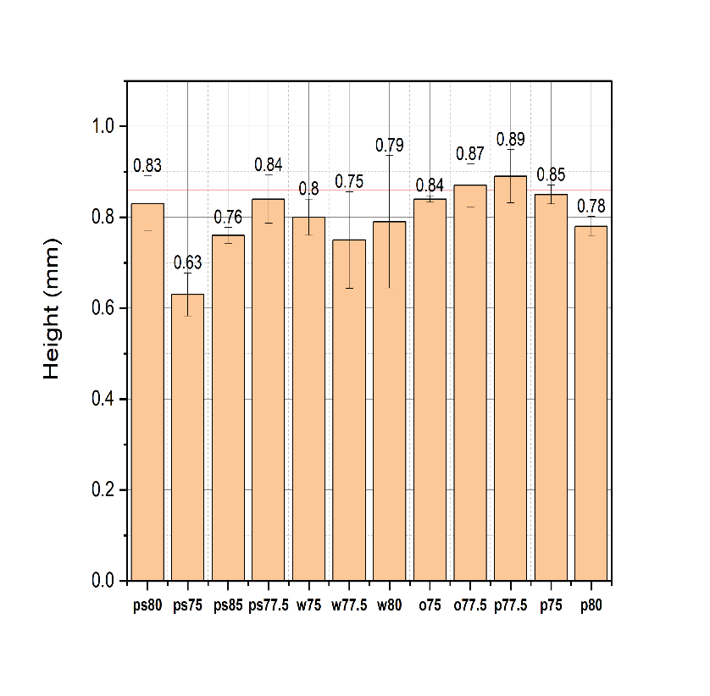

Figure (-) :- Height of the 3D printed lines, for a) SPI (poly 82.5%, poly 85%, psyllium husk 82.5%, psyllium husk 85%, wheat 77.5%, wheat 80%, wheat 82.5%, oats 82.5% and poly 80%) and b) PPI (psyllium husk 80%, psyllium husk 75%, psyllium husk 85%, psyllium husk 77.5%, wheat 75%, wheat 77.5%, wheat 80%, oats 75%, oats 77.5%, poly 77.5%, poly 75% and poly 80%) respectively evaluated by an image algorithm analysis.

Length of the SPI based inks were lower than expected as shown in the figure (-). For all the food inks of SPI they showed length lower than 50 mm which is very low. The lowest length was observed for 82.5% wheat, 85% wheat, 80% polydextrose (17.78, 27.48mm). The decreased viscosity of the ink or the fact that the food ink system was weaker may be the cause of this dimension's watery sample. 82.5% hydration polydextrose, psyllium husk 82.5%, psyllium husk 85%, showed better results but 85% psyllium husk, 77.5% wheat and 82.5% oats showed better results than the others although the length were not exactly as supposed of 50 mm. Higher standard deviations were sometimes seen, which can be explained by the fact that some food inks couldn't draw straight lines and that it was also noticed that inks were breaking off in the middle. As a result, the MATLAB script failed to recognize the line correctly, which ultimately caused deviations and lower length values than predicted. Another reason between SPI and PPI lines was that SPI inks were stronger, and the particles were more attracted to each other causing them to break apart and leading into the lower values than 50 mm.

Better length values were observed for PPI than the SPI since for PPI all the food inks showed values near to 50 mm. All the food inks length value such as 82.5% psyllium husk, 75% psyllium husk, wheat, oats and polydextrose, 85% psyllium husk, and 80% psyllium husk and polydextrose, 77.5% wheat, psyllium husk, oats and polydextrose were as predicted as shown in the figure (-). Except the 80% psyllium husk, 80% polydextrose although higher standard deviation was observed for 80% psyllium husk which could be due to the problem with lighting, printing parameters such as levelling of the bed and interruption due to the air bubbles specially for SPI 80% psyllium husk.

While printing the food inks, it observed that there was always oozing out of the material for the nozzle for SPI with all the dietary fibers such as oats, polydextrose and psyllium husks. And clear separation between the material and water was observed with the increase in the hydration such as for 85% hydration of SPI with all the samples there was clear separation thus printing wasn’t possible for wheat and oats whereas 85% polydextrose somehow printed but there was clear separation and oozing out of the water was continuously seen. This depicts that the lower hydrations such as 77.5%, 80% are good for oats, polydextrose and wheat whereas 82.5% and 85% is good for psyllium husk although all the food inks where under-extruded and many inks such as psyllium husk 85%, 82.5% showed to form a wavy line. It was also observed for the psyllium husk inks that the larger gel particles were blocking the nozzle, which when pushed by the pressure enough force was built up.

From the observation overall it can be concluded that PPI inks were better than the SPI inks for lines for dimensions such as length and height.

c)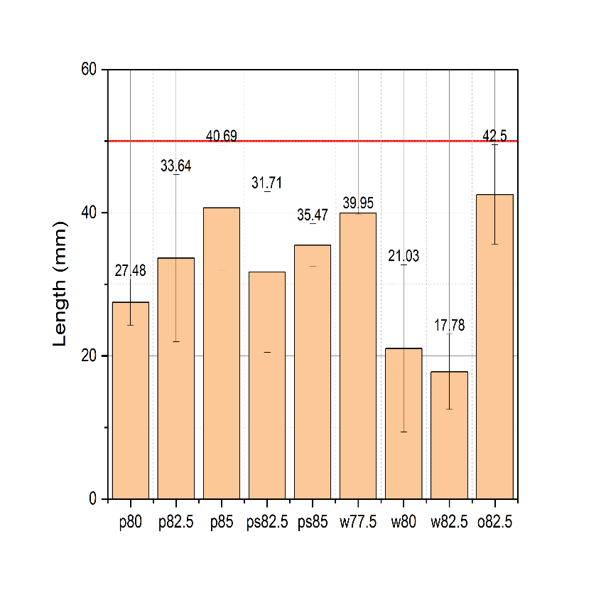d)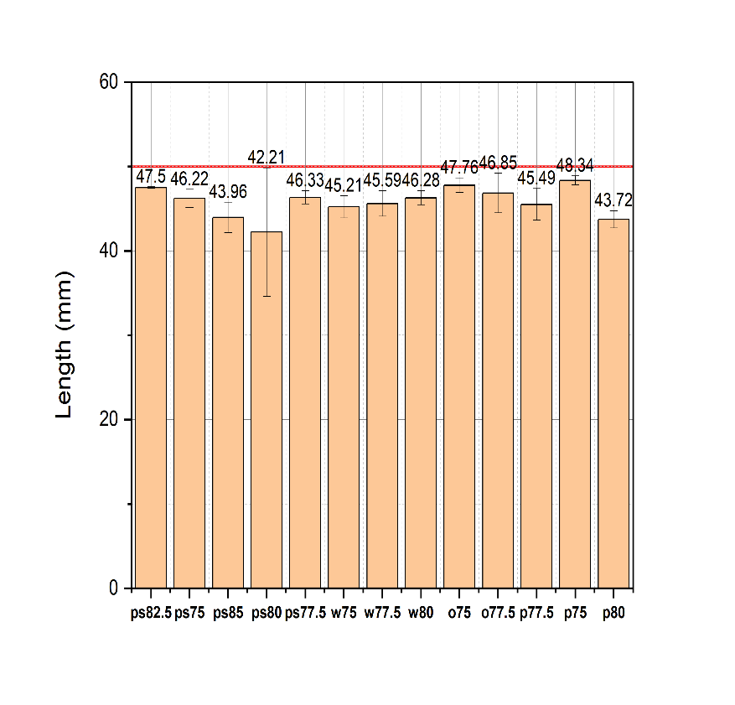

Figure (-):- Length of the 3D printed lines, for c) SPI (poly 80%, poly 82.5%, poly 85%, psyllium husk 82.5%, psyllium husk 85%, wheat 77.5%, wheat 80%, wheat 82.5% and oats 82.5%) and d) PPI (psyllium husk 82.5%, psyllium husk 75%, psyllium husk 85%, psyllium husk 80%, psyllium husk 77.5%, wheat 75%, wheat 77.5% wheat 80%, oats 75%, oats 77.5%, poly 77.5%, poly 75% and poly 80%)) respectively evaluated by an image algorithm analysis.

**3.5 Geometrical stability of 3D printed cubes**

To determine, the stability of printed cubes with the dimensions of 15*15*5 mm were printed. The layer height was set up at 0.84 mm which resulted in six printed layers. The cubes are as shown below (-). Using the image analysis algorithm, the height and length of the cubes were determined as described earlier (-).

SPI polydextrose

| 77.5% |  |  |
| --- | --- | --- |
| 80% |  |  |
| 82.5% |  |  |

SPI oats

| 77.5% |  |  |
| --- | --- | --- |
| 80% |  |  |
| 82.5% |  |  |

PPI polydextrose

| 75% |  |  |
| --- | --- | --- |
| 77.5% |  |  |
| 80% |  |  |

PPI oats

| 75% |  |  |
| --- | --- | --- |
| 77.5% |  |  |
| 80% |  |  |

PPI psyllium husk

| 75% |  |  |
| --- | --- | --- |
| 77.5% |  |  |
| 80% |  |  |
| 82.5% |  |  |

PPI wheat

| 75% |  |  |
| --- | --- | --- |
| 77.5% |  |  |
| 80% |  |  |

The length of the SPI based inks showed greater values than the standard value, that is 15 mm. Whereas 77.5% polydextrose and 82.5% wheat showed poor structural integrity for the cubes although the 80% polydextrose showed better length values than 77.5% but it should have been opposite as viscosity is increasing and should not have been able to hold the shape. This reason can be explained by the fact that increasing the water hydrations caused clear separation in the nozzle thus the water was on the top and the pressure caused to build up the force which led to push the rest of the material with the stronger concentration of the ink. Overall, it can be concluded that hydration of more than 80% for SPI as well as PPI were able to print but it was not structurally stable, and the printed cubes and lines were not properly homogeneous due to the over hydration leading to clear separation thus causing it to print the ink.

With oats increasing the hydration content is causing the length value to be slightly higher (from 77.5% to 82.5%) which was observed almost same for the wheat (77.5% to 82.5%). Whereas psyllium husk also showed the same pattern but not for the 85% hydration content, but it also had higher standard deviation than others.

PPI based inks showed overall better structural stability than the SPI for cubes. The lowest value was observed for 82.5% psyllium husk (14.53mm) which should have been around 15.56 to 15.03mm that is between 80% and 85% hydration. The reason for this deviation could be due to the improper settings of printing parameters. Whereas the highest value of length was observed for psyllium husk 77.5%.

On the other hand, for PPI based inks it was clearly shown in the graph that increasing the hydration content is slightly increasing the value of length for oats, wheat and polydextrose but for psyllium husk increasing the hydration content caused slightly decreased value for the length. This can be again explained by the fact that psyllium husk has strong absorbing capacity which is causing strong force of attraction between the particles.

e)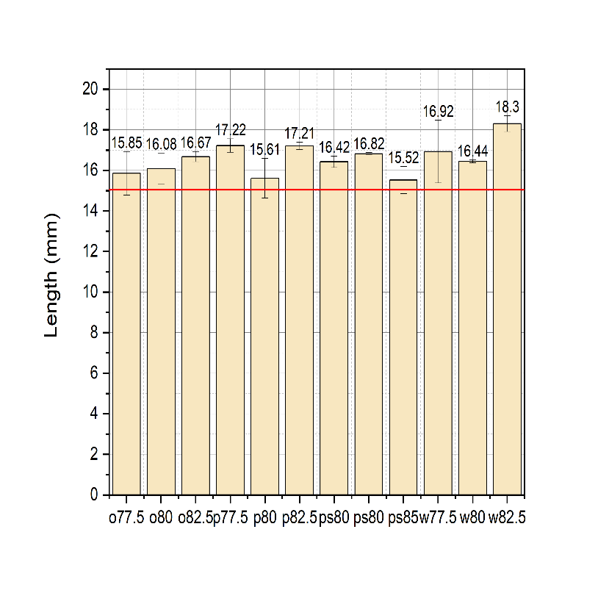f)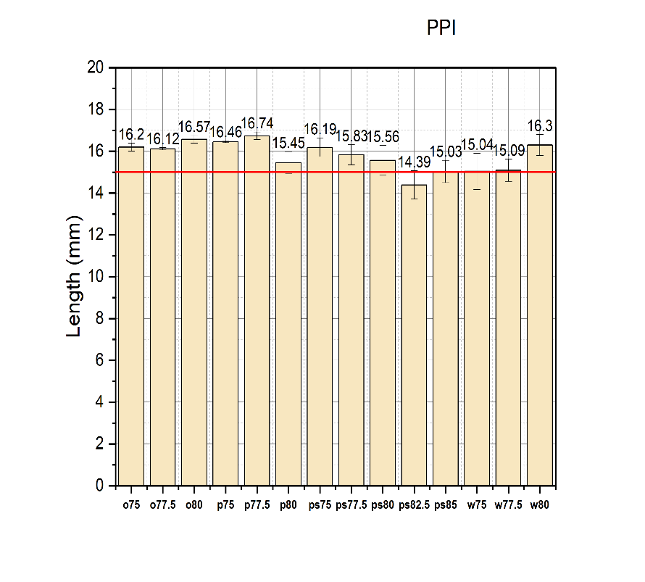

Figure (-):- Length of the 3D printed cubes, for e) SPI (oats 77.5%, oats 80%, oats 82.5%, poly 77.5%, poly 80%, poly 82.5%, psyllium husk 80%, psyllium husk 82.5%, psyllium husk 85%, wheat 77.5%, wheat 80% and wheat 82.5%) and f) PPI (oats 77%, oats 77.5%, oats 80%, poly 75%, poly 77.5%, poly 80%, psyllium husk 75%, psyllium husk 77.5%, psyllium husk 80%, psyllium husk 82.5%, psyllium husk 85%, wheat 75%, wheat 77.5% and wheat 80%)) respectively evaluated by an image algorithm analysis.

The height of the printed cubes was analyzed as shown in the figure (-). And the results were as predicted which are as follows. For SPI-based inks, the lowest value was observed for 77.5% polydextrose with 3.74 mm which is very low whereas increasing the concentration caused an increase in the value of height. To sum up, increasing the hydration content increased the height value for all the SPI-based inks except the wheat 80% and 82.5% which can be explained as the same reason with the non-homogenous inks caused by the clear separation of water and material.

The height of the printed cubes for PPI is shown in the figure (-). The results predict that increasing the hydration content caused the increase in the height value slightly except for the 82.5% psyllium husk which may be due to improper printing parameters settings. The value should have been in between the 4.54 and 4.32 mm which is between the 80% and 85% psyllium husk whereas for polydextrose 75%, 77.5%, and 80% slight deviations and differences were observed. As the mean values are not increasing with hydration but very slightly decreasing.

g)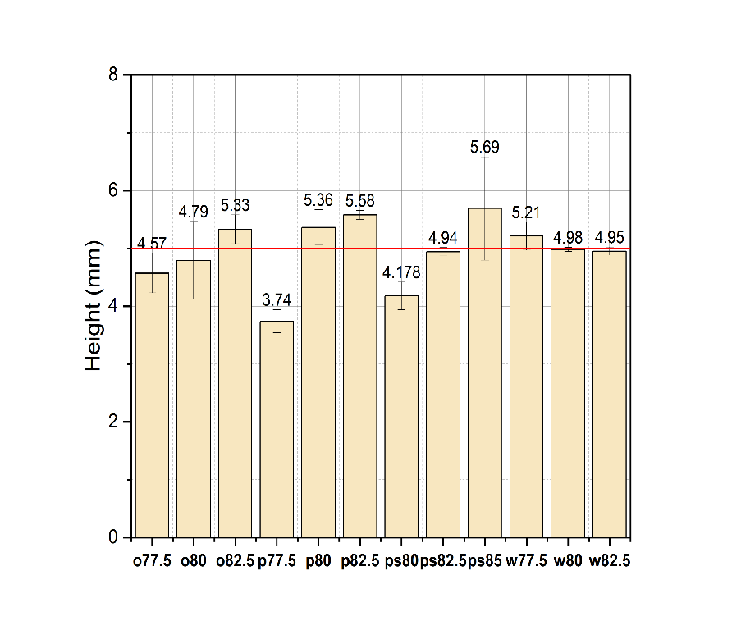h)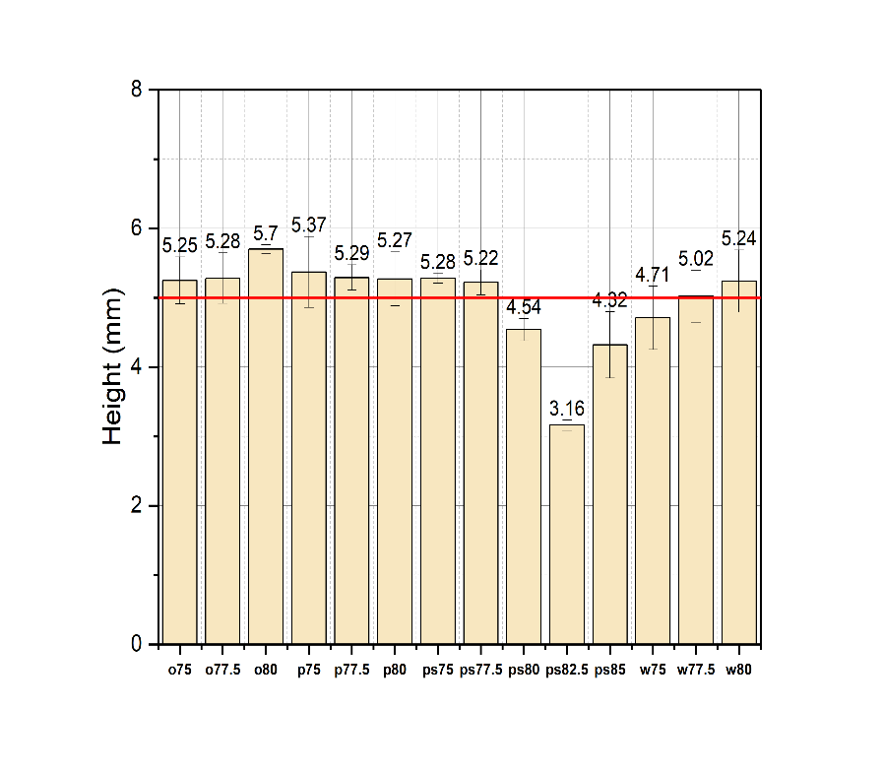

Figure (-):- Height of the 3D printed cubes, for g) SPI (oats 77.5%, oats 80%, oats 82.5%, poly 77.5%, poly 80%, poly 82.5%, psyllium husk80, psyllium husk 82.5%, psyllium husk 85%, wheat 77.5%, wheat 80%, wheat 82.5%) and h) PPI (oats 75%, oats 77.5%, oats 80%, poly 75%, poly 77.5%, poly 80%, psyllium husk 75%, psyllium husk 80%, psyllium husk 82.5%, psyllium husk 85%, wheat 75%, wheat 77.5% and wheat 80%) respectively evaluated by an image algorithm analysis.

**References**

[Agarwal, P. S., Poddar, S., Varshney, N., Sahi, A. K., Vajanthri, K. Y., Yadav, K., Parmar, A. S., & Mahto, S. K. (2021). Printability assessment of psyllium husk (isabgol)/gelatin blends using rheological and mechanical properties. *Journal of Biomaterials Applications*, *35*(9), 1132–1142. https://doi.org/10.1177/0885328220979473](https://www.zotero.org/google-docs/?lgd5YR)

[Aidoo, R. P., Afoakwa, E. O., & Dewettinck, K. (2015). Rheological properties, melting behaviours and physical quality characteristics of sugar-free chocolates processed using inulin/polydextrose bulking mixtures sweetened with stevia and thaumatin extracts. *LWT - Food Science and Technology*, *62*(1), 592–597. https://doi.org/10.1016/j.lwt.2014.08.043](https://www.zotero.org/google-docs/?lgd5YR)

[*Amplitude sweeps | Anton Paar Wiki*. (n.d.). Anton Paar. Retrieved August 27, 2023, from https://wiki.anton-paar.com/en/amplitude-sweeps/](https://www.zotero.org/google-docs/?lgd5YR)

[Berland, S., & Launay, B. (n.d.). *Rheological Properties of Wheat Flour Doughs in Steady and Dynamic Shear: Effect of Water Content and Some Additives*.](https://www.zotero.org/google-docs/?lgd5YR)

[Bryant, S. J., & Anseth, K. S. (2002). Hydrogel properties influence ECM production by chondrocytes photoencapsulated in poly(ethylene glycol) hydrogels. *Journal of Biomedical Materials Research*, *59*(1), 63–72. https://doi.org/10.1002/jbm.1217](https://www.zotero.org/google-docs/?lgd5YR)

[Guo, J., Zhang, M., Li, J., & Fang, Z. (2023). Using Soy Protein Isolate to Improve the Deformation Properties of 4D-Printed Oat Flour Butterfly. *Food and Bioprocess Technology*, *16*(5), 1165–1176. https://doi.org/10.1007/s11947-023-02994-6](https://www.zotero.org/google-docs/?lgd5YR)

[Makshakova, O. N., & Zuev, Y. F. (2022). Interaction-Induced Structural Transformations in Polysaccharide and Protein-Polysaccharide Gels as Functional Basis for Novel Soft-Matter: A Case of Carrageenans. *Gels*, *8*(5), Article 5. https://doi.org/10.3390/gels8050287](https://www.zotero.org/google-docs/?lgd5YR)

[Nath, B., Arora, S., & Nagaraj, V. (2015). *Polydextrose as a functional ingredient and its food applications: A review*. *69*, 239–251.](https://www.zotero.org/google-docs/?lgd5YR)

[Rahman, J. M. H., Shiblee, M. N. I., Ahmed, K., Khosla, A., Kawakami, M., & Furukawa, H. (2020). Rheological and mechanical properties of edible gel materials for 3D food printing technology. *Heliyon*, *6*(12), e05859. https://doi.org/10.1016/j.heliyon.2020.e05859](https://www.zotero.org/google-docs/?lgd5YR)

[Shand, P. J., Ya, H., Pietrasik, Z., & Wanasundara, P. K. J. P. D. (2007). Physicochemical and textural properties of heat-induced pea protein isolate gels. *Food Chemistry*, *102*(4), 1119–1130. https://doi.org/10.1016/j.foodchem.2006.06.060](https://www.zotero.org/google-docs/?lgd5YR)

Anton Paar GmbH: e-learning course – Basics of Rheometry, [part 1: Rotation](https://wiki.anton-paar.com/en/basics-of-rheology/); [part 2: Oscillation](https://wiki.anton-paar.com/en/basics-of-rheology/). Graz, 2010

[*Amplitude sweeps | Anton Paar Wiki*. (n.d.). Anton Paar. Retrieved August 27, 2023, from https://wiki.anton-paar.com/en/amplitude-sweeps/](https://www.zotero.org/google-docs/?lgd5YR)

Bi, C., Gao, F., Zhu, Y., Ji, F., Zhang, Y., Li, D., & Huang, Z. (2018). Effects of xanthan gum on the rheological properties of soy protein dispersion. *International Journal of Agricultural and Biological Engineering,* 11(2), 208–213.

Ozkan, N., Xin, H., & Chen, X. D. (2002). Application of a depth sensing indentation hardness test to evaluate the mechanical properties of food materials. *Journal of Food Science,* 67(5), 1814–1820.

Hussain, Saddam; Malakar, Santanu; Arora, Vinkel Kumar (2022): Extrusion-Based 3D Food Printing: Technological Approaches, Material Characteristics, Printing Stability, and Post-processing. In: *Food Eng Rev* 14 (1), S. 100–119. DOI: 10.1007/s12393-021-09293-w.

[*Flow curve and yield point determination with rotational viscometry | Anton Paar Wiki*. (n.d.). Anton Paar. Retrieved August 27, 2023, from https://wiki.anton-paar.com/en/flow-curve-and-yield-point-determination-with-rotational-viscometry/](https://www.zotero.org/google-docs/?lgd5YR)

Publication bibliography

Liu, Zhenbin; Zhang, Min; Bhandari, Bhesh; Wang, Yuchuan (2017): 3D printing: Printing precision and application in food sector. In *Trends in Food Science & Technology* 69, pp. 83–94. DOI: 10.1016/j.tifs.2017.08.018.

**Appendix**

a) 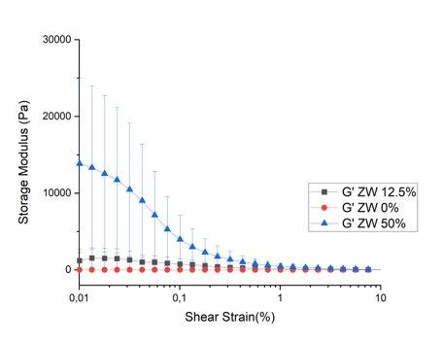b) 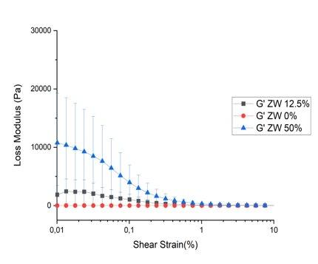

c)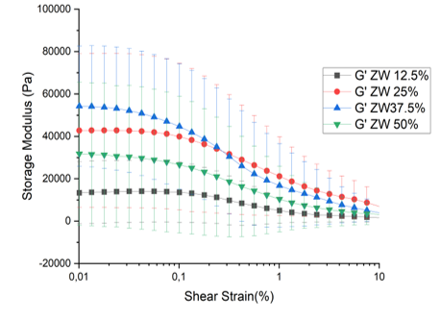d)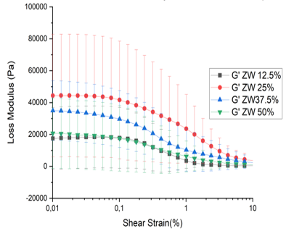

e) 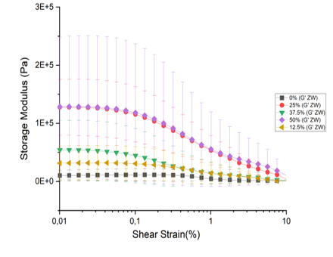f) 

